

**THE UNIVERSITY OF EDINBURGH**

**SCHOOL OF GEOSCIENCES**

**SLEEPING ON ICE: YEAR-ROUND ACTIVITY AND DORMANCY OF CONTINENTAL ANTARCTIC LICHEN *AUSTROPLACA SOROPELTA* AND MOSS *BRYUM ARGENTEUM***

*BY*

**Ainhoa Jiménez Molina**

in partial fulfilment of the requirement for the

Degree of BSc with Honours in

Ecological and Environmental Sciences

April 2024

# ABSTRACT

Lichens and mosses dominate the vegetation in continental Antarctica. They are poikilohydric, meaning they go dormant when dry and reactivate when wet. Understanding their activation patterns over time is crucial for comprehending their ecological functions and functionality in a changing climate. Harsh Antarctic conditions have hindered long-term, in-situ monitoring of these organisms in the past. Here, we present the longest continuous record of photosynthetic activity of Antarctic cryptogams. We utilised measurements from a PAM (Pulse-Amplitude-Modulation) chlorophyll fluorometer from 2019 to 2023 to: i) describe the microclimatic conditions to which *Austroplaca soropelta* and *Bryum argenteum* are exposed to in Scott Base, Continental Antarctica; ii) characterise their activity and activation patterns, and analyse how they change over time; iii) assess the activity of both species under snow cover.

We observed nearly identical cyclical activity patterns in both species. Both exhibited strong, continuous activity from the end of November until the beginning of February, followed by dormancy for the rest of the year. Moreover, we noted a decreasing trend in active time each year over the observation period. Regarding their behaviour under snow, their response depended on whether the snow event occurred at the beginning, middle, or end of the summer season. These results provide further insights into the behaviour of both species and underscore essential considerations for future studies examining lichens and mosses at singular points throughout the season.

# TABLE OF CONTENTS

Table of Contents

ABSTRACT II

TABLE OF CONTENTS III

ACKNOWLEDGEMENTS V

LIST OF ABBREVIATIONS VI

1. INTRODUCTION - 1 -

1.1. Pulse-amplitude modulated (PAM) chlorophyll fluorometer. - 3 -

1.2. Objectives & Research Questions - 4 -

2. METHODS - 5 -

2.1. Site description - 5 -

2.2. Investigated Species - 6 -

2.3. Data collection - 7 -

2.4. Data Processing - 8 -

2.5. Data analysis - 8 -

3. RESULTS - 11 -

3.1. MICROCLIMATIC CONDITIONS IN SCOTT BASE - 11 -

3.2. CHARACTERIZATION OF AUSTROPLACA AND BRYUM ACTIVIVTY AND ACTIVATION PATTERNS AND CHANGE OF THOSE OVER TIME - 15 -

3.3. CORRELATION BETWEEN ACTIVITY AND MICROENVIRONMENTAL VARIABLES- DRIVERS OF ACTIVITY - 17 -

3.4. BEHAVIOUR UNDER SNOW - 19 -

4. DISCUSSION - 21 -

4.1. Climatic conditions in Scott Base and comparison with the rest of Antarctica - 21 -

4.2. Cyclical identical continuous activity in both species - 22 -

4.2.1. Cyclical and Identical activity - 22 -

4.3. Continuous activity - 23 -

4.4. Decrease in active time. - 24 -

4.5. Different behaviour under snow - 25 -

4.5.1. Behaviour under snow at the beginning of the season - 26 -

4.5.2. Behaviour under snow in the middle of the season - 26 -

4.5.3. Behaviour under snow at the end of the season - 26 -

4.6. Other results - 27 -

4.7. Limitations and further study - 27 -

5. CONCLUSION AND IMPLICATIONS - 28 -

BIBLIOGRAPHY - 29 -

# ACKNOWLEDGEMENTS

I want to thank my supervisor Dr. Claudia Colesie and Professor Allan Green for their invaluable guidance and support through this project and for introducing me to the world of cryptograms and polar studies. The data set used for the completion of this study was provided to me by Dr. Colesie and installed and maintained by Dr. Craig Cary and the team of New Zealand Antarctica.

Lastly, I wajhjnt to thank (familia y amigos!!!)

LIST OF ABBREVIATIONS

|  |  |  |
| --- | --- | --- |
| Abbreviation | Term | Unit |
| BSC | Biological Soil Crust | - |
| PAM | Pulse Amplitude Modulation | - |
| PAR | Photosynthetic Active Radiation | μmol m-2 s-1 |
| RH | Relative Humidity | % |
| TT | Thallus Temperature | °C |
| WC | Water Content | % |
| ETR | Electron Transport Rate | μmol e- m-2 s-1 |

# INTRODUCTION

Polar regions are particularly vulnerable to climate change (Robinson et al., 2003; Schroeter et al., 2010, 2011). There is strong evidence of ongoing impact in terrestrial and aquatic ecosystems in both the Arctic and the Antarctic (IPCC, 2024). However, within the South Pole, there is significant contrast in the level of understanding on the extent and consequences of climate change between Maritime Antarctica and Continental Antarctica (Fig. 1). It is well understood that in Maritime Antarctica temperature is rising and ice is melting, affecting plant distribution (Comiso, 2000; Doran et al., 2002; Raggio et al., 2016; Shindell & Schmidt, 2004; Thompson & Solomon, 2002). On the contrary, the impacts in Continental Antarctica are yet to be determined. While some studies claim that East Antarctica has suffered a cooling of 0.08 to 0.7 °C every decade over the last 30 years, with summer season having the most pronounced changes. (Comiso, 2000; Doran et al., 2002; Shindell & Schmidt, 2004; Thompson & Solomon, 2002); others claim that there has been an overall warming (Bertler et al., 2004) that in the future will dominate (Shindell & Schmidt, 2004). There is an urgency to ascertain the climatic future of the Continent, since both scenarios pose different challenges for ecosystems in the area, which, already exposed to extreme climatic conditions, are highly sensitive to changes in temperature and radiation that eventually translate in changes in water availability (Doran et al., 2002).

Continental Antarctica is the coldest, driest and windiest continent on Earth (Raggio et al., 2016). Precipitation is below 100 mm yr-1, and mainly restricted to snowfall during winter (Pannewitz, Green, et al., 2003; Schroeter et al., 2010), and, under cold conditions, snow sublimes instead of melting, and soil water freezes, so there is no liquid water available for plants (Colesie et al., 2016; Seybold et al., 2009). Moreover, the environment is highly variable (Gemal et al., 2022). During the summer, sunlight is continuous, with high light levels from over 1500 to 2500 μmol m-2 s-1 (Schroeter et al., 2011) that, in some regions can heat the ground up to 35.2 °C (Pannewitz et al., 2005a). During winter there is total darkness for three months (Gemal et al., 2022; Schroeter et al., 2010) and temperatures fall to averages below -50 °C, with the lowest ever recorded being -89.2 °C (“Encyclopedia of the Antarctic,” 2006; Pannewitz, Schlensog, et al., 2003). The Ross Sea Region is the most widely researched area within Continental Antarctica (Doran et al., 2010; Raggio et al., 2016; Schroeter et al., 2010, 2011), and within this region where life approaches its environmental limit (Doran et al., 2010).

As a result of this extreme environment, biodiversity decreases heavily in the area (T. G. A. Green, Sancho, Türk, et al., 2011) and vegetation is restricted to Biological Soil Crusts (BSC). These are small-scale communities of cryptograms like lichens or mosses, algae or cyanobacteria that associate with soil particles and live within or on top of the uppermost millimeters of soil in areas where vascular plant growth is restricted due to severe environmental conditions (Colesie et al., 2016). They are present in most landscapes across the globe and cover around 8% of the terrestrial surface (T. G. A. Green, Sancho, & Pintado, 2011), but are especially important in environments with low amount of available liquid water (Colesie et al., 2016; Raggio et al., 2014), which they can inhabit thanks to their poikilohydric nature (Pannewitz et al., 2005a). Poikilohydric organisms keep their water content (WC) in equilibrium with their environment so that they are dormant when the environment is dry and reactivate again when there is water available(Kappen & Valladares, 2007; Raggio et al., 2014; Rundel & Lange, 1980). This strategy increases their resistance to drought but limits their potential carbon gain to times when there is sufficient water available (Raggio et al., 2014; Schroeter et al., 2011). For most mosses and lichens this desiccation and reactivation happens very quickly and without major damage (Schlensog et al., 2004; Schroeter et al., 2011), which makes them highly sensitive to their environment (Raggio et al., 2016; Schroeter et al., 2011).

Lichen and mosses are the only carbon fixator in Continental Antarctica (T. G. A. Green, Sancho, & Pintado, 2011; Raggio et al., 2014). They also are ecosystem engineers: they stabilize the soil and prevent habitat degradation while creating micro niches for other organisms with increased water and nutrient availability (Barrera et al., 2022; Colesie et al., 2016; Raggio et al., 2014). In consequence, understanding the links between microclimatic conditions and physiological performance of lichens and mosses is essential to understand ecosystem functioning and generate nutrient or climatic models of Continental Antarctica (Raggio et al., 2014). Moreover, the effects of climatic changes in such an extreme environment are quickly visible in primary producers and can affect their survival and productivity, generating ecological cascades (Doran et al., 2002). For instance, changes in precipitation or snow melting patterns can impede or improve carbon productivity, that is already restricted to a few months a year (Schroeter et al., 2011). Therefore, we first must understand which factors control photosynthetic productivity to forecast the possible climatic repercussions(Schroeter et al., 2011). Lastly, their sensitiveness to their environment presents cryptograms as bioindicators to successfully track and monitor climatic changes in areas of the Continent where other monitoring would be harder, thereby providing valuable information in the currently uncertain landscape of climate chance in Continental Antarctica (Pannewitz et al., 2005a; Raggio et al., 2016).

Current knowledge stablishes that cryptograms are scarce in Continental Antarctica and limited to micro habitats with wind protection and a reliable water supply (Convey, 2006; Kappen et al., 1991; Pannewitz, Green, et al., 2003; Raggio et al., 2016; Schroeter et al., 2010). Water supply seem, in fact, the main driver of distribution and continuous activity of cryptograms (Colesie et al., 2016; T. G. A. Green et al., 2007; Raggio et al., 2014; Schroeter et al., 2010), and whereas mosses seem to mainly use liquid water (T. G. A. Green, Sancho, & Pintado, 2011; Rundel & Lange, 1980) lichens can access moisture from a wider variety of sources, although liquid water generates more effective photosynthetic production (Colesie et al., 2016). Both cryptograms seem to be well adapted to high-light environments (Clarke & Robinson, 2008; T. G. A. Green et al., 2005) although lichens are more prone to deactivation in scenarios of full sunlight (Lange, 2003).

Nevertheless, even though some studies have been done in the ecophysiology of cryptograms in Continental Antarctic, detailed knowledge of lichens and mosses activity as a response to their environment is rare, especially under natural conditions (Pannewitz et al., 2005a; Raggio et al., 2014; Schroeter et al., 2010, 2011). Field studies provide more definitive information about the conditions in which physiological activity is occurring, giving a better understanding of microclimates present inside the continent, which seem to influence the stresses the organisms face and their rate of recovery after desiccation(Pannewitz et al., 2005a). Moreover, long-term in-situ studies encompassing different seasons provide key information like year-to-year variability in net production or behaviour under snow cover, which are vital to understand their whole activity cycle and produce reliable estimates of seasonal carbon gain (Belnap et al., 2001; Pannewitz et al., 2005a; Pannewitz, Green, et al., 2003; Schroeter et al., 2011; Winkler et al., 2000). Even so, the extreme conditions of Continental Antarctica, and the logistical effort associated, have meant that the studies for the photosynthetic activity of continental Antarctic cryptogams that involve human interaction only span part of the summer season, so data is brief and incomplete (Gemal et al., 2022; Schroeter et al., 2011).

### Pulse-amplitude modulated (PAM) chlorophyll fluorometer.

Recently, chlorophyl a fluorescence has gained popularity as a non-invasive technique for monitoring plant ecophysiology (Schroeter et al., 1992; Tuba et al., 1997). It allows for the non-contact measurement of the microclimatic conditions and the photosynthetic and metabolic activity of the plant without disturbing the snow or the samples(Pannewitz, Green, et al., 2003; Schroeter et al., 2011).

The PAM fluorometer is portable and autonomous, so it facilitates continuous year-round monitoring of samples(Raggio et al., 2016) and it is especially useful to explain changes through time of an individual sample (Maxwell & Johnson, 2000). This technique has increased the number of long-term in situ experiments in the Antarctic Continent (Pannewitz, Schlensog, et al., 2003; Raggio et al., 2016; Schroeter et al., 2010, 2011), but still the severe climatic conditions in Antarctica have not allows for long projects. Schroeter et al., (2010, 2011) have the longest monitoring study up to date, but due to logistics they only measure activation and not amount of activity and measurements are discontinuous and with shutdowns.

This study aims to fill this gap on the literature by using a PAM fluorometer to take long-term in situ measurements of the lichen *Austroplaca soropelta* and the bryophyte *Bryum argenteum* in Scott Base, Continental Antarctica.

Scott Base is a research station of New Zealand Antarctica. It is located in Ross Island, in the Ross Sea in southern Victoria land, Continental Antarctica (Fig. 2).

Lichens and mosses pose many differences in the mechanisms and structures they use to survive desiccation (T. G. A. Green, Sancho, & Pintado, 2011). Mosses are multicellular plants. Lichens, on the contrary are a symbiosis of a hyphal fungus (Kingdom Fungi) with a unicellular, colonial or ﬁlamentous algae (Kingdom Protista) or cyanobacteria (Kingdom Eubacteria)(T. G. A. Green, Sancho, & Pintado, 2011). Studying both organisms allows for comparison and a better understanding of the ecophysiology of cryptograms in this area. *Bryum argenteum* and *Austroplaca soropelta* are two of the main cryptograms present in Scott Base. *Bryum argenteum* is the most spread species of moss across Victoria Land (Gemal et al., 2022). It has been well studied in different locations across the Dry Valleys (Gemal et al., 2022; T. Green et al., 2000; Longton, 1974; Pannewitz et al., 2005a; Rastorfer, 1970; Schroeter et al., 2012) and across the globe (Pisa et al., 2013; Stark et al., 2010; Wang et al., 2019), and represents the general characteristics of bryophytes in the area. *Austroplaca soropelta* is a lichen with a very strong presence in Continental Antarctica. It is a general example of crustose lichen and has also been previously studied in the area (Raggio et al., 2016), which eases future comparison.

### Objectives & Research Questions

As a step towards a better understanding of the ecophysiological behavior of the most representative lichens and mosses in Continental Antarctica, this study aims to use the longest continuous record of photosynthetic activity on the Antarctic Continent to:

describe the microclimatic conditions to which *Austroplaca soropelta* and *Bryum argenteum* are exposed to in Scott Base, Continental Antarctica.

characterise their activity and activation patterns and analyse how they change over time.

assess the activity of both species under snow cover.

I expect i) hard and microclimatic conditions consistent with the previously reported in the Ross Sea Region (Pannewitz, Schlensog, et al., 2003; Schlensog et al., 2004; Schroeter et al., 2010, 2012); ii) different activation patterns between the lichen and the moss (T. G. A. Green, Sancho, & Pintado, 2011), with limited activation in both groups but a more intermittent sequence in the former in accordance with Schlensog & Schroeter (2000). Lastly, iii) I expect no activation under snow, since previous studies in Continental Antarctica have found that snow cover retained winter cold temperatures, maintaining the samples inactive(Pannewitz, Schlensog, et al., 2003).

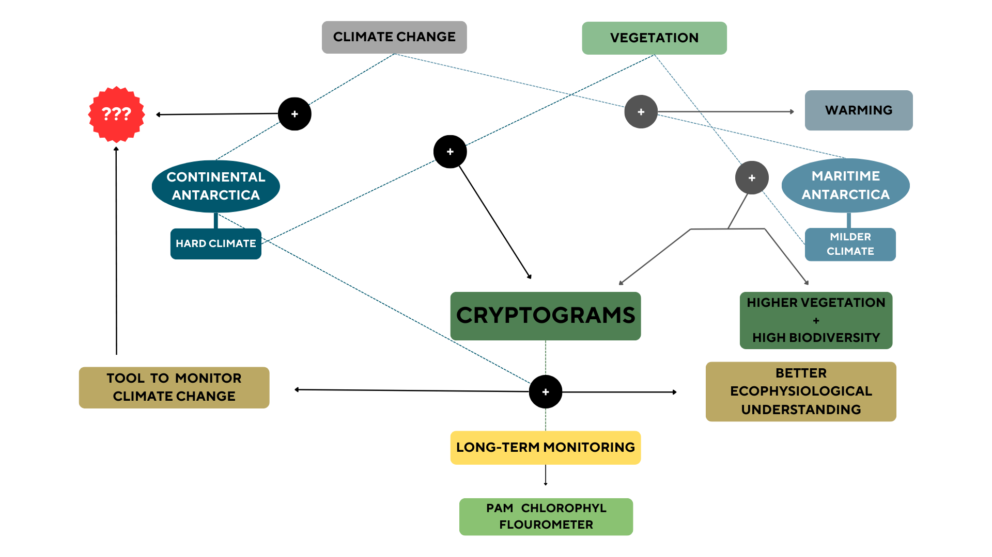

***Fig. 1.*** *A conceptual diagram explaining relevant interactions between climate change and vegetation in Maritime and Continental Antarctica, and how does this study add value. Dashed lines indicate an interaction and solid arrows indicate the result. Magnitude of the interactions is not displayed in the figure.*

# METHODS

## Site description

#### Location

Scott Base is located Pram Point, in Hut Point Peninsula, Ross Island, Southern Victoria Land, Antarctica (Fig. 2) at approximately *-*77.848797° S, 166.767922° E. The measuring probes were located in the base of a hill, slightly north to the base (Fig. 2). We got the climatic data from the Scott Base Climatic Station, which is situated uphill from the Base, on a side slope at 38 m elevation (Seybold et al., 2009).

A

B

C

D

E

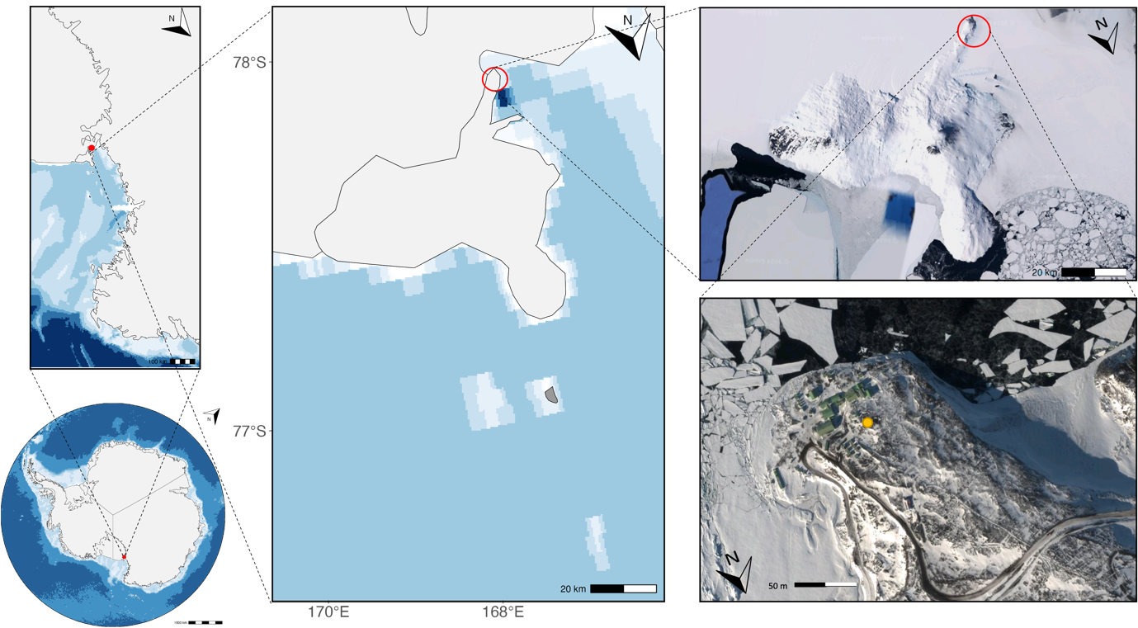

***Fig. 2****. Location Map showing the study site withing Antarctica (A), within South Victoria Land (B), within Ross Island (C & D) and within Hut Point Peninsula (E). Sample place marked with a yellow circle in plot E)(-77.848797° S, 166.767922° E).*

*Figures A, B and C made with ggOceanMaps in RStudio (Posit team, 2024). Figures D and E from (Google Maps, 2024).*

#### Geology, topography and climatic conditions

Pram Point is located in the McMurdo Volcanic Formation (Sheppard et al., 2000). The soil is mainly formed by flows of strongly unsaturated alkaline basal (Kyle, 1981; Sheppard et al., 2000), and consists of loosely compacted stony gravelly sand (Council of Managers of National Antarctic Programs, 2017). The tectonic history of the area remains unclear (Kyle, 1981).

The base is located at 10 m of altitude, at the side of a hill that gently slopes southwards towards the sea (Council of Managers of National Antarctic Programs, 2017), and ice has modified the surface (Sheppard et al., 2000). Permafrost occurs at 30 cm depth (Council of Managers of National Antarctic Programs, 2017).

This topography diverts air from the south, so at the Base the main winds blow from the north-east, whereas at higher altitudes they predominantly come from the south and are stronger (Sheppard et al., 2000). The mean wind speed is 19.1 km h-1 (Council of Managers of National Antarctic Programs, 2017). Water content of the soil over the permafrost is around 6% (Seybold et al., 2009), and average mean soil temperature is one degree higher than the air temperature that hovers around -19.4 °C (Seybold et al., 2009). This is because during the summer the soil gets warmer than the air due to the constant solar radiation 24 h a day (Seybold et al., 2009). Precipitation occurs mainly in winter and autumn, and it is sporadic and light during the summer (Kappen & Schroeter, 1997; Pannewitz et al., 2005a). There is snow all year round (Council of Managers of National Antarctic Programs, 2017).

#### Management

The area hosts New Zealand’s main Antarctic research base, and it has an occupation of 10 people during the winter season and around a 100 during the summer (Sheppard et al., 2000). The United States’ McMurdo Station is also located in Hut Point Peninsula, and it hosts more that 1000 people during the summer (Lohrer et al., 2023). Both stations serve as research bases and posts for expeditions further inland(Sheppard et al., 2000). As a result of the human activity in the area, the environment around the base has been highly modified, resulting in a reduction in moss, lichen, and snow cover (Sheppard et al., 2000). Spills of waste, oils and chemicals have polluted the soils closer to the base (Aislabie et al., 2000; Lohrer et al., 2023; Sheppard et al., 2000).

#### Biodiversity

There are diverse biological communities of organisms in the area, including mosses, lichens, algae and soil invertebrates(Council of Managers of National Antarctic Programs, 2017). Lichen’s biodiversity is higher than mosses’ in a ratio 30:7(Green et al., 2007). They are sparsely distributed in small patches, with higher abundance in moist low-disturbed areas (Council of Managers of National Antarctic Programs, 2017; Seppelt & Green, 1998). Weddell seals (*Leptonychotes weddellii)* and South polar skua (*Catharacta maccormicki*) can be abundantly found in the mid-summer (Council of Managers of National Antarctic Programs, 2017).

## Investigated Species

The species studied are *Bryum argenteum* (Fig. 3 A)) and A*ustroplaca soropelta* (Fig. 3 B)). *Bryum argenteum* was previously referred to as *Bryum subrotundifolium* when refereeing to the variety *muticum*, but this is no longer valid (Gemal et al., 2022; Ochyra et al., 2008). *Austroplaca soropelta* was previously refer to in the literature as *Caloplaca soropelta* (Garrido-Benavent & Pérez-Ortega, 2017).

*Bryum argenteum* is a cosmopolitan moss with a strong presence on the Antarctic (Gemal et al., 2022)– Bryum is the most widespread genus of moss across continental Antarctica (Pannewitz et al., 2005a; Seppelt & Green, 1998), and the species *argenteum* the most widespread species across Victoria Land (Gemal et al., 2022). It grows in disturbed soils in moist or wet sites with soft and rocky ground (Pannewitz et al., 2005a; Schlensog et al., 2004). Its wide distribution has resulted in it being extensively studied, but it has also created a lot of taxonomic confusion (Gemal et al., 2022; Seppelt & Green, 1998). The appearance of *Bryum argemteum* changes between sun and shade adapted organisms. Whereas the sun variety is more yellowish and densely packed, the shade form is darker and less densely packed. Both forms blend into one another, with the shade one being less common (Schroeter et al., 2012). For a full morphological description refer to Seppelt & Green (1998).

*Austroplaca soropelta* is mainly spread in the Southern Hemisphere (Garrido-Benavent & Pérez-Ortega, 2017) – the genus *Austroplaca* is one on the largest genera is Antarctica (Søchting & Castello, 2012) – but it is also found in northern latitudes like Iceland or Greenland(Søchting & Castello, 2012). It grows in strongly convex moss cushions, and it is characterized by initially convex yellow lobes (Søchting & Castello, 2012). For a full morphological description refer to Søchting & Castello (2012).

***Fig. 3****. A) Picture of MoniDa Pam Chlorophyll a Fluorometer individual probe with ﬂuorescence, temperature and light sensors monitoring Sample X3 (Lichen Austroplaca soropelta)*

*B) Picture of MoniDa Pam Chlorophyll a Fluorometer individual probe with ﬂuorescence, temperature and light sensors monitoring Sample X1 (Moss Bryum argenteum). Samples X2 and X4 are the same.*

*C) Picture of MoniDa Pam Chlorophyll a Fluorometer*

## Data collection

A Pulse Amplitude Modulation fluorometer (MoniDa) was installed (Fig. 3 C)) (Raggio et al., 2014, 2016; Schroeter et al., 2011). Each of the 4 probes monitor a sample – 1,2 and 4 correspond to *Bryum argenteum* and probe 3 measures the activity of *Austroplaca soropelta*. Each probe is equipped with temperature and light sensors that measure thallus temperature (TT) and photosynthetic active radiation (PAR), and one fiber optic that monitors the physiological performance of the sample (Raggio et al., 2016). The data are stored in a central unit and transmitted to a central server over Iridium Satellite (T. Green, personal communication).

Measurements are taken every hour, when the sample is illuminated with a low intensity modulated light to record fluorescence (*Ft*) followed by a saturating flash of actinic light. After the flash the resulting maximal fluorescence (*Fm*) is recorded and the effective quantum use efficiency of PSII, or Yield, can be calculated $Φ_{PSII}=(F_{m}-F_{t})/F_{m}$. Relative Electron Transport Rate (ETR) of the PSII is also calculated $(ETR = Yield × Light ×0.5 × 0.84$) and can be used as a proxy for photosynthetic CO2 fixation (Raggio et al., 2016). For a full description of the methodology refer to Raggio et al. (2014), and for an in-depth explanation of the use of florescence to measure photosynthetic activity refer to Baker (2008); Hanelt (2018); Johnson et al., (1993); Kromdijk & Walter, (2023) and Maxwell & Johnson (2000).

Measurements started on January 18th, 2019, and continue to present (March 2024). I used measurements from January 18th, 2019, until 1st of November 2023. Time and date of each of the measurement were also recorded.

Air temperature, and relative humidity (RH) were collected from the Scott Base Climatic Station. Every hour average, minimum and maximum values for each of the variables were recorded. Data is accessible in: <https://cliflo.niwa.co.nz>

## Data Processing

#### Screening of the data

Lower estimates of Fm and Ft can give deceivingly high Yield values because of the proportional nature of the latter (Maxwell & Johnson, 2000). MoniDA has an internal data filter to avoid this from happening, so the machine will not record any yield values ($Φ_{PSII}=0$) (Raggio et al., 2016) if Ft is below 10 measuring units of Fm below 50. However, in some cases, this can give a false sense of inactivity and hide trends when significant differences between Ft and Fm exists and the fluorometer’s shut down. To avoid missing important information, I manually calculated the Yield and ETR of each measurement and compared this value to the machine’s recorded value in each activity period. I filtered measurements that showcased a discrepancy between both values. If they had a significant *Fm-Ft* difference (Fm-Ft > 5) (T. Green, personal communication, 11th December 2023) I used the calculated yield, and if Fm-Ft was not significant I maintained the machine’s measurement of inactivity.

#### Definition of activity and activity periods

We consider as activity every value of Yield $Φ_{PSII}>0$ after the screening (Raggio et al., 2014). This is a measure of photosynthetic performance instead of metabolic activity (Raggio et al., 2016), but there were no events in which we found metabolic activity ($∆F_{m}>0$) and no yield.

I plotted the data for the whole measuring period to assess the behavior under snow and microclimatic conditions of all samples throughout the whole year. However, I limited statistical comparisons and in-depth graphical observations to the “active periods”. After observing the activation patterns for the whole measuring period and comparing it to measuring times in previous literature, I considered *active periods* in the context of this paper, as time between the 1st of November and last day of February each year (Colesie et al., 2016; Gemal et al., 2022; Pannewitz, Schlensog, et al., 2003; Schlensog et al., 2004, 2013). This definition covers the entirety of the Antarctic summer and includes the snowmelt at the beginning of the season and the snowfall at the end, allowing observations of activity under snow for both species.

I used R Studio (Posit team, 2024) and the Tidyverse package (Wickham et al., 2019) to wrangle and format all the data.

## Data analysis

There were three replicas of *Bryum argemteun* and one replica or *Austroplaca soropelta*. Since I did not have a statistically relevant number of samples, I could not conduct any parametrical statistics. Therefore, most of this study was observational and used descriptive statistics. I used non-parametrical statistics after observing a decline in active time over the years, to test the significance of it and the correlation to possible drivers.

#### Observational Study: climatic conditions in Scott Base, characterization of activity and activation patterns and behaviour under snow.

Yield, TT, Air temperature, RH and PAR were plotted against time for the whole measuring period (FIG.1), and each summer (Fig. 3 as an example). And used to assess patterns over time and responses to changes in microclimatic conditions.

Between the 15th and 19th of March 2023 a heat wave spread over East Antarctica with temperature anomalies of 30 to 40 °C (Wille et al., 2024). At the peak of the heatwave, an area of 3.3 million km2 including Victoria Land,exceeded monthly temperatures expected during March (Wille et al., 2024). I plotted a closeup during this period to observe for any anomalies on microclimatic or photosynthetic performance in either of the species.

Snowmelt and snowfall events were identified in the graphs as moments when TT was ~0 °C and there was a no PAR available (Pannewitz, Green, et al., 2003; Pannewitz, Schlensog, et al., 2003; Raggio et al., 2016). I generated closeup activity and microclimate graphs for each of them to assess and compare the behaviour of both species under the snow.

I also calculated descriptive statistics for TT, yield, ETR, PAR, and in the case of the meteorological data air temperature and RH. Mean, maximum and minimum values were extracted for each sample and species across the whole period, as well as each month and summer.

#### Statistical analysis: decline of active time over the years and possible correlations.

I tested whether there was a significant difference in the number of active hours per year using a Kruskal Wallis test. This test allows to measure the difference between groups even if they do not meet the assumptions of normality and independency(McKight & Najab, 2010; Vargha & Delaney, 1998).

I then assessed whether there was a correlation between i) the number of active hours and TT of the samples during active time, ii) yield and TT of the samples during active time, and iii) number of active hours and the number of reactivation events according to two metrics:

1. *High* metric: A sample had a reactivation event when there was at least one measurement (one hour) in which $Φ_{PSII}=0$ followed by at least one measurement (1 hour) in which $Φ_{PSII}>0$.
2. *Low* metric: A sample had a reactivation event when there was at least one day (24 measurements) in which $Φ_{PSII}=0$ followed by at least one day (24 measurements) in which $Φ_{PSII}>0$

I used the Spearman’s correlation test to measure these and backed it up with a Kendal Tau test to increase reliability. These two tests are the most widely accepted measures of rank correlation and are appropriate when extreme values are present (Mukaka, 2012; Puka Llukan, 2011). I only considered as significant those results in which both tests gave similar values for the correlation coefficient and its significance. Since all the samples showed similar changes in TT and activation patterns, I analysed measurements for all samples together independently of the species. This increased sample size, increasing the reliability of the tests.

I used R Studio (Posit team, 2024) and the Tidyverse package (Wickham et al., 2019) to create and the graphs and statistical analysis.

All the graphs and code are available on GitHub: <https://github.com/Ainhoa-Jimenez/dissertation.git>

# RESULTS

## MICROCLIMATIC CONDITIONS IN SCOTT BASE

The climate is Scott Base is governed by a marked **cyclical pattern** constant over the years (Fig. 4).

Cryptograms in Scott Base start receiving sunlight between the end of November and the beginning of December, when snow starts to melt (Fig. 4). Light is available until late February or early March in the following year (Fig. 4). During those three months, PAR follows a daily pattern in which at some points during the summer there is photosynthetic light available all the time throughout the day, but its intensity decreases around noon (Fig. 2). The amount of PAR received varied across samples, but in average all the samples received a mean radiation of ~200 μmol m-2 s-1, as summarised in Table 1, with maximum values of around 1500 μmol m-2 s-1 (Table 1).

A

B

C

D

E

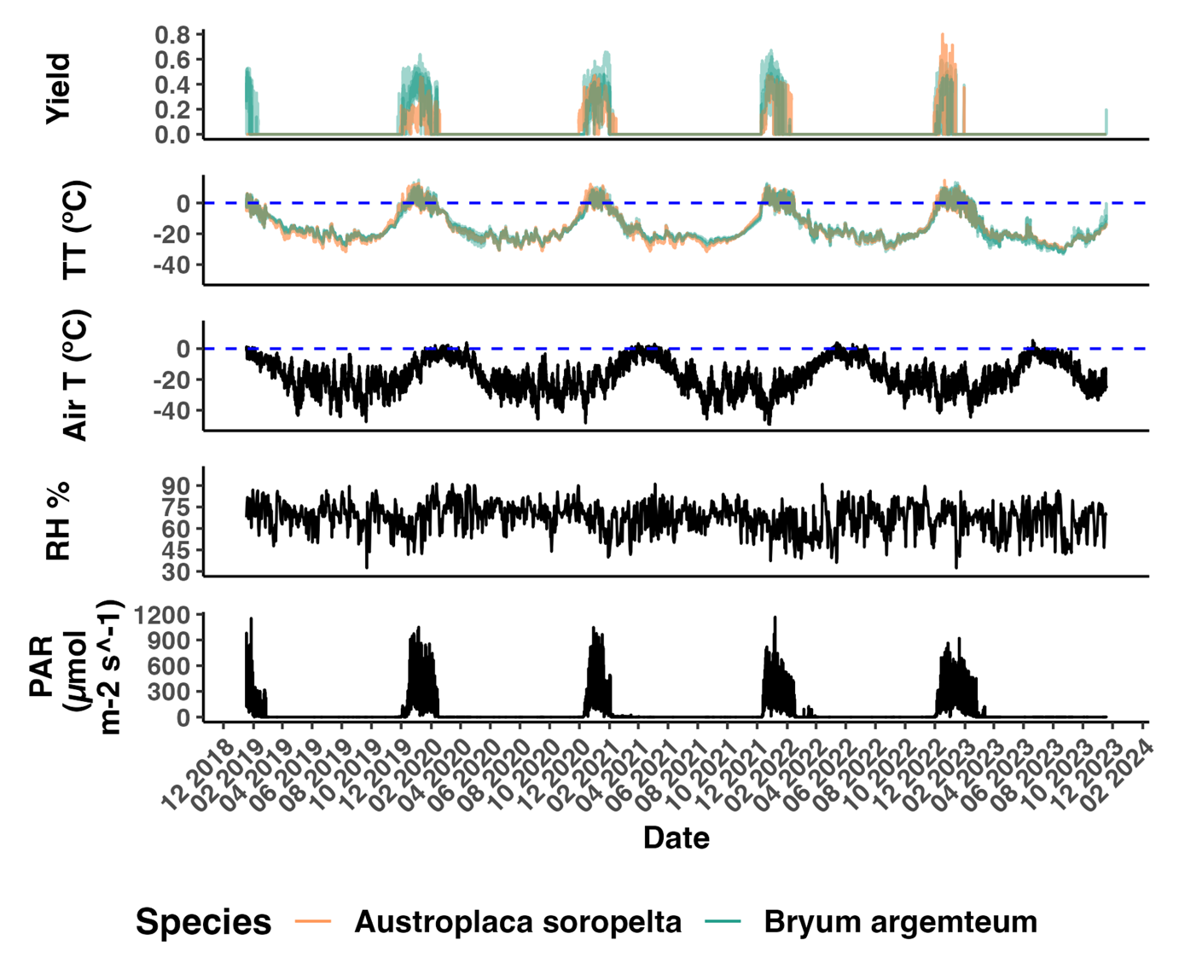

***Fig. 4.*** *A) Photosynthetic activity (Yield), B) Thallus temperature, C) Air temperature, D) relative humidity, and E) Photosynthetic active radiation for moss Bryum argenteum (green) and lichen Austroplaca soropelta (orange) in Scott Base, Continental Antarctica. Environmental variables are in black. Measurements of three samples of Bryum argenteum and one of Austroplaca soropelta.*

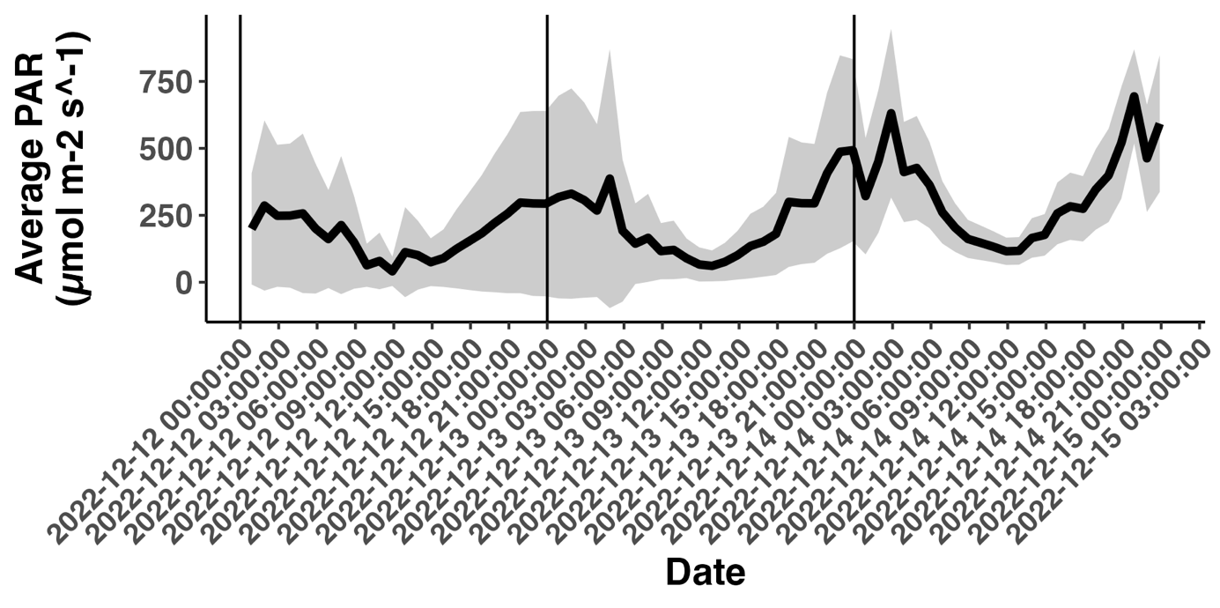

*Fig. 2*. Average Photosynthetic Active Radiation (PAR) received by *moss Bryum argenteum and lichen Austroplaca soropelta in Scott Base, Continental Antarctica. Standard deviation between samples represented with shadow.*

The average air temperature over the whole measuring period was -17.4 °C (Table 1) and values over 0 °C where only recorded in the summer months – defining as summer the period from the beginning of November until the end of February (Fig. 4). This generated a contrast of almost 11 degrees between the overall mean and the summer mean that was -6.73 °C in average across all years (Table 1). The minimum air temperature recorded was reached in August 2021, and was -53.4 °C, and the maximum, documented in December of 2022, 6.45 °C (Table 1). The minimum temperature during a summer season was – 28.9 °C and it was recorded in November 2022 (Table 2). December was the warmest month every year (Fig. 4, Appendix E)

*Table 1.*

RH had an average value of 67.5% over the whole measuring period (Table 1), nearly identical to the 67.2% average over the summer months (Table 2). It did not show any seasonal variation (Figure 1).

All of these variables remained constant over time, and there was no clear increasing or decreasing trend over time in any of them (Figure 1, Table 2).

Only PAR seemed to increase from 0 up to 200 μmol m-2 s-1  during the heatwave from the 15th to the 19th of March 2023 (Figure 1 and closeup in Appendix D).



*Table 1.*



*Table 2.*

## CHARACTERIZATION OF AUSTROPLACA AND BRYUM ACTIVIVTY AND ACTIVATION PATTERNS AND CHANGE OF THOSE OVER TIME

#### Active time

Both species showed **nearly identical annual activity cycles** highly coupled with available radiation. All the **activity was concentrated in the summer** months (Figure 1). The activity for both species is **continuous throughout the summer** except for occasional short inactivity events with an average length of 48 hours (Figure 3, see Appendix C). These were followed by uninterrupted dormancy until the following summer. There was a significant difference in the number of active hours each year for both species (Kruskal-Wallis, X2 = 13.336, df = 3, p = 0.003) and both species showed a decline over time (Fig. X, Table 2).

Both the lichen and the moss stayed inactive during the heatwave of March 2023 (Figure 1).

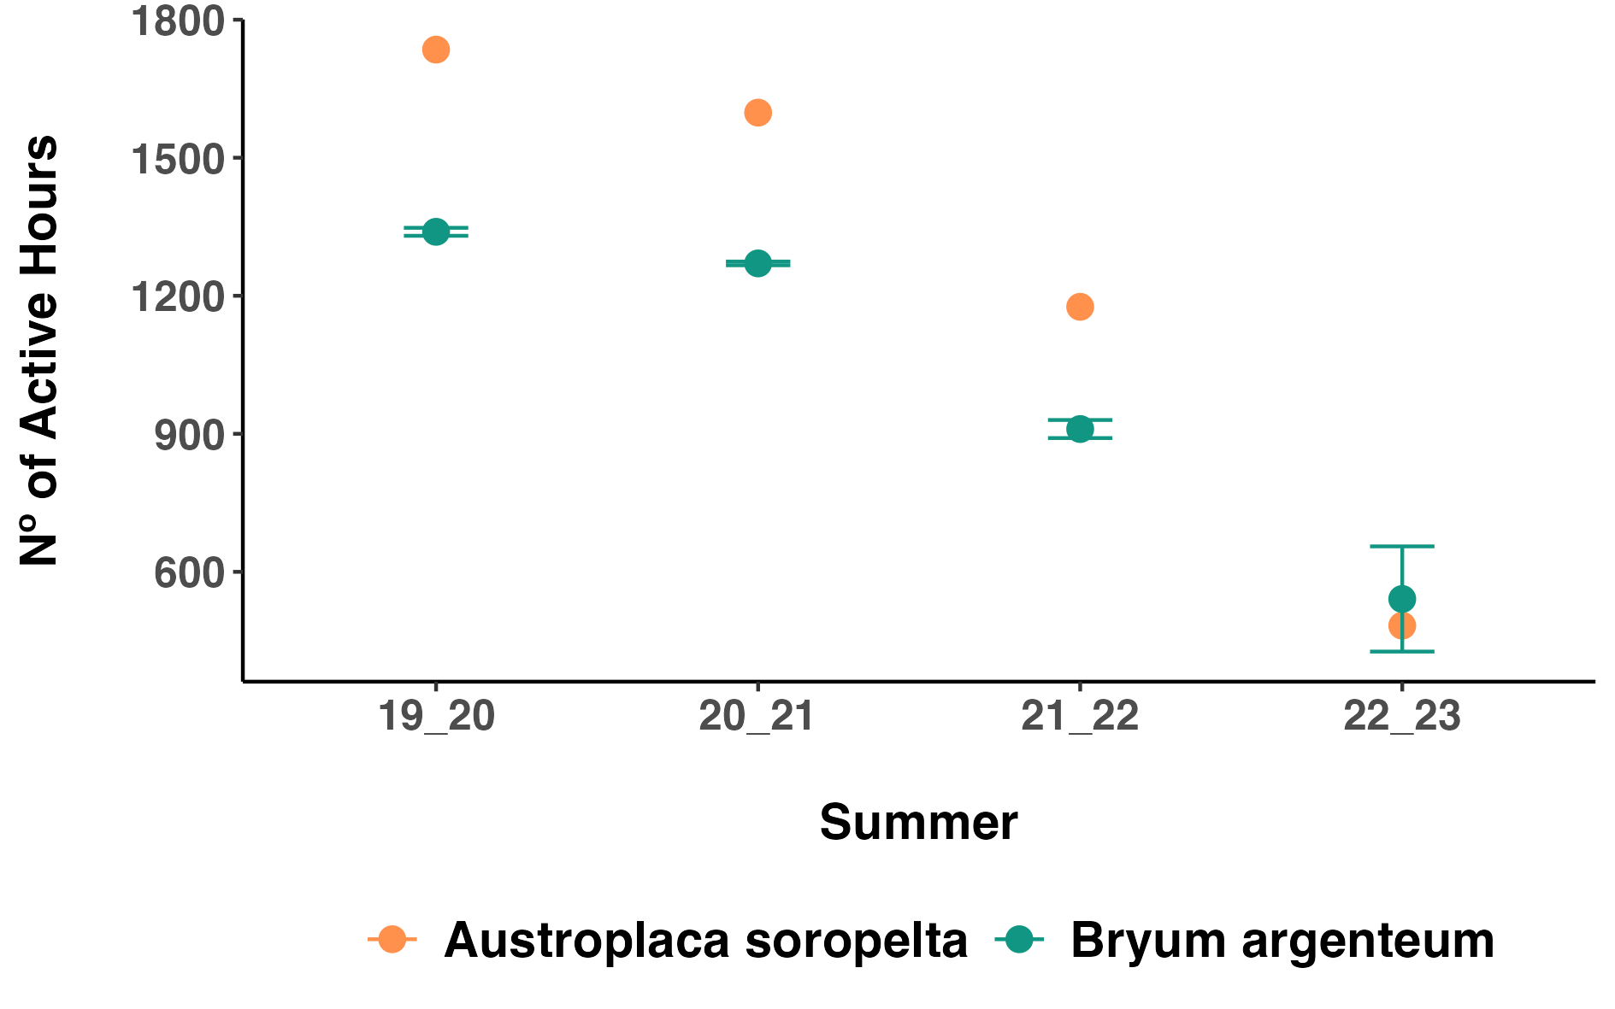

*Figure X.*

##### *Austroplaca soropelta*

*Austroplaca* was active 11.77% of the measuring period (Table 1). A total of 4991 hours of activity were distributed in a **decreasing trend** between the four measured summers, as seen in Table 2. There is a steep decline from the summer 21-22, when there were 1176 active hours, to the summer 22-23, when there were only 483 (Table 2). Activity during the last summer was more sporadic with longer interruptions than in previous years (Check Appendix C).

Every summer, *Austroplaca* had the less active time during the month of November, with 31, 24, 0 and 8 hours each respective year (Check Appendix B for monthly values). This is because activation did not occur until late in the month (Table 3, Appendix C). In 2019 *Austroplaca* activated on the 29th of November, in 2020 on the 30th of the same month, in 2021 on the 8th of December (meaning there was no active time during the month of November), and in 2023 again on the 29th of November.

Then activity increases dramatically during the months of December and January, December being the month with the most active hours every year (741, 715, 533, 301 active hours respectively).

Lastly, active time decreased in February with 240, 147, 125 and 0 hours each year. The decrease on the number of hours of activity over February through the years indicates that the **lichen dries earlier in the month every year** as summarised in Table 3**.** In 2023 it dried the 11th of January, so there was no activity in February.

##### *Bryum argenteum*

*Bryum* was active 10.33% of the measured time (Table 1). The total 4380 hours, as with *Austroplaca*, were unevenly distributed over the summers showcasing a **decreasing trend over time** (Table 2). The decline was especially abrupt from summer 2021-2022 to summer 2022-2023 when the active hours reduced, in average, from 910 to 541, as shown in Table 2. This last summer activity was more sporadic, with longer periods of interruption (Appendix C).

Every year, November was the month of the summer when Bryum was the less active. Two of the samples did not have any active time during this month any of the years, and Sample X2 only had 15 hours of activity in 2019 –it was active from the 24th to the 26th of November before drying until 2nd of December– and 21 in 2023 –activated the 30th of November. The dates of activation each year of the rest of samples are summarised in Table 3.

Bryum had the most active time during December and January. During the summers of 2019-2020 and 2021-2022 it had more active hours during the December whereas

In 2020-2021 and 2022-2023 it had more active hours during the month of January. This variation was constant across the three samples (check Appendix B).

Lastly, as with the lichen, active time in February decreased over the years. Specifically, there was a dramatic reduction in the number of active hours between the first two summers – of 84.67 and 47.33 hours of activity on average respectively – and the second two, in which the moss was active 4.33 and 0 hours respectively. This indicates that **the samples dried, on average, earlier in the month each year**, as evidenced in Table 3.



*Table 3.*

#### Yield and ETR

*Austroplaca*’s average yield when active was 0.25, which was lower than *Bryum*’s, that had an average of 0.35 as showed in the summarized data of Table 1. On the contrary, *Austroplaca* reached higher maximum yield, that got up to 0.8 in December 2023. The maximum yield for *Bryum* was, in average, 0.61 (Table 1).

*Austroplaca*’s mean and maximum yield when active increased over the years, as shown in Table 2 and Figure 1. This trend was not present in Bryum.

When was max yield reached?

ETR followed a similar pattern. Whereas *Austroplaca* showcased a higher maximum ETR, *Bryum* has a higher mean ETR during active time (Table 1). None of the species showed a trend of change over time in ETR values (Table 2).

#### Thallus Temperature

Thallus temperature (TT) followed a nearly **identical cycle** in both species (Fig. 4). Both species had similar mean, maximum and minimum TT values over the measuring and active time (Table 1). The mean TT over the active time is around 0°C in both cryptograms, and the minimum TT is around -32 °C for both species, 20 degrees over the minimum air temperature (Table 1).

Values remained below 0 °C for most of the year, only reaching above freeze values during the summer (Fig. 4). TT did not show a changing trend over time of any of the species (Table 2).

## CORRELATION BETWEEN ACTIVITY AND MICROENVIRONMENTAL VARIABLES- DRIVERS OF ACTIVITY

The three main microenvironmental variables affecting the cryptograms are incidental PAR, TT, and RH. There is a clear relationship between Yield, PAR and TT (Fig. 4). From the graphs under snow, TT seemed to be more closely related to activity than PAR, since activity started once TT was closer to 0 °C, even if PAR was still not available (Fig. 3). This relationship was more obvious in *Bryum*.

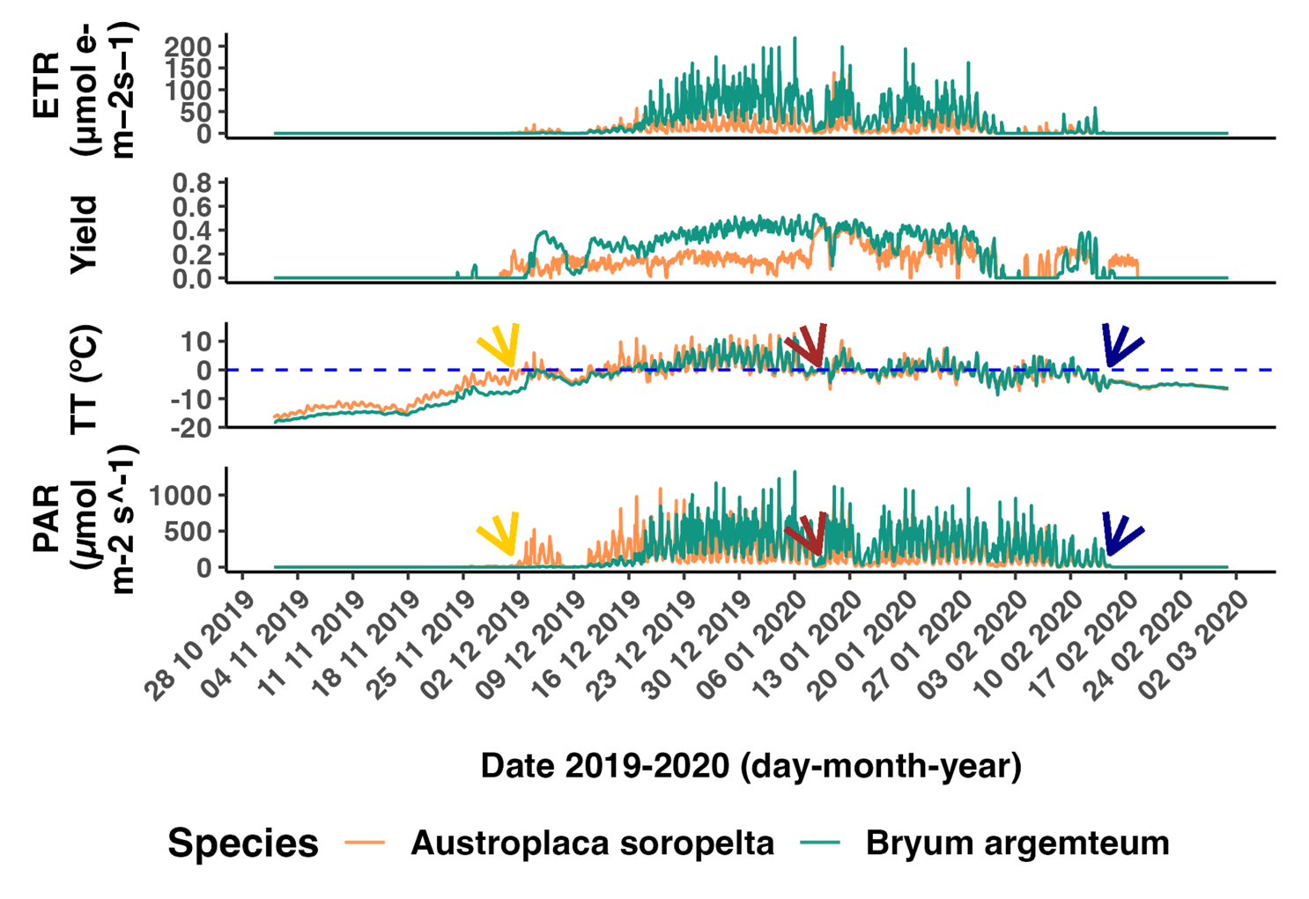

*Fig. 3*.

From plotting the relationship between yield and RH and yield- TT showed a higher connection in the latter (Fig. 4). However, there was no correlation between Yield and TT of samples during active time (Spearman’s Rank Correlation analysis, ρ = 0.37, n = 16, p = 0.15), (Kendall Tau Test, t = 0.37, n =16, p = 0.15). No correlation was found either between TT during active time and number of active hours, neither with Spearman’s Rank Correlation analysis ( ρ = -0.18, n = 16, p = 0.48) nor Kendall Tau Test (t = -0.12, n =16, p = 0.53).

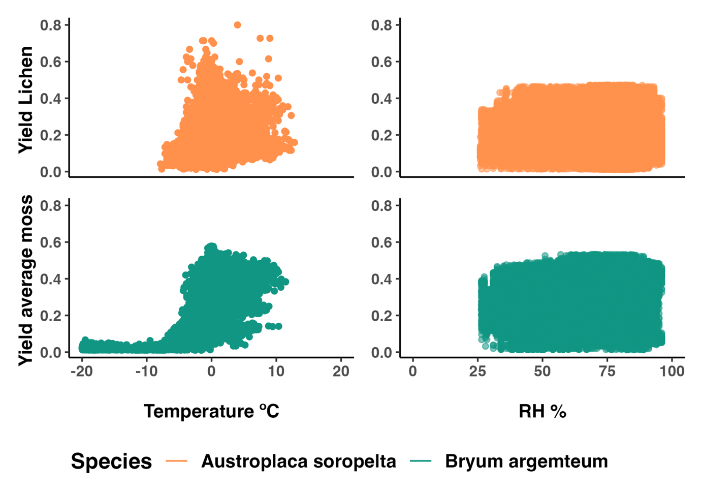

*Figure 4.*

The number of reactivation events for each species every summer are summarized in Table 3. *Austroplaca* had more reactivation events, which are not always related to snowfall. We found no correlation between the number of reactivation events and the number of active hours nor in the high metric (Spearman’s rank correlation, ρ = -0.07, n = 16, p = 0.78) (Kendall Tau Test, t = -0.05,n =16, p = 0.78) nor in the low one (Spearman’s rank correlation, ρ = -0.00, n=16, p = 0.99) (Kendall Tau Test, t = -0.02, n=16, p = 0.88)

## BEHAVIOUR UNDER SNOW

We classified three different types of under-snow activity events: the snowmelt at the beginning of the season (Fig. 5), snowfalls in the middle of the season (Fig. 6), and the last snowfall of the season (Fig. 7). In all three types of events, and in both species, TT had to reach values near 0 °C for activation to occur (Fig. 3, 5 & 6). ETR for all under-snow activity was 0 in both species (Fig. 3)

In the snowmelt at the beginning of the season, the lichen had, on average across the years, 5.5 days of activity under snow. *Bryum* had an average of 8.5. The lichen also had less days in which TT reached freeze point but there was still snow cover (Fig. 5). Both species could activate without PAR if the TT was close to melting point (Fig. 5). The relationship between TT and activation was more evident in the moss (Fig. 5). Yield was lower under snow that it was over snow for the lichen (Fig. 3, Appendix C). This difference was less notable for the moss.

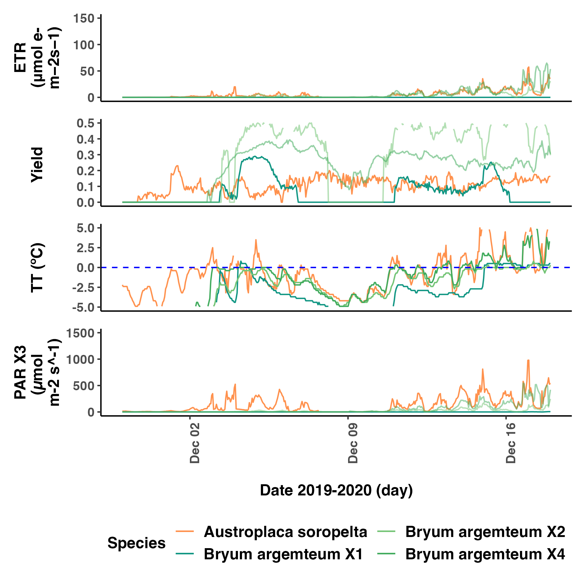

*Fig. 5*

Snowfall events in the middle of the season lasted between 24 and 48 hours and generated a very similar response in the lichen and the moss. Yield did not variate significantly in any of the two species during a snowfall event unless the sample was dry before, in which case, it reactivated. Both species were exposed to the same snowfall events.

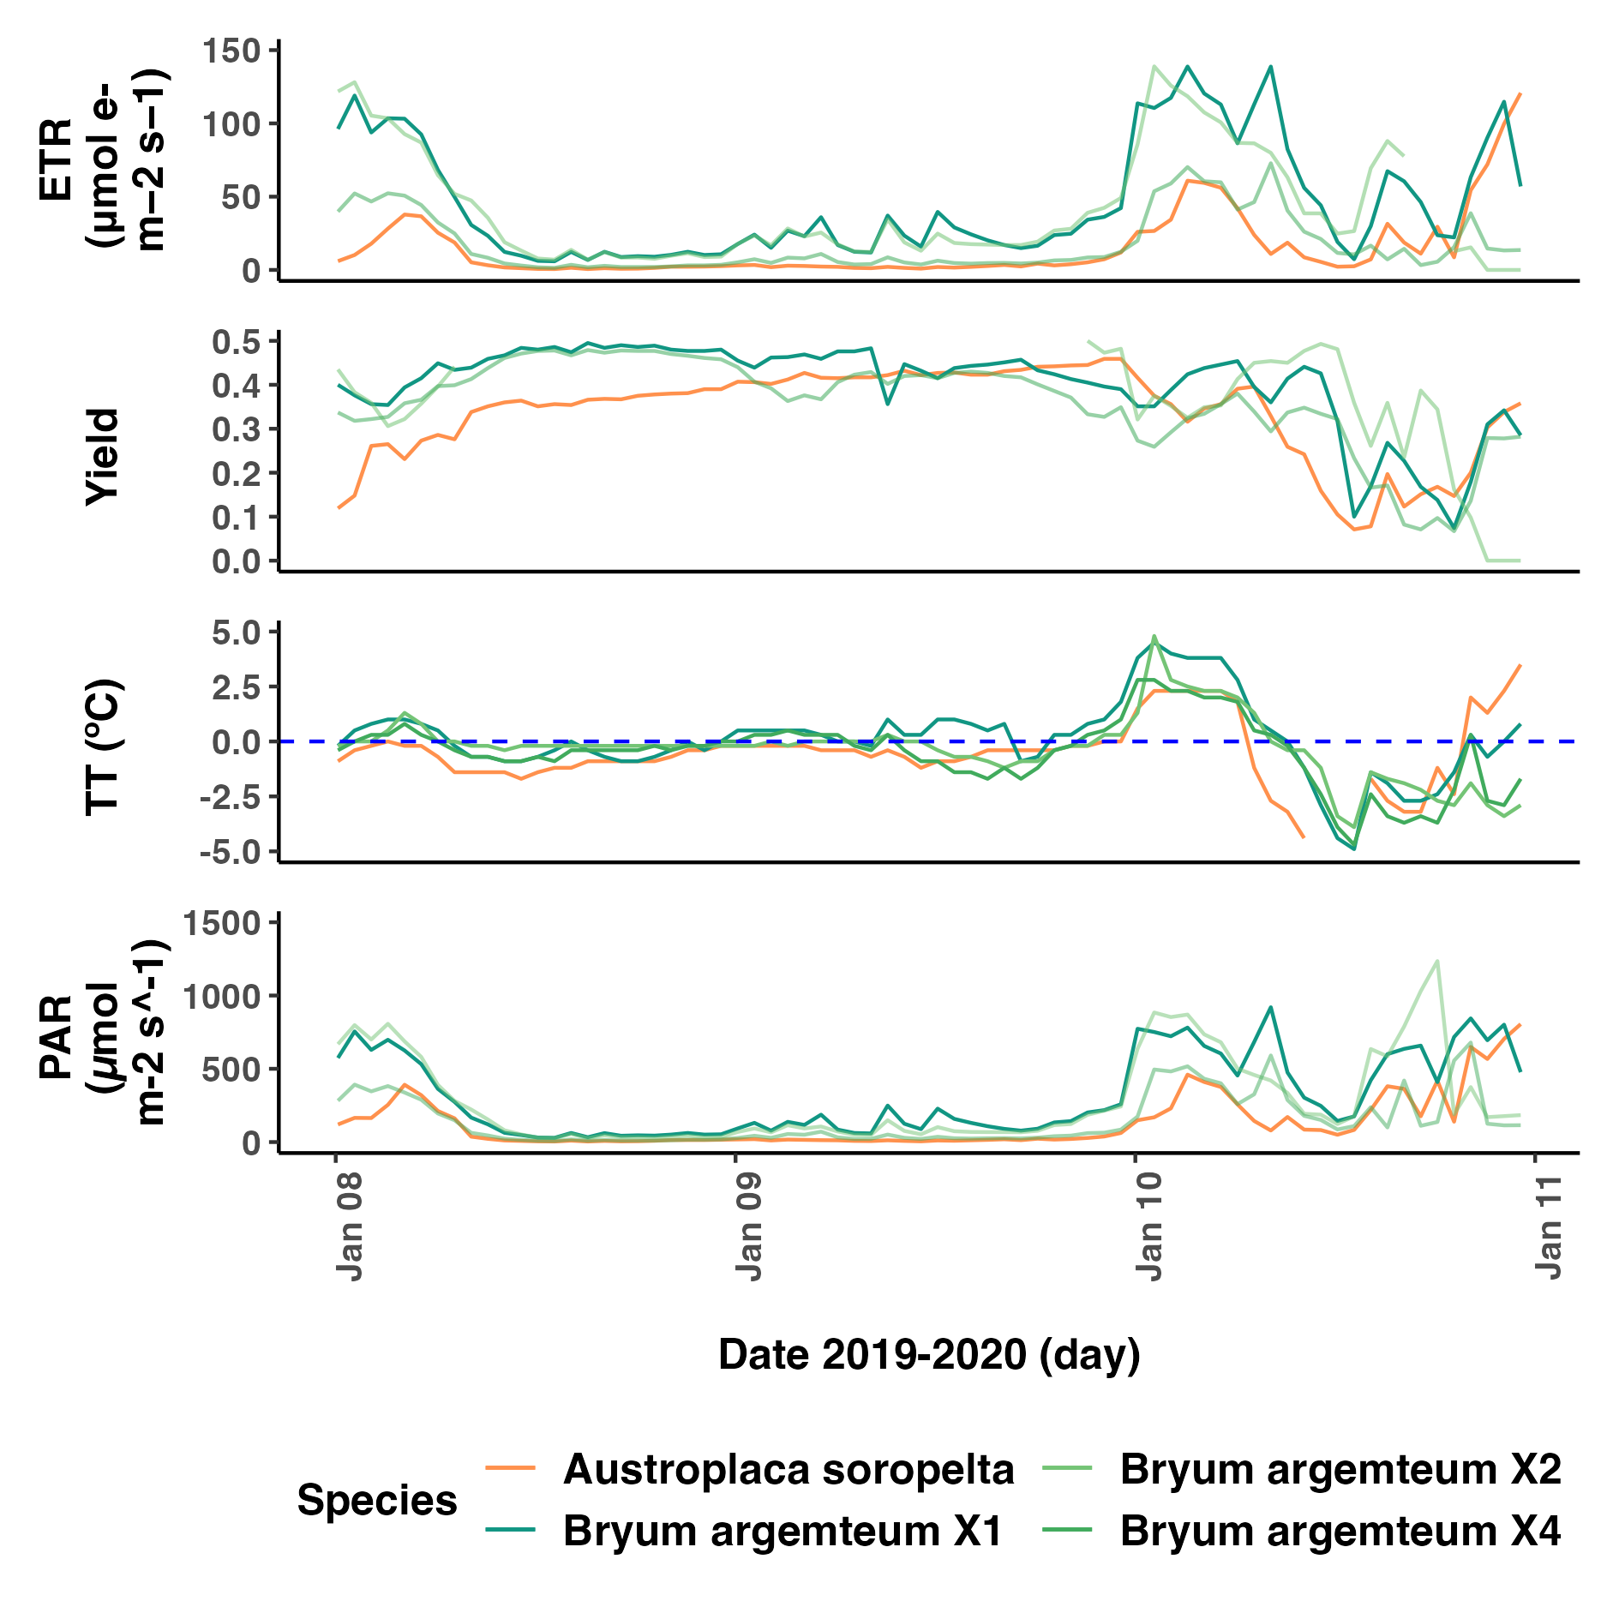

*Fig. 6*

Lastly, *Bryum* did not have any activity under snow at the end of the season. *Austroplaca* was active under snowcover for 5 and 7 days in 2020 and 2021 respectively. It did not show any activity under snow in the last two summers.

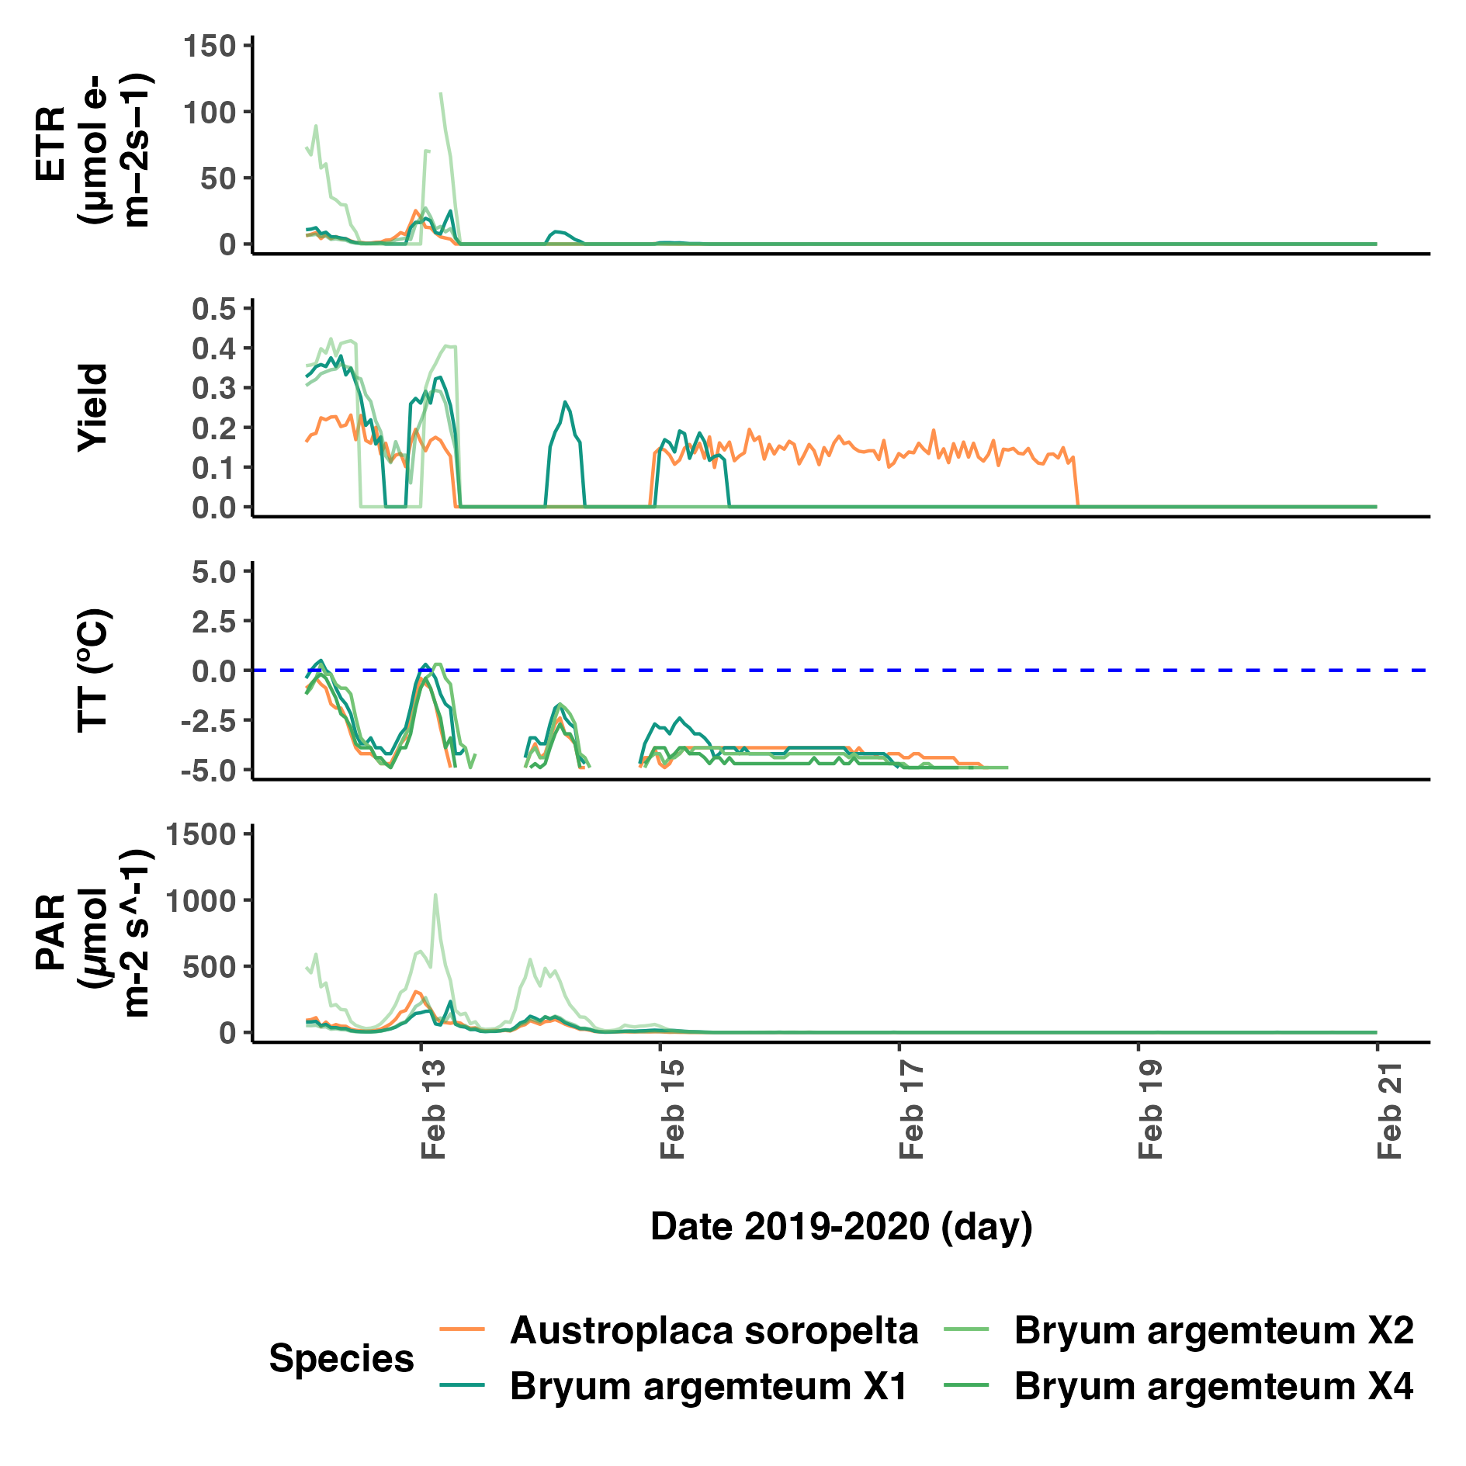

*Fig. 7*

# DISCUSSION

The aim of this study was to use the longest continuous record of photosynthetic activity in Continental Antarctica to: i) describe the microclimatic conditions which *Austroplaca soropelta* and *Bryum argenteum* are exposed to in Scott Base; ii) characterise their activity and activation patterns, and analyse how they change over time; iii) assess the activity of both species under snow cover.

I found that cryptograms in Scott Base spend most of the year under snow cover, which translates in no available radiation and TT tens of degrees below 0 °C (Fig.1). However, as PAR becomes available in the summer months, and temperature reaches values around freeze point both *Austroplaca soropelta* and *Bryum argenteum* activate and maintain continuous activity for most of the summer (Fig.1). This pattern was remarkably similar for both species and repeated cyclically over the years which suggests that the **environmental conditions driving activity had a higher influence than the species physiology**

(Fig. 4). Moreover, both species showed a significant decline in active time each summer over the years (Fig. X). Lastly, I found that both Bryum arg. and Austroplaca srp. could maintain activity under snow cover. However, their behaviour and patterns changed depending on whether the snow was at the beginning, middle or end of the season (Fig. 3,5,6 & 7).

## Climatic conditions in Scott Base and comparison with the rest of Antarctica

The microclimatic environment in Scott Base resembles the one already described in different regions of Continental Antarctica(Longton, 1974). It is a cold dessert and a large change in PAR radiation is the main driver of microclimatic change is Scott Base (Schroeter et al., 2010, 2011).

Scott Base is located inside the Antarctic Circle, which means that there is continuous sunlight from the 27th of October to the 17th of February, and during the winter there is constant darkness (Schroeter et al., 2010, 2011). Even if the sun was in the sky, snow covering the probes made it unavailable for the plants until the summer months. The PAR levels recorded during the summer showed a diel pattern with a deep depression around noon (Fig. 2). As observed in Pannewitz et al., (2005), this is probably explained by the position of the Sun in the sky, that creates a shadow over the samples at that time, thereby driving changes in activity, temperature, and water content.

PAR levels recorded in Scott Base are slightly lower than the expected for Continental Antarctica (Schroeter et al., 2010). Although during the summer we saw the sharp increase characteristic of the area (Fig. 4), the values reached were far lower than the ones recorded in Botany Bay by Schroeter et al., (2010)(2011), who got over 2500 μmol m-2 s-1. Pannewitz et al., (2005) values in Granite Harbour were also higher than the received by most of our samples. In contrast, or PAR levels resemble those recorded by Pannewitz et al., (2003) in Canada Glacier, and Colesie et al., (2016) in Garwood Valley, with the majority of readings between 500 and 1500 μmol m-2 s-1. This lower PAR might be explained by the low albedo of the brown granulated soil (Figure B). (Pannewitz et al., 2005a; Pannewitz, Green, et al., 2003). This reduces the stress on the plants, potentially allowing for more continuous activity but limits their ETR (Pannewitz, Green, et al., 2003).

Air temperature is colder than in Botany Bay, that got a maximum of 10 °C (Schroeter et al., 2010, 2011), but is similar to the rest of the Dry Valleys (Pannewitz, Green, et al., 2003). This likely explains the richer biological community in Botany Bay(Schroeter et al., 2010). Temperature suffered diel fluctuations, as expected from previous observations in the area(Longton, 1974). However, this were less extreme near the ground, where cryptogram enjoyed more stable conditions (Longton, 1974). Differences between air T and TT were more pronounced in summer months, likely due to high insolation.

Conversely, RH in Scott Base was very similar to Botany Bay(Schroeter et al., 2011), that had an average of 63%, and was lower than in the Dry Valleys (< 50%) (Fritsen et al., 1999; Pannewitz, Green, et al., 2003). It showed a diel pattern previously described by Longton (1974).

## Cyclical identical continuous activity in both species

### Cyclical and Identical activity

Both species showed a very cyclical pattern, with similar activity periods every year, except for the trend of earlier drying observed every summer (Fig.1). This contradicts earlier studies which have documented significant variability over the years, the cause of which remains unidentified. Activity was highly coupled with increasing PAR, that led to higher TT and liquid water (Fig. 4)(Schroeter et al., 2010). This same driver restricted activity to the summer season in Botany Bay(Raggio et al., 2016; Schroeter et al., 2010)

The akin activity patterns between both species, despite their differences in structure and physiology(T. G. A. Green, Sancho, & Pintado, 2011) suggests that environmental stressors exert a bigger pressure. This was already observed by Raggio et al., (2014) in Tabernas, Spain.

For the cryptograms to activate they had to be sheltered from high winds (Pannewitz, Green, et al., 2003) and TT was warmer than air T with most of the activity occurring around freezing point (Schroeter et al., 2011). When the samples where active their range of TT was smaller, with lower maximums and higher minimums. This indicates that cryptograms activate when conditions are more moderate, which is consistent with previous literature (Raggio et al., 2016; Schlensog et al., 2013; Schroeter et al., 2010). Despite the wide range of climatic conditions TT are consistent across cryptograms in different regions of Antarctica (Raggio et al., 2016).

#### Activity Drivers

Activity patterns are identical for the moss and the lichen, indicating that they are driven by microclimatic conditions over any physiological strategies (Pannewitz et al., 2005b; Pannewitz, Green, et al., 2003; Pannewitz, Schlensog, et al., 2003; Raggio et al., 2014). Temperature and water are the most influential limitations, and both are highly coupled with changes in PAR (Fig. 4)(Sancho et al., 2007; Schroeter et al., 2011).

TT seems highly coupled with activity levels (Fig. 3, 4). However, we found no correlation between TT and Yield. Previous studies had already claimed that yield is TT independent, which further supports our results (Colesie et al., 2016; Pannewitz et al., 2005a). Nevertheless, this same literature suggest that TT is predominantly influenced by thallus water content (WC)(Pannewitz et al., 2005a). Wet thallus are more likely to maintain stable temperatures around 0 °C due to the buffering effect of water (Pannewitz et al., 2005a). Concurrently, WC is a primary driver of activity (Pannewitz et al., 2005a; Raggio et al., 2014). This simultaneous influence of WC in both activity and TT could explain the apparent association between yield and TT even if they are not statistically correlated.

Even if TT and Yield are not correlated, it needs to reach a certain threshold for photosynthesis to occur (Pannewitz et al., 2005a). Ino (1990) detected photosynthetic activity up to -10 °C, Raggio et al. (2016) of -29.4 °C, and Lange (1965) of -24 °C. On the contrary, Pannewitz, et al.(2003) did not find any photosynthesis below -2 °C ,and Kappen & Schroeter (2002) below water freezing point. With a lowest active TT of -8.2 °C, my results do not fully agree with neither of them. On the contrary they are supported by Schroeter et al. (2011). They indicate that the cryptograms tolerate temperatures low enough to maintain photosynthesis through daily freezing, but do not get to temperatures below -10 °C when hydrated, probably due to the buffering effect of water (Pannewitz et al., 2005a; Pannewitz, Green, et al., 2003).

RH is not correlated to Yield (Fig. 4). Moreover, it does not show significant change over the year (Fig. 4), so it is an unlikely driver of activity. However, this RH data was collected at the meteorological station of Scott Base and does not reflect the microclimatic changes that RH probably suffers under snow (T. Green, personal communication, 11th December 2023). For an accurate description of the role of RH in the BSCs activity microclimatic measurements need to be analysed.

### Continuous activity

Activity was very continuous over the summer months, with higher number of monthly activity hours than in Maritime Antarctica (Schroeter et al., 2010). While many studies in the South Victoria Land found similar results (Pannewitz et al., 2005a, 2006; Pannewitz, Green, et al., 2003; Smith, 1999), others show the opposite: sporadic and short activity events (Colesie et al., 2016; Raggio et al., 2016; Schroeter et al., 2010).

To try make sense of these results, we first need to consider that lichens and mosses use different strategies to cope with dryness and stress (Schroeter et al., 2010). Whereas mosses maintain activity over longer periods of time by storing water in the turf (Lange, 2003; Longton, 1973; Pannewitz, Green, et al., 2003), lichens have a higher tendency of deactivation under stressors, like light, and quicker reactivation (Colesie et al., 2016; T. G. A. Green, Sancho, & Pintado, 2011; Lange, 2003). Moreover, lichens can access moisture from a wider variety of sources (Colesie et al., 2016; Raggio et al., 2014), including dew, frost and fog; whereas mosses mainly reactivate with liquid water (T. G. A. Green, Sancho, & Pintado, 2011; Rundel & Lange, 1980). *Austroplaca* showcased a higher number of reactivation events, which could be linked to the different adaptation strategies (Table 3). However, the difference found between both species is lower than what we could initially expect from the literature (Lange, 2003; Pannewitz, Green, et al., 2003). One possible explanation for the lichen’s continuous activity is that is might be growing in moss or soil, rather than rock. This is a preferred niche habitat for lichens in Continental Antarctica, since it allows for higher water accumulation and thallus thickness (Colesie et al., 2012; T. G. A. Green et al., 2018). Moreover*, Austroplaca soropelta* tends towards more continuous activity, probably because it is especially good at accessing alternative moisture sources (Raggio et al., 2016).

I have classified as reactivation events driven by dew, fog or frost those that consisted in a brief peak of activity after sunrise(Colesie et al., 2016), but without on site observations it is unviable to differentiate between them. In any case, reactivation due sources other than liquid water will provide low thallus WC. As a result, the activation period is usually shorter than 24 hours and yield is low (Colesie et al., 2016; T. G. A. Green, Sancho, & Pintado, 2011; Raggio et al., 2014), so their contribution to long-term continuous activity is not substantial.

Within this framework, an alternative source of meltwater occurring during the whole summer seems to be the main driver of continuous activity. Studies that had sporadic activity during the summer relied in snowmelt as their main source of liquid water. Rewetting events after the first snowmelt are rare since precipitation is scarce on the summer and activity is constrained (Colesie et al., 2016; Schlensog et al., 2003; Smith, 1999). On the contrary, study sites that had an alternative meltwater stream, like a melting glacier nearby, sustained activity longer through the season (Pannewitz et al., 2005a; Pannewitz, Green, et al., 2003). Scott Base has a glacier uphill which meltwater reaches Scott Base (Campbell et al., 2018; Fountain et al., 2017; Sheppard et al., 1997), so it could explain the continuous activity.

#### Implications of continuous activity

Continuous active time is important for productivity and growth, especially considering that cryptogram remain dormant for most of the year, and that, due to their high pigmentation, a small proportion of light reaching the organisms has photosynthetic worth (Dietz, 2000; Raggio et al., 2016; Sancho et al., 2007).

However, the metabolic cost of the stress of being active also needs to be factored in (Schroeter et al., 2010, 2011). For carbon fixation to occur, the plant needs to be active when PAR levels are higher than the light compensation point (Raggio et al., 2016). Low temperatures during active time can also be a stressor (Schroeter et al., 2010). This can result in damages by high radiances (Pannewitz et al., 2005a; Robinson et al., 2003). However, both *Bryum* and *Austroplaca* seem to have adapted to cope with those stressors(Pannewitz et al., 2005a; Pannewitz, Green, et al., 2003; Raggio et al., 2017). Previous literature showed no photoinhibition in Bryum, probably due to high non-photosynthetical quenching systems (T. G. A. Green et al., 2005; Heber et al., 2000; Johnson et al., 1993; Kromdijk & Walter, 2023), which tend to increase with yield (T. Green et al., 2000); and pigmentation (Clarke & Robinson, 2008). Austroplaca has light filters that exclude most of the light, reducing the light sensitivity characteristic of the lichens (Gauslaa & Solhaug, 2001; T. G. A. Green, Sancho, & Pintado, 2011; T. G. A. Green, Sancho, Pintado, et al., 2011; Schroeter et al., 2011).

## Decrease in active time.

To my best knowledge, this is the best time that such a clear trend in active time over the years is mentioned in literature for cryptograms in Continental Antarctica.

Since I stablished before, activation is highly influenced by microclimate (Raggio et al., 2014). Therefore, we expect a climatic variable to drive this decrease(Pannewitz et al., 2005a). Nonetheless, none of the climatic variables measured in this study showcased change over the years (Fig. 4). Moreover, there was no correlation between the number of reactivation events and active time, so most likely, the decrease in active time in both species is associated to earlier dryness each year (Table 3). As stablished in 2.3., RH only activates lichens, and over short periods of time, so a change in RH is unlikely to have a significant impact on when the cryptograms dry at the end of the season (Pannewitz, Schlensog, et al., 2003).

On the contrary, an earlier dryness could be influenced by changes in the type of snow cover and liquid water flows, since they are the primary driver for continuous activity (Pannewitz et al., 2005a). For instance, if streams coming from a nearby glacier stopped due to earlier dryness or later melting of the glacier, the cryptograms would have no source of hydration, and activity would stop (Doran et al., 2002; Pannewitz et al., 2005a; Schroeter et al., 2011). Moreover, stream in Antarctica have diel patterns and freeze in over casted and cold conditions (Lewis et al., 1998; Pannewitz, Green, et al., 2003). In Granite Harbour, during the 2000 - 2001 season the Glacier which provided the main meltwater stream did not melt until too late, so after the initial snowmelt of the season, samples dried and remained inactive, which further supports our hypothesis. Changes in precipitation and cloud occurrence are likely to also have an impact(Pannewitz et al., 2005a) , but this data cannot assess it.

Lastly, although TT seems highly coupled with activation (Fig. 5), specially for the moss, it has no correlation. Additionally, studies comparing cryptograms in Marine and Continental Antarctica, showed that the range of TT when active is the same in both environments, despite the amount of active time being extremely different, so TT is unlikely to be impacting activity (Colesie et al., 2016; Raggio et al., 2016; Schroeter et al., 2010). Following the same reasoning as in 2.2, the apparent relationship between TT and activation could be driven by a third variable influencing both of them.

#### Decrease in active time and climate change.

The effects of climate change in Continental Antarctica are still under debate (Colesie. C. Personal communication. Meeting 11th march). Part of the studies claim that, whereas the Antarctic peninsula has been warming, in East Antarctica there has been a cooling of 0.08 to 0.7 °C every decade over the last 30 years (Comiso, 2000; Doran et al., 2002; Shindell & Schmidt, 2004; Thompson & Solomon, 2002). This cooling could drive the freeze of available meltwater streams, and support our hypothesis of a change in available water driving the decrease in active time. On the other hand, other studies claim that there has been an overall warming (Bertler et al., 2004), and that, in the future, warming will dominate (Shindell & Schmidt, 2004). We have no data to support either hypothesis, since our of our temperature measured did not change over the years. Additionally, (Pannewitz et al., 2005a) claimed large between years variation in Antarctica. Since the driver of this variability is unknown, this adds complexity to understanding the long-term effects of climate change.

Overall, there seems to be a clear decrease on active time over the years that could be explained by the effects of climate change. However, we do noy know what is driving it, so we cannot discard the possibility of it being due annual variation, especially considering it has been previously reported on the area. On site observations and longer term data are needed to determine its source.

## Different behaviour under snow

Activity under snow occurred for both species but it was limited in general (Pannewitz, Schlensog, et al., 2003). This is because snowmelt drives activation in most cases, and higher yields occur after snow melts and the WC in the thallus is higher(Colesie et al., 2016; Kappen et al., 1998; Pannewitz, et al., 2003).

Snow seems to have an isolating effect that reduces the influence of air temperature in TT. For instance, minimum air temperature during the winter was -53.4 °C, whereas TT remained around -32 °C for all the samples (Table 1). However, this isolating effect seemed to hinder activation at the beginning of the summer, since snow retained cold winter temperatures and prevented air and PAR from warming up the thallus of the samples (Fig. 3), as explained by Pannewitz, et al., (2003)

Activity under snow occurred at different points during the season for the lichen and the moss: *Bryum* showed some activity under snow at the beginning of the summer, and none at the end. *Austroplaca* on the contrary, seems to be able to maintain activity after the last snowfall of the season but it is limited before the initial snowmelt.

### Behaviour under snow at the beginning of the season

From the beginning of November, there is a steady TT rise for every sample as snow thins (Pannewitz et al., 2003). Towards the end of the month, when PAR rises and snowmelt starts, behaviour changes between lichens and mosses.

*Austroplaca* had a less days of activity under snow at the beginning of the season, probably because its snow cover did not uniformly thin when conditions got warmer, but instead retreated. As a result, conditions changed from very thick snow under which there is no possibility for activity, to no snow cover (Fig. 5). This scenario was observed before with *C. flava* and *P. dubia* (Pannewitz, Schlensog, et al., 2003). Other factors controlling activity under snow can be shading or verticality of the sample, but in site observations are needed to determine those (Pannewitz et al., 2003).

*Bryum*, on the contrary, remained covered with high TT until December in most cases, indicating that the snow layer is thinning, and allows for activation by snowmelt and warming of TT. This results in higher activity under snow(Raggio et al., 2016; Schroeter et al., 2011).

### Behaviour under snow in the middle of the season

Snowfalls in the middle of the season reactivated dry samples, but did not alter the activity levels of active ones, indicating that snow was enough to provide liquid water to reactivate both species, but it did not stay long enough to obstruct activity (Pannewitz, Schlensog, et al., 2003; Raggio et al., 2016). This matches the idea of light precipitation in Scott Base during the summer.

### Behaviour under snow at the end of the season

Lichens – specially *Austroplaca* *sp*.– can utilise water vapour transferred from the snow until a certain temperature below 0 °C (Raggio et al., 2016; Rundel & Lange, 1980; Schroeter et al., 2011). Mosses, contrarily, need liquid water to maintain hydration(Raggio et al., 2016). Under snow, the saturation point of ice facilitates sublimation over melting, allowing *Austroplaca* to maintain activity, but preventing *Bryum* from doing so. Moreover, lichens can maintain activity under suboptimal WC longer than mosses, explaining why *Bryum* dries earlier than *Austroplaca* every year (T. G. A. Green et al., 2007; T. G. A. Green, Sancho, & Pintado, 2011; Lange, 2003; Schroeter et al., 2011).

Since it is the end of the summer, snow seem to retain the warm temperatures of the season allowing the lichen to maintain TT around 0 °C and elongate activity. This greenhouse effect of the snow is characteristic from alpine environments (Pannewitz, Schlensog, et al., 2003). Additionally, since snow cover builds up progressively, PAR can still penetrate when the cover is thin, allowing photosynthesis(Schroeter et al., 2011).

The last two years the lichen dried before the last snowmelt of the season and did not reactivate in the snowfall (Appendix 3). This suggests that at the end of the season snow can elongate activity if the lichen is already active, but not reactivate it if it previously dried, despite Rundel & Lange (1980) observations claiming differently. The last snowfall of the season is unlikely to melt, so all the moisture the lichen can access is the water vapour from the snow. This will probably not produce enough WC to reactivate a dried thallus, and liquid water is required(Raggio et al., 2016; Schroeter et al., 2011). Another possibility is that in summers of 2021-2022 and 2022-2023 by the time PAR disappeared (lichen fully covered in snow) the TT was already too low to maintain any activity (Rundel & Lange, 1980).

## Other results

Both the lichen and the moss got yield values consistent with previous studies in the area, but lower than the 0.6 or 0.7 expected for unstressed plants (Pannewitz et al., 2006; 2003; Schlensog et al., 2003). This indicates that they are not under conditions of optimal performance. For instance, in southern Victoria land the optimal TT for Bryum photosynthesis is 13.7 °C (Pannewitz et al., 2005a). However, this was far from its average active TT, (Table 1) and it was not even reached for some of the summers (Table 2). This indicates that, consistently with previous research, Bryum operates at optimal conditions less than 0.1% of potential active time (Pannewitz et al., 2005a; Pannewitz, Green, et al., 2003; Schroeter et al., 2010).

Austroplaca’s average yield is lower than Bryum’s. This could be driven by the difference in surface and volume between both species (Colesie, C., Personal communication, 11th of march). On the contrary the lichen’s maximum yield is higher than the moss’s (Table 3). This could be due to an unusually low level of Fm in the lichen that year (data not shown) (Johnson et al., 1993) and not related to photosynthetic activity.

PAR increased to 200 μmol m-2 s-1 during the heatwave from the 15th to the 19th of March 2023. However, a similar increased was recorded during March 2022 and TT, air temperature remined constant, so we cannot ascertain that the heatwave affected the microclimatic in Scott Base, specially, since both the lichen and the moss remained inactive.

## Limitations and further study

Only one sample of A*ustroplaca soropelta* was monitored in this study. The comparison with the moss is valid because we have long records over time that inform of on-site variability (Schroeter et al., 2010), but natural variation should be considered as a possible confounding variable to our results. Future research should aim to observe more replicas of each species to confirm our results. Additionally, for an accurate description of the role of RH in activity microclimatic measurements of RH need to be included. Measurements for thallus WC would also provide valuable information. For *Bryum argenteum*, we averaged across samples to give a mean value. This is not completely accurate, since microclimatic conditions are likely to be distinct between samples(Raggio et al., 2014). I kept the individual values in the tables to retain as much information as possible.

The main constrain of this study was the lack of on-site observations that impede the monitoring of important variables such as snow depth, melting patterns or frost formation (Raggio et al., 2014). Maintaining on-site observations is costly, especially for a long-term study, considering the environmental conditions, but camera recordings would be a good addition for further research.

Additionally, this study has opened a new knowledge gap, leaving room to analyse what is driving the decline in *Austroplaca sp*. and *Bryum argenteum* active time in Scott Base, trying to forecast the future of such trend and study whether it can be observed in other species or ecosystems within BSC in Continental Antarctica.

# CONCLUSION AND IMPLICATIONS

This study has used the longest continuous record of photosynthetic activity in Continental Antarctica to analyse the activation and activity patterns of the moss *Bryum argenteum* and the lichen *Austroplaca soropelta*. It is the first analysis on the Continent of complete year-long data and provides a step forward into understating BSC’s ecology and long-term interaction with the environment. At present ideas about the effects of climate change in Antarctica are conflicting (Colesie. C. Personal communication. Meeting 11th march) and cryptograms are good to follow the impact of possible climatic changes in Antarctica, because of their response to harsh environmental conditions(Raggio et al., 2016). One method to do so is through long-term studies, like the one here presented, that link microclimatic conditions with activity.

I found that lichens and mosses in Scott Base have annual, nearly identical cycles of continuous activity during the summer and dormancy during the year. Both species have different structure and physiology (Green, Sancho, & Pintado, 2011). However, here they behave similarly, which means the stress of the outside pressures is higher than their differences. Each year all samples are drying earlier in the season, reducing their active time. This reduction of activity is problematic, since it can harm the already limited growth of these organisms that conform the main vegetation of the ecosystem (Schroeter et al., 2010). I did not find what is driving this decrease, but one hypothesis is reduced access to melt water. These finding contradict Schroeter et al. (2011) who claims that “*Climate changes affecting temperature are not likely to have much inﬂuence, but changes in snow fall will have major consequences*”. Changes in temperature affect melting of snow and glaciers, which, in turn, seem to affect continuity of activity.

Lastly, we found that *Bryum argenteum* *and Austroplaca sp*. have different behaviour under snow depending on whether they are at the beginning, middle or end of the summer season. This is an important consideration to factor in when planning future studies involving under-snow measurements in the field at some point during the summer season. The point of the season in which the measurements are taken will, most likely, influence the results and, therefore, they should not be extrapolated to other points in time.

# BIBLIOGRAPHY

Aislabie, J., Foght, J., & Saul, D. (2000). Aromatic hydrocarbon-degrading bacteria from soil near Scott Base, Antarctica. *Polar Biology*, *23*(3), 183–188. https://doi.org/10.1007/S003000050025/METRICS

Baker, N. R. (2008). Chlorophyll Fluorescence: A Probe of Photosynthesis In Vivo. *Https://Doi.Org/10.1146/Annurev.Arplant.59.032607.092759*, *59*, 89–113. https://doi.org/10.1146/ANNUREV.ARPLANT.59.032607.092759

Barrera, A., Acuña-Rodríguez, I. S., Ballesteros, G. I., Atala, C., & Molina-Montenegro, M. A. (2022). Biological Soil Crusts as Ecosystem Engineers in Antarctic Ecosystem. *Frontiers in Microbiology*, *13*. https://doi.org/10.3389/FMICB.2022.755014

Belnap, J., Büdel, B., & Lange, O. L. (2001). *Biological Soil Crusts: Characteristics and Distribution*. 3–30. https://doi.org/10.1007/978-3-642-56475-8_1

Bertler, N. A. N., Barrett, P. J., Mayewski, P. A., Fogt, R. L., Kreutz, K. J., & Shulmeister, J. (2004). El Niño suppresses Antarctic warming. *Geophysical Research Letters*, *31*(15). https://doi.org/10.1029/2004GL020749

Campbell, S., Lamie, N., & Schild, K. (2018). *Structure and Stability of the McMurdo Ice Shelf Transition Zone and Glaciated Hillside near Scott Base, Antarctica*. www.erdc.usace.army.mil.

Clarke, L. J., & Robinson, S. A. (2008). Cell wall-bound ultraviolet-screening compounds explain the high ultraviolet tolerance of the Antarctic moss, Ceratodon purpureus. *The New Phytologist*, *179*(3), 776–783. https://doi.org/10.1111/J.1469-8137.2008.02499.X

Colesie, C., Green, T. G. A., Raggio, J., & Büdel, B. (2016). Summer activity patterns of antarctic and high alpine lichen-dominated biological soil crusts-similar but different? *Arctic, Antarctic, and Alpine Research*, *48*(3), 449–460. https://doi.org/10.1657/AAAR0015-047

Colesie, C., Scheu, S., Green, T. G. A., Weber, B., Wirth, R., & Büdel, B. (2012). The advantage of growing on moss: Facilitative effects on photosynthetic performance and growth in the cyanobacterial lichen Peltigera rufescens. *Oecologia*, *169*(3), 599–607. https://doi.org/10.1007/s00442-011-2224-5

Comiso, J. C. (2000). Variability and Trends in Antarctic Surface Temperatures from In Situ and Satellite Infrared Measurements. *Journal of Climate*, *13*(10), 1674–1696. https://doi.org/10.1175/1520-0442(2000)013

Convey, P. (2006). Antarctic climate change and its influences on terrestrial ecosystems. *Trends in Antarctic Terrestrial and Limnetic Ecosystems: Antarctica as a Global Indicator*, 253–272. https://doi.org/10.1007/1-4020-5277-4_12

Council of Managers of National Antarctic Programs. (2017). *Antarctic station catalogue.*

Dietz, S. (2000). Transmittance of light through the cortex of lichens from contrasting habitats. *Contributions in Honour of Ludger Kappen*, 171–182.

Doran, P. T., Lyons, W. Berry., & McKnight, D. M. (2010). *Life in Antarctic deserts and other cold dry environments : astrobiological analogs*. 307.

Doran, P. T., Priscu, J. C., Berry Lyons, W., Walsh, J. E., Fountain, A. G., McKnight, D. M., Moorhead, D. L., Virginia, R. A., Wall, D. H., Clow, G. D., Fritsen, C. H., McKay, C. P., & Parsons, A. N. (2002). Antarctic climate cooling and terrestrial ecosystem response. *Nature*, *415*(6871), 517–520. https://doi.org/10.1038/NATURE710

Encyclopedia of the Antarctic. (2006). *Encyclopedia of the Antarctic*. https://doi.org/10.4324/9780203943182

Fountain, A. G., Glenn, B., & Scambos, T. A. (2017). The changing extent of the glaciers along the western Ross Sea, Antarctica. *Geology*, *45*(10), 927–930. https://doi.org/10.1130/G39240.1

Fritsen, C. H., Grue, A. M., & Priscu, J. C. (1999). *Distribution of organic carbon and nitrogen in surface soils in the McMurdo Dry Valleys, Antarctica*.

Garrido-Benavent, I., & Pérez-Ortega, S. (2017). Past, present, and future research in bipolar lichen-forming fungi and their photobionts. *American Journal of Botany*, *104*(11), 1660–1674. https://doi.org/10.3732/AJB.1700182

Gauslaa, Y., & Solhaug, K. A. (2001). Fungal melanins as a sun screen for symbiotic green algae in the lichen Lobaria pulmonaria. *Oecologia*, *126*(4), 462–471. https://doi.org/10.1007/S004420000541/METRICS

Gemal, E. L., Green, T. G. A., Cary, S. C., & Colesie, C. (2022). High Resilience and Fast Acclimation Processes Allow the Antarctic Moss Bryum argenteum to Increase Its Carbon Gain in Warmer Growing Conditions. *Biology*, *11*(12). https://doi.org/10.3390/biology11121773

Google Maps. (2024). *Ross Island, 1:20000*.

Green, T. G. A., Kulle, D., Pannewitz, S., Sancho, L. G., & Schroeter, B. (2005). UV-A protection in mosses growing in continental Antarctica. *Polar Biology*, *28*(11), 822–827. https://doi.org/10.1007/S00300-005-0011-7

Green, T. G. A., Pintado, A., Raggio, J., & Sancho, L. G. (2018). The lifestyle of lichens in soil crusts. *The Lichenologist*, *50*(3), 397–410. https://doi.org/10.1017/S0024282918000130

Green, T. G. A., Sancho, L. G., & Pintado, A. (2011). *Ecophysiology of Desiccation/Rehydration Cycles in Mosses and Lichens*. 89–120. https://doi.org/10.1007/978-3-642-19106-0_6

Green, T. G. A., Sancho, L. G., Pintado, A., & Schroeter, B. (2011). Functional and spatial pressures on terrestrial vegetation in Antarctica forced by global warming. *Polar Biology*, *34*(11), 1643–1656. https://doi.org/10.1007/S00300-011-1058-2

Green, T. G. A., Sancho, L. G., Türk, R., Seppelt, R. D., & Hogg, I. D. (2011). High diversity of lichens at 84°S, Queen Maud Mountains, suggests preglacial survival of species in the Ross Sea region, Antarctica. *Polar Biology*, *34*(8), 1211–1220. https://doi.org/10.1007/S00300-011-0982-5

Green, T. G. A., Schroeter, B., & Sancho, L. G. (2007). Plant life in Antarctica. *Functional Plant Ecology, Second Edition*, 389–433. https://doi.org/10.1201/9781420007626-13/PLANT-LIFE-ANTARCTICA-ALLAN-GREEN-BURKHARD-SCHROETER-LEOPOLDO-SANCHO

Green, T., Schroeter, B., & Seppelt, R. (2000). Effect of temperature, light and ambient UV on the photosynthesis of the moss Bryum argenteum Hedw. in continental Antarctica. *Antarctic Ecosystems: Models for Wider Ecological Understanding. The Caxton Press, Christchurch, New Zealand*, 165–170.

Hanelt, D. (2018). Photosynthesis assessed by chlorophyll fluorescence. *Bioassays: Advanced Methods and Applications*, 169–198. https://doi.org/10.1016/B978-0-12-811861-0.00009-7

Heber, U., Bilger, W., Bligny, R., & Lange, O. L. (2000). Phototolerance of lichens, mosses and higher plants in an alpine environment: Analysis of photoreactions. *Planta*, *211*(6), 770–780. https://doi.org/10.1007/S004250000356

Ino, Y. (1990). Field measurement of net photosynthesis of mosses at Langhovde, East Antarctica. *Ecological Research*, *5*(2), 195–205. https://doi.org/10.1007/BF02346991

IPCC. (2024). *Polar Regions (Arctic and Antarctic) — IPCC*. https://www.ipcc.ch/report/ar4/wg2/polar-regions-arctic-and-antarctic/

Johnson, G. N., Young, A. J., Scholes^, J. D., & Horton’, P. (1993). The dissipation of excess excitation energy in British plant species. *Plant. Cell and Environment*, *16*(993), 673–679. https://doi.org/10.1111/j.1365-3040.1993.tb00485.x

Kappen, L., Breuer, M., & B61ter, M. (1991). Ecological and physiological investigations in continental Antarctic cryptogams 3. Photosynthetic production of Usnea sphacelata: diurnal courses, models, and the effect of photoinhibition. In *Polar Biol*. Springer-Verlag.

Kappen, L., & Schroeter, B. (1997). ACTIVITY OF LICHENS UNDER THE INFLUENCE OF SNOW AND ICE. In *Proc. NIPR Symp. Polar Biol* (Vol. 10).

Kappen, L., & Schroeter, B. (2002). *Plants and Lichens in the Antarctic, Their Way of Life and Their Relevance to Soil Formation*. 327–373. https://doi.org/10.1007/978-3-642-56318-8_18

Kappen, L., & Valladares, F. (2007). *Opportunistic Growth and Desiccation Tolerance: The Ecological Success of Poikilohydrous Autotrophs*.

Kappen, Schroeter, B., Green, T. G. A., & Seppelt, R. D. (1998). Microclimatic conditions, meltwater moistening, and the distributional pattern of Buellia frigida on rock in a southern continental Antarctic habitat. *Polar Biology*, *19*(2), 101–106. https://doi.org/10.1007/S003000050220/METRICS

Kromdijk, J., & Walter, J. (2023). *Relaxing non-photochemical quenching (NPQ) to improve photosynthesis in crops* (pp. 113–130). https://doi.org/10.19103/as.2022.0119.09

Kyle, P. R. (1981). Mineralogy and Geochemistry of a Basanite to Phonolite Sequence at Hut Point Peninsula, Antarctica, based on Core from Dry Valley Drilling Project Drillholes 1, 2 and 3. *Journal of Petrology*, *22*(4), 451–500. https://doi.org/10.1093/PETROLOGY/22.4.451

Lange, O. L. (1965). Der CO2-gaswechsel von flechten bei tiefen temperaturen. *Planta*, *64*(1), 1–19. https://doi.org/10.1007/BF00518617/METRICS

Lange, O. L. (2003). Photosynthetic productivity of the epilithic lichen Lecanora muralis: long-term field monitoring of CO2 exchange and its physiological interpretation: II. Diel and seasonal patterns of net photosynthesis and respiration. *Flora - Morphology, Distribution, Functional Ecology of Plants*, *198*(1), 55–70. https://doi.org/10.1078/0367-2530-00076

Lewis, K., Fountain, A., & Langevin, P. (1998). McMurdo Dry Valleys LTER: The role of terminus cliff melt in streamflow, Taylor Valley, Antarctica. *Antarctic Journal of the United States - 1996 Review Issue (NSF 98-28)*, *31*(2).

Lohrer, A. M., Mangan, S., Marriott, P., Budd, R., Bremner, D., Grant, B., & Tait, L. W. (2023). Diverse marine benthic communities and reduced anthropogenic contaminants near Scott Base (Hut Point Peninsula, Ross Island, Antarctica). *Polar Biology*, *46*(10), 1039–1052. https://doi.org/10.1007/S00300-023-03181-1/TABLES/4

Longton, R. E. (1973). A classification of terrestrial vegetation near McMurdo Sound, continental Antarctica. *Canadian Journal of Botany*, *51*(12), 2339–2346. https://doi.org/10.1139/B73-302

Longton, R. E. (1974). Microclimate and Biomass in Communities of the Bryum Association on Ross Island, Continental Antarctica. *The Bryologist*, *77*(2), 109. https://doi.org/10.2307/3241549

Maxwell, K., & Johnson, G. N. (2000). Chlorophyll fluorescence-a practical guide. In *Journal of Experimental Botany* (Vol. 51, Issue 345).

McKight, P. E., & Najab, J. (2010). Kruskal-Wallis Test. *The Corsini Encyclopedia of Psychology*, 1–1. https://doi.org/10.1002/9780470479216.CORPSY0491

Mukaka, M. M. (2012). A guide to appropriate use of Correlation coefficient in medical research. *Malawi Medical Journal : The Journal of Medical Association of Malawi*, *24*(3), 69. /pmc/articles/PMC3576830/

Ochyra, Ryszard., Bednarek-Ochyra, H., & Lewis Smith, R. I. (Ronald I. (2008). The illustrated moss flora of Antarctica. *Cambridge University Press*, 685. https://books.google.com/books/about/Illustrated_Moss_Flora_of_Antarctica.html?id=J4QwIGkreN8C

Pannewitz, S., Allan, T. G., Schlensog, M., Seppelt, R., Sancho, L. G., & Schroeter, B. (2006). Photosynthetic performance of Xanthoria mawsonii C. W. Dodge in coastal habitats, Ross Sea region, continental Antarctica. *The Lichenologist*, *38*(1), 67–81. https://doi.org/10.1017/S0024282905005384

Pannewitz, S., Green, T. G. A., Maysek, K., Schlensog, M., Seppelt, R., Sancho, L. G., Türk, R., & Schroeter, B. (2005a). Photosynthetic responses of three common mosses from continental Antarctica. *Antarctic Science*, *17*(3), 341–352. https://doi.org/10.1017/S0954102005002774

Pannewitz, S., Green, T. G. A., Maysek, K., Schlensog, M., Seppelt, R., Sancho, L. G., Türk, R., & Schroeter, B. (2005b). Photosynthetic responses of three common mosses from continental Antarctica. *Antarctic Science*, *17*(3), 341–352. https://doi.org/10.1017/S0954102005002774

Pannewitz, S., Green, T. G. A., Scheidegger, C., Schlensog, M., & Schroeter, B. (2003). Activity pattern of the moss Hennediella heimii (Hedw.) Zand. in the Dry Valleys, Southern Victoria Land, Antarctica during the mid-austral summer. *Polar Biology*, *26*(8), 545–551. https://doi.org/10.1007/S00300-003-0518-8

Pannewitz, S., Schlensog, M., Green, T. G. A., Sancho, L. G., & Schroeter, B. (2003). Are lichens active under snow in continental Antarctica? *Oecologia*, *135*(1), 30–38. https://doi.org/10.1007/s00442-002-1162-7

Pisa, S., Werner, O., Vanderpoorten, A., Magdy, M., & Ros, R. M. (2013). Elevational patterns of genetic variation in the cosmopolitan moss Bryum argenteum (Bryaceae). *American Journal of Botany*, *100*(10), 2000–2008. https://doi.org/10.3732/AJB.1300100

Posit team. (2024). *RStudio: Integrated Development Environment for R*. Posit Software, PBC.

Puka Llukan. (2011). Kendall’s Tau. *International Encyclopedia of Statistical Science*, 713–715. https://doi.org/10.1007/978-3-642-04898-2_324

Raggio, J., Allan Green, T. G., Sancho, L. G., Pintado, A., Colesie, C., Weber, B., & Büdel, B. (2017). Metabolic activity duration can be effectively predicted from macroclimatic data for biological soil crust habitats across Europe. *Geoderma*, *306*, 10–17. https://doi.org/10.1016/J.GEODERMA.2017.07.001

Raggio, J., Green, T. G. A., & Sancho, L. G. (2016). In situ monitoring of microclimate and metabolic activity in lichens from Antarctic extremes: a comparison between South Shetland Islands and the McMurdo Dry Valleys. *Polar Biology*, *39*(1), 113–122. https://doi.org/10.1007/S00300-015-1676-1

Raggio, J., Pintado, A., Vivas, M., Sancho, L. G., Büdel, B., Colesie, C., Weber, B., Schroeter, B., Lázaro, R., & Green, T. G. A. (2014). Continuous chlorophyll fluorescence, gas exchange and microclimate monitoring in a natural soil crust habitat in Tabernas badlands, Almería, Spain: Progressing towards a model to understand productivity. *Biodiversity and Conservation*, *23*(7), 1809–1826. https://doi.org/10.1007/s10531-014-0692-8

Rastorfer, J. R. (1970). Effects of Light Intensity and Temperature on Photosynthesis and Respiration of Two East Antarctic Mosses, Bryum argenteum and Bryum antarcticum. *The Bryologist*, *73*(3), 544. https://doi.org/10.2307/3241493

Robinson, S. A., Wasley, J., & Tobin, A. K. (2003). Living on the edge – plants and global change in continental and maritime Antarctica. *Global Change Biology*, *9*(12), 1681–1717. https://doi.org/10.1046/J.1365-2486.2003.00693.X

Rundel, P. W., & Lange, O. L. (1980). Water Relations and Photosynthetic Response of a Desert Moss. *Flora*, *169*(4), 329–335. https://doi.org/10.1016/S0367-2530(17)31962-X

Sancho, L. G., Allan Green, T. G., & Pintado, A. (2007). Slowest to fastest: Extreme range in lichen growth rates supports their use as an indicator of climate change in Antarctica. *Flora: Morphology, Distribution, Functional Ecology of Plants*, *202*(8), 667–673. https://doi.org/10.1016/J.FLORA.2007.05.005

Schlensog, M., Green, T. G. A., & Schroeter, B. (2013). Life form and water source interact to determine active time and environment in cryptogams: An example from the maritime Antarctic. *Oecologia*, *173*(1), 59–72. https://doi.org/10.1007/S00442-013-2608-9

Schlensog, M., Pannewitz, S., Green, T. G. A., & Schroeter, B. (2004). Metabolic recovery of continental antarctic cryptogams after winter. *Polar Biology*, *27*(7), 399–408. https://doi.org/10.1007/S00300-004-0606-4

Schlensog, M., & Schroeter, B. (2000). Poikilohydry in Antarctic cryptogams and its role for photosynthetic performance in mesic and xeric habitats. *Antarctic Ecosystems: Models for Wider Ecological Understanding. The Caxton Press, Christchurch*, 175–182.

Schlensog, M., Schroeter, B., Pannewitz, S., & Green, T. (2003). Adaptation of mosses and lichens to irradiance stress in maritime and continental antarctic habitats. *Antarctic Biology in a Global Context. Leiden: Backhuys Publishers*, 161–166.

Schroeter, B., Allan Green, T. G., Pannewitz, S., Schlensog, M., & Sancho, L. G. (2010). Fourteen degrees of latitude and a continent apart: comparison of lichen activity over two years at continental and maritime Antarctic sites. *Antarctic Science Ltd*, *22*(6), 681–690. https://doi.org/10.1017/S0954102010000647

Schroeter, B., Green, T. G. A., Kulle, D., Pannewitz, S., Schlensog, M., & Sancho, L. G. (2012). The moss Bryum argenteum var. muticum Brid. is well adapted to cope with high light in continental Antarctica. *Antarctic Science*, *24*(3), 281–291. https://doi.org/10.1017/S095410201200003X

Schroeter, B., Green, T. G. A., Pannewitz, S., Schlensog, M., & Sancho, L. G. (2011). Summer variability, winter dormancy: Lichen activity over 3 years at Botany Bay, 77°S latitude, continental Antarctica. *Polar Biology*, *34*(1), 13–22. https://doi.org/10.1007/S00300-010-0851-7

Schroeter, B., Green, T. G. A., Seppelt, R. D., & Kappen, L. (1992). Monitoring photosynthetic activity of crustose lichens using a PAM-2000 fluorescence system. *Oecologia*, *92*(4), 457–462. https://doi.org/10.1007/BF00317836/METRICS

Seppelt, R. D., & Green, T. G. A. (1998). A bryophyte flora for Southern Victoria Land, Antarctica. *New Zealand Journal of Botany*, *36*(4), 617–635. https://doi.org/10.1080/0028825X.1998.9512599

Seybold, C. A., Harms, D. S., Balks, M., Aislabie, J., Paetzold, R. F., Kimble, J., & Sletten, R. (2009). Soil Climate Monitoring Project in the Ross Island Region of Antarctica. *Soil Horizons*, *50*(2), 52. https://doi.org/10.2136/SH2009.2.0052

Sheppard, D. S., Claridge, G. G. C., & Campbell, I. B. (2000). Metal contamination of soils at Scott Base, Antarctica. *Applied Geochemistry*, *15*(4), 513–530. https://doi.org/10.1016/S0883-2927(99)00055-4

Sheppard, D. S., Deely, J. M., & Edgerley, W. H. L. (1997). Heavy metal content of meltwaters from the Ross Dependency, Antarctica. *New Zealand Journal of Marine and Freshwater Research*, *31*(3), 313–325. https://doi.org/10.1080/00288330.1997.9516769

Shindell, D. T., & Schmidt, G. A. (2004). Southern Hemisphere climate response to ozone changes and greenhouse gas increases. *Geophysical Research Letters*, *31*(18). https://doi.org/10.1029/2004GL020724

Smith, R. I. L. (1999). Biological and environmental characteristics of three cosmopolitan mosses dominant in continental Antarctica. *Journal of Vegetation Science*, *10*(2), 231–242. https://doi.org/10.2307/3237144

Søchting, U., & Castello, M. (2012). The polar lichens Caloplaca darbishirei and C. soropelta highlight the direction of bipolar migration. *Polar Biology*, *35*(8), 1143–1149. https://doi.org/10.1007/S00300-012-1161-Z/FIGURES/5

Stark, L. R., McLetchie, D. N., & Eppley, S. M. (2010). Sex ratios and the shy male hypothesis in the moss Bryum argenteum (Bryaceae). *Https://Doi.Org/10.1639/0007-2745-113.4.788*, *113*(4), 788–797. https://doi.org/10.1639/0007-2745-113.4.788

Thompson, D. W. J., & Solomon, S. (2002). Interpretation of recent Southern Hemisphere climate change. *Science (New York, N.Y.)*, *296*(5569), 895–899. https://doi.org/10.1126/SCIENCE.1069270

Tuba, Z., Csintalan, Z., Badacsonyi, A., & Proctor, M. C. F. (1997). Chlorophyll fluorescence as an exploratory tool for ecophysiological studies on mosses and other small poikilohydric plants. *Journal of Bryology*, *19*(3), 401–407. https://doi.org/10.1179/JBR.1997.19.3.401

Vargha, A., & Delaney, H. D. (1998). The Kruskal-Wallis Test and Stochastic Homogeneity. *Journal of Educational and Behavioral Statistics*, *23*(2), 170–192. https://doi.org/10.3102/10769986023002170

Wang, L., Zhao, L., Song, X., Wang, Q., Kou, J., Jiang, Y., & Shao, X. (2019). Morphological traits of Bryum argenteum and its response to environmental variation in arid and semi-arid areas of Tibet. *Ecological Engineering*, *136*, 101–107. https://doi.org/10.1016/J.ECOLENG.2019.06.013

Wickham, H., Averick, M., Bryan, J., Chang, W., McGowan, L., François, R., Grolemund, G., Hayes, A., Henry, L., Hester, J., Kuhn, M., Pedersen, T., Miller, E., Bache, S., Müller, K., Ooms, J., Robinson, D., Seidel, D., Spinu, V., … Yutani, H. (2019). Welcome to the Tidyverse. *Journal of Open Source Software*, *4*(43), 1686. https://doi.org/10.21105/JOSS.01686

Wille, J. D., Alexander, S. P., Amory, C., Baiman, R., Barthélemy, L., Bergstrom, D. M., Berne, A., Binder, H., Blanchet, J., Bozkurt, D., Bracegirdle, T. J., Casado, M., Choi, T., Clem, K. R., Codron, F., Datta, R., Di Battista, S., Favier, V., Francis, D., … Zou, X. (2024). The Extraordinary March 2022 East Antarctica “Heat” Wave. Part I: Observations and Meteorological Drivers. *Journal of Climate*, *37*(3), 757–778. https://doi.org/10.1175/JCLI-D-23-0175.1

Winkler, J., Kappen, L., & Schulz, F. (2000). Snow and ice as an important ecological factor for the cryptogams in the maritime Antarctic. *Antarctic Ecosystems: Models For*, 220–224.

APPENDIX 1.

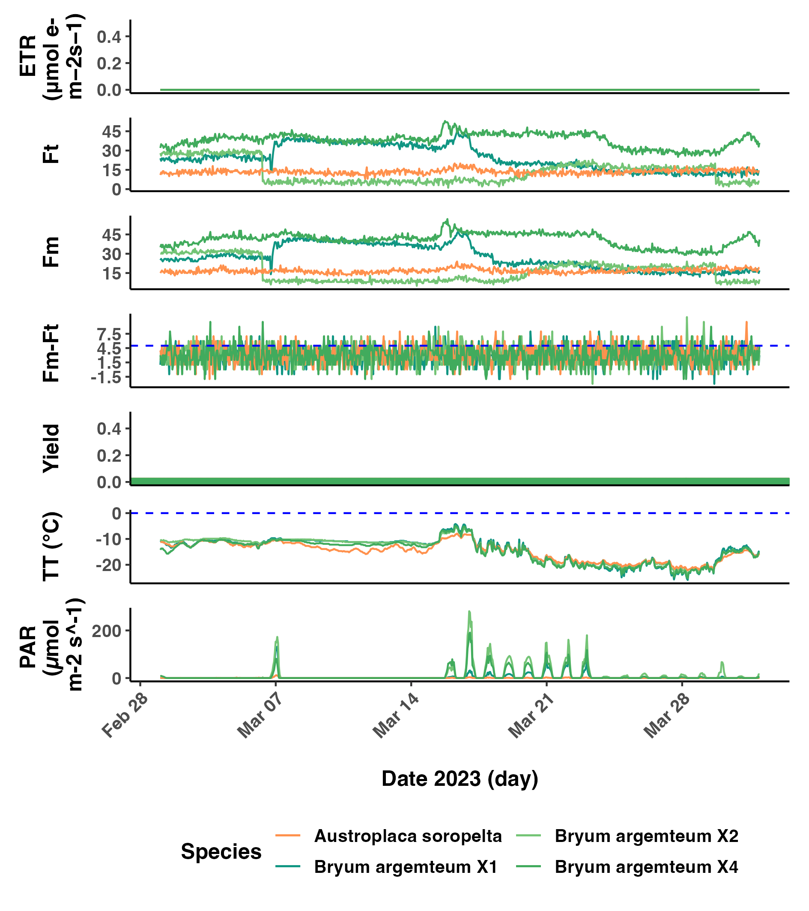

Fig.

APPENDIX 2













APPENDIX 3

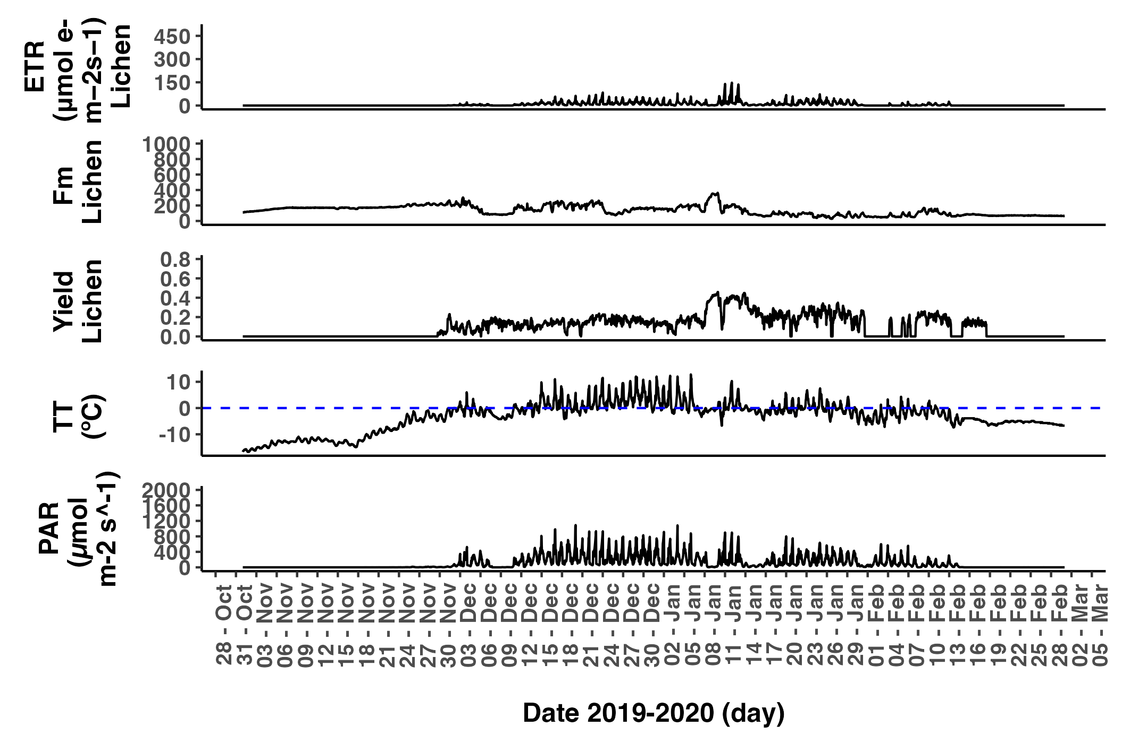

Fig.

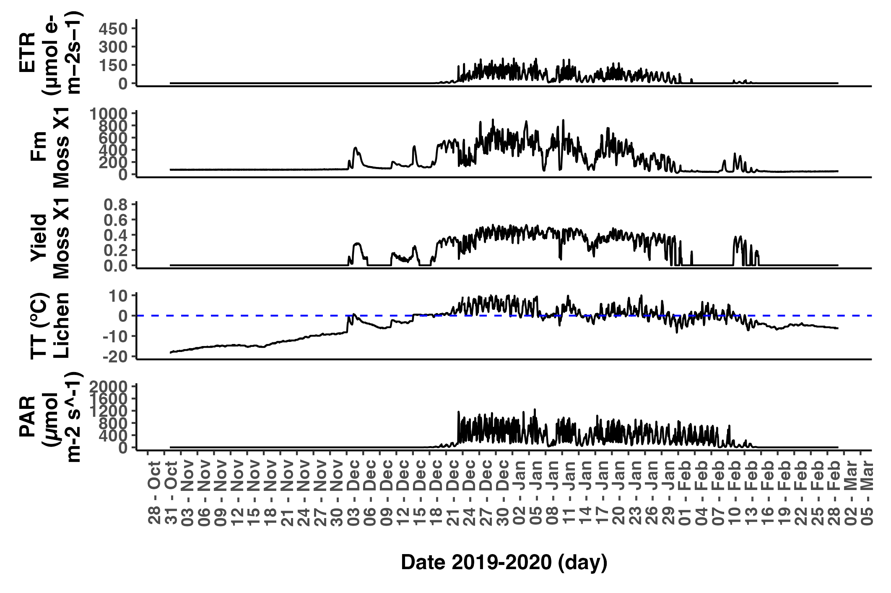

Fig.

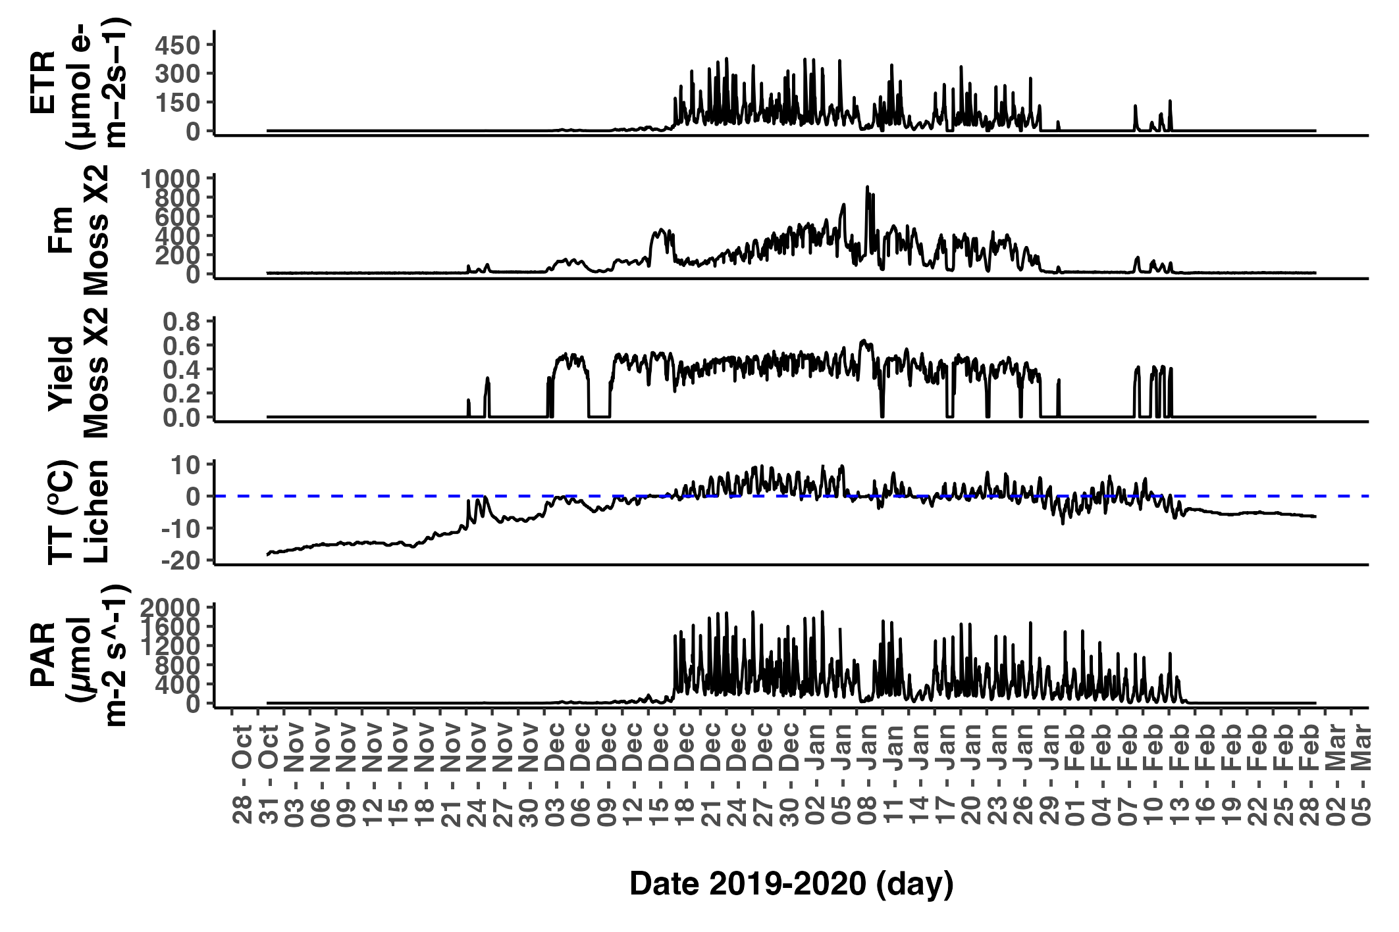

Fig.

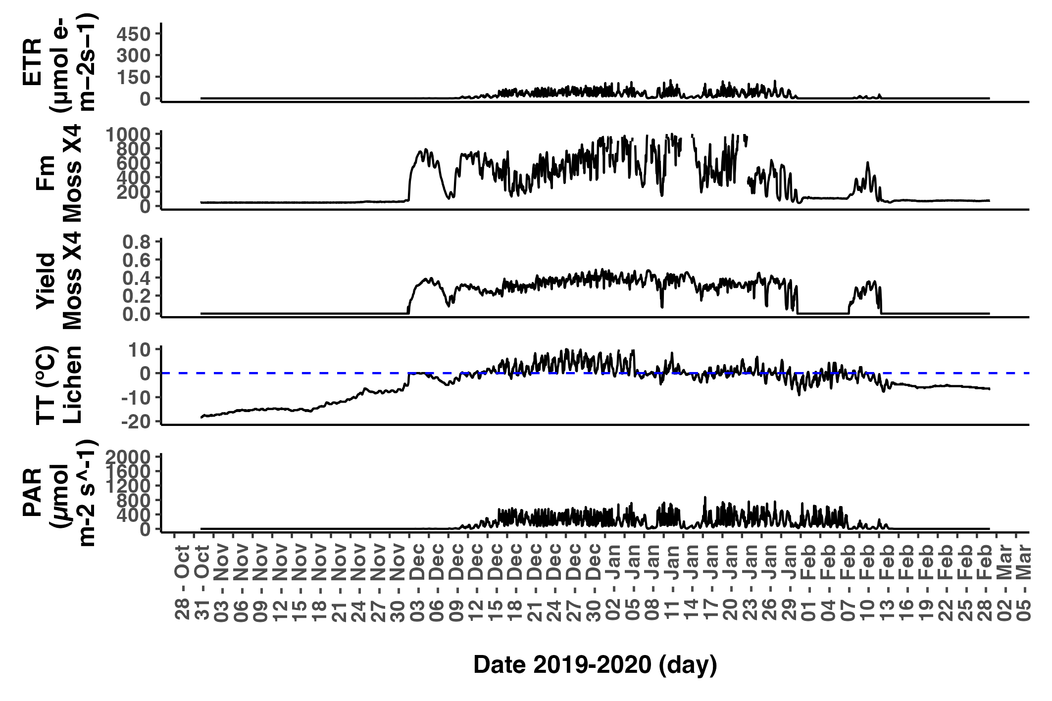

Fig.

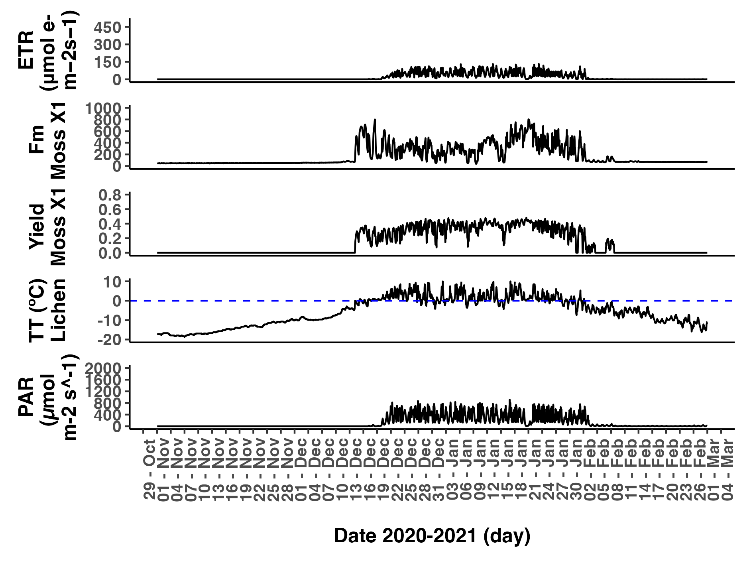

Fig.

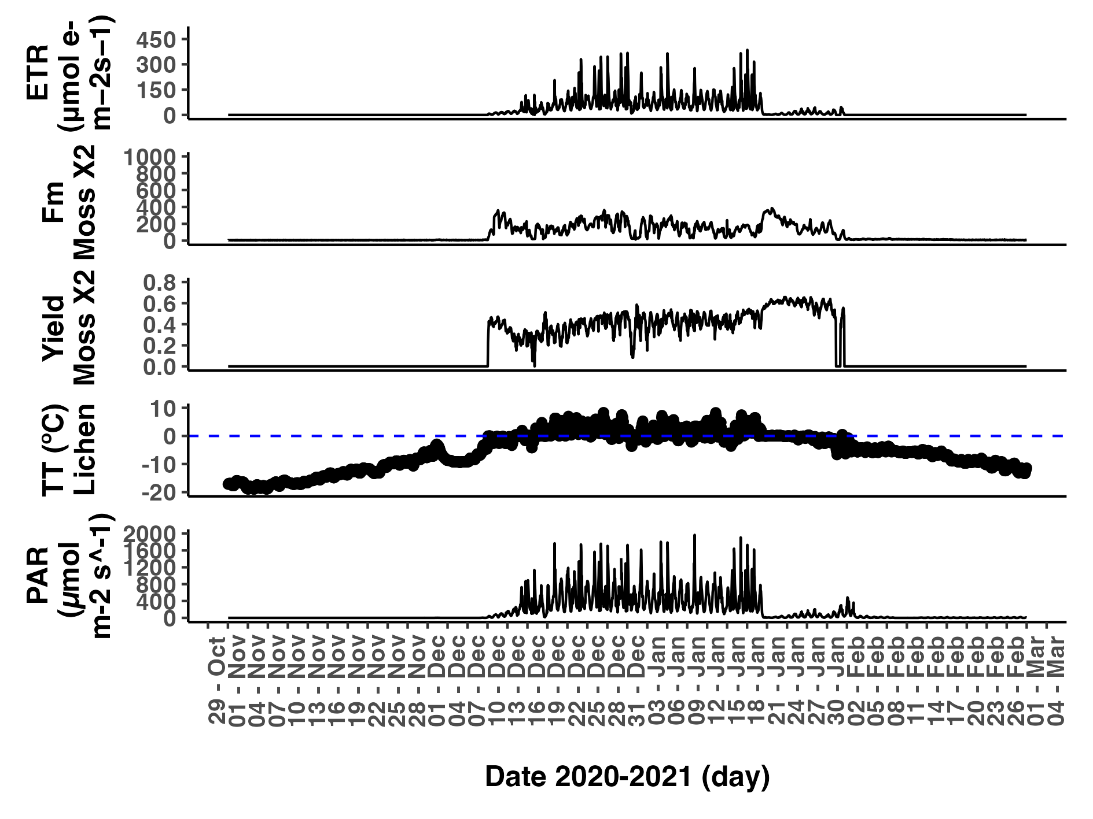

Fig.

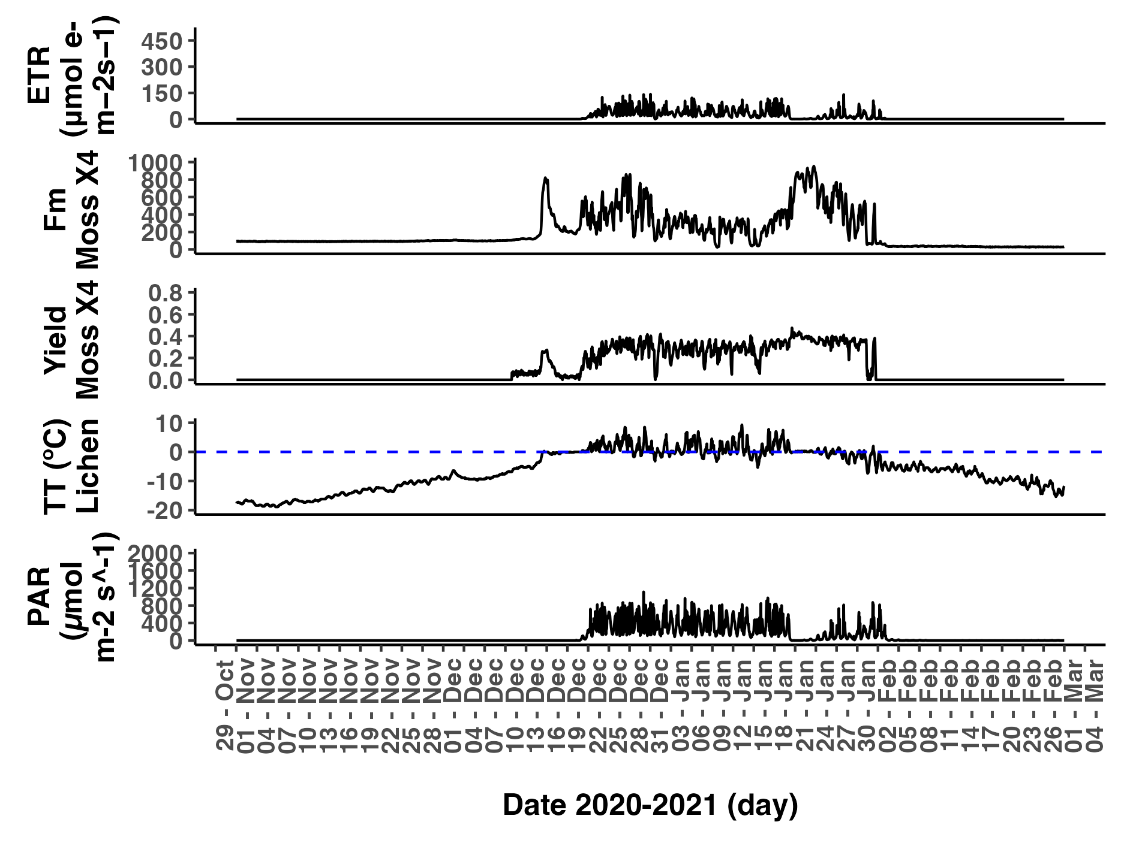

Fig.

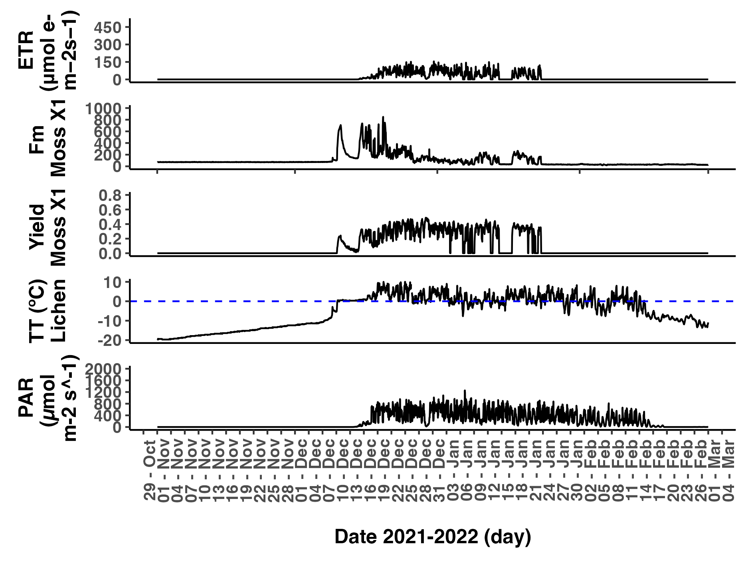

Fig.

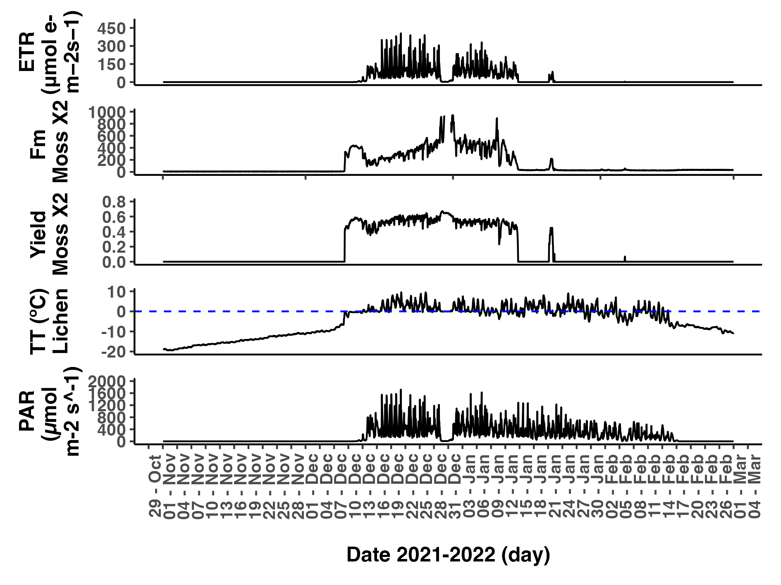

Fig.

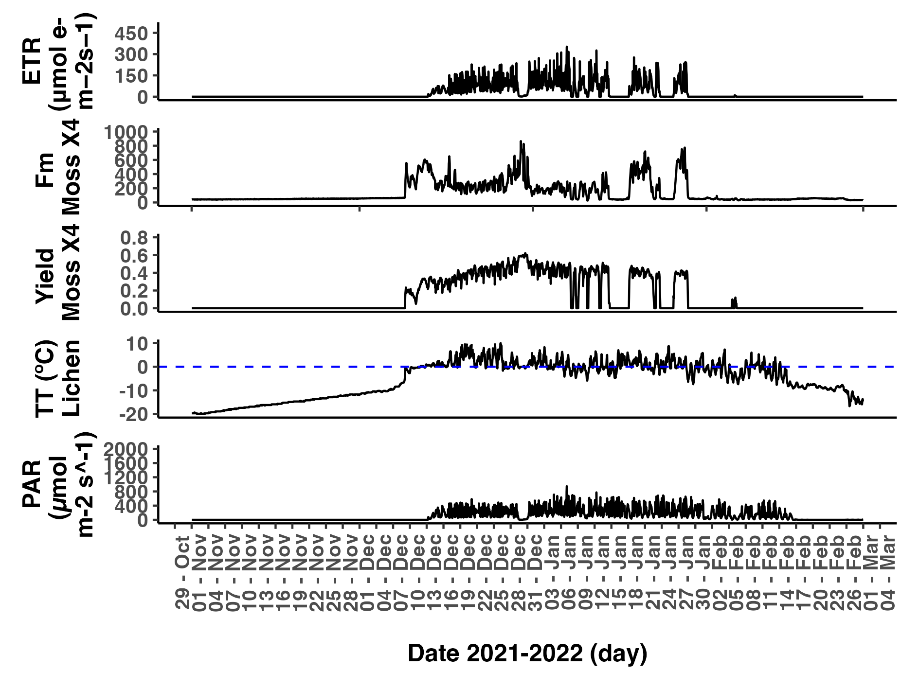

Fig.

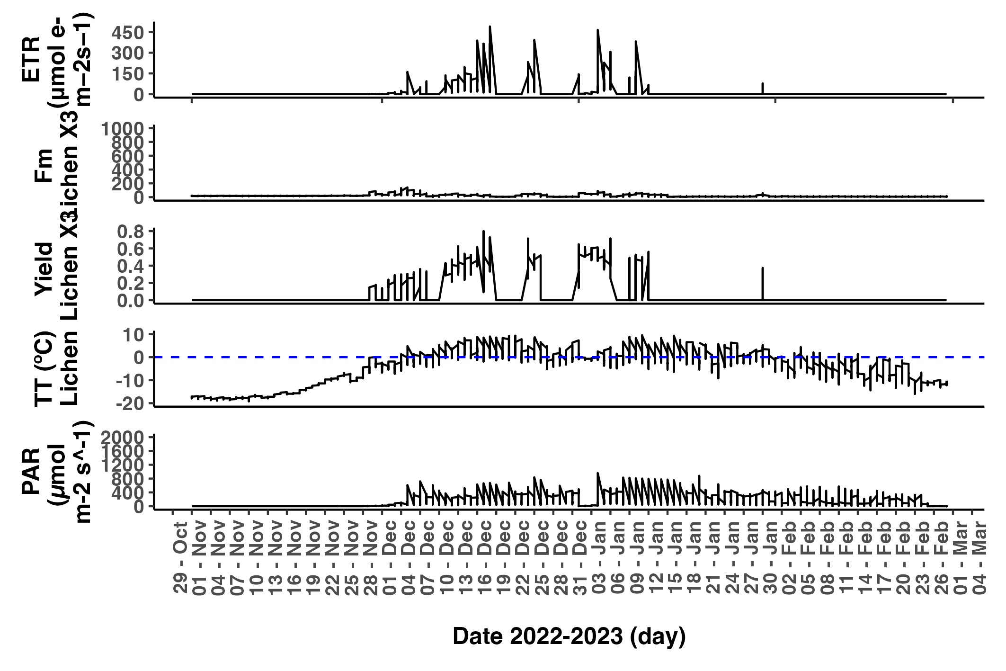

Fig.

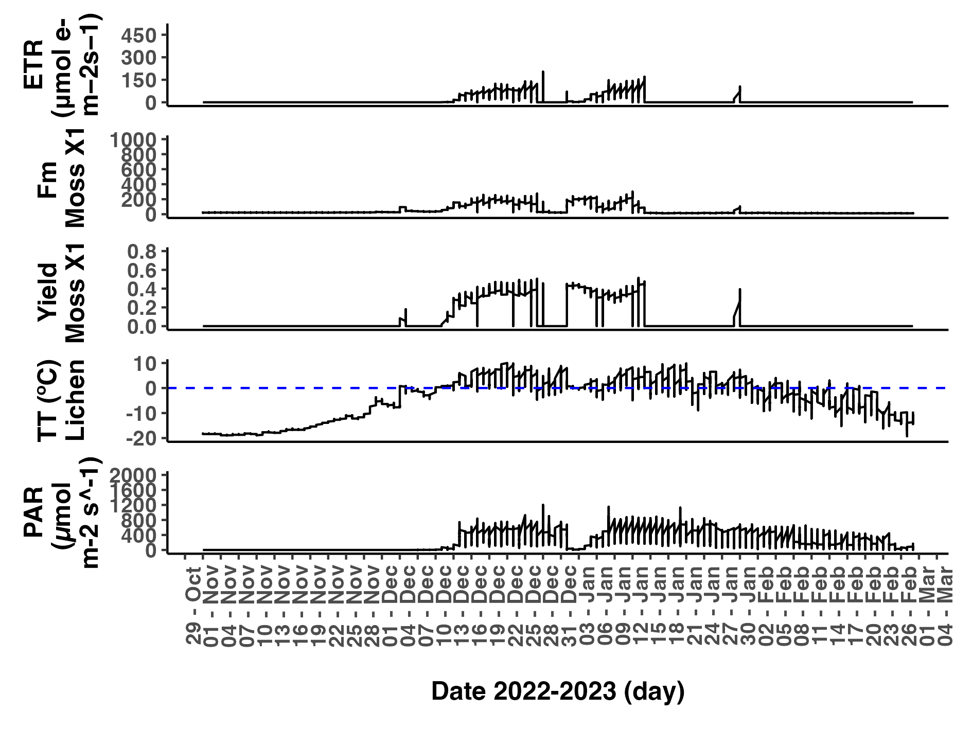

Fig.

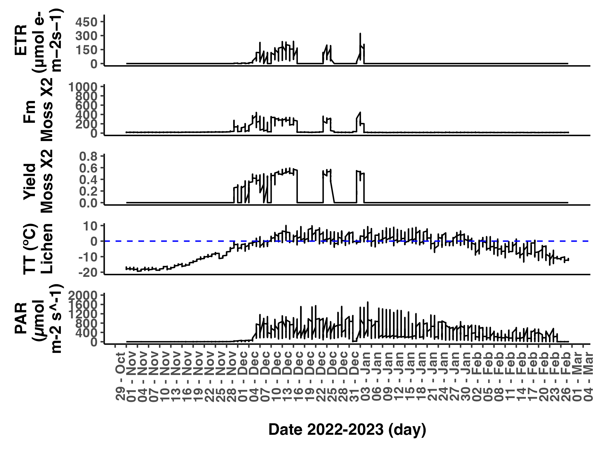

Fig.

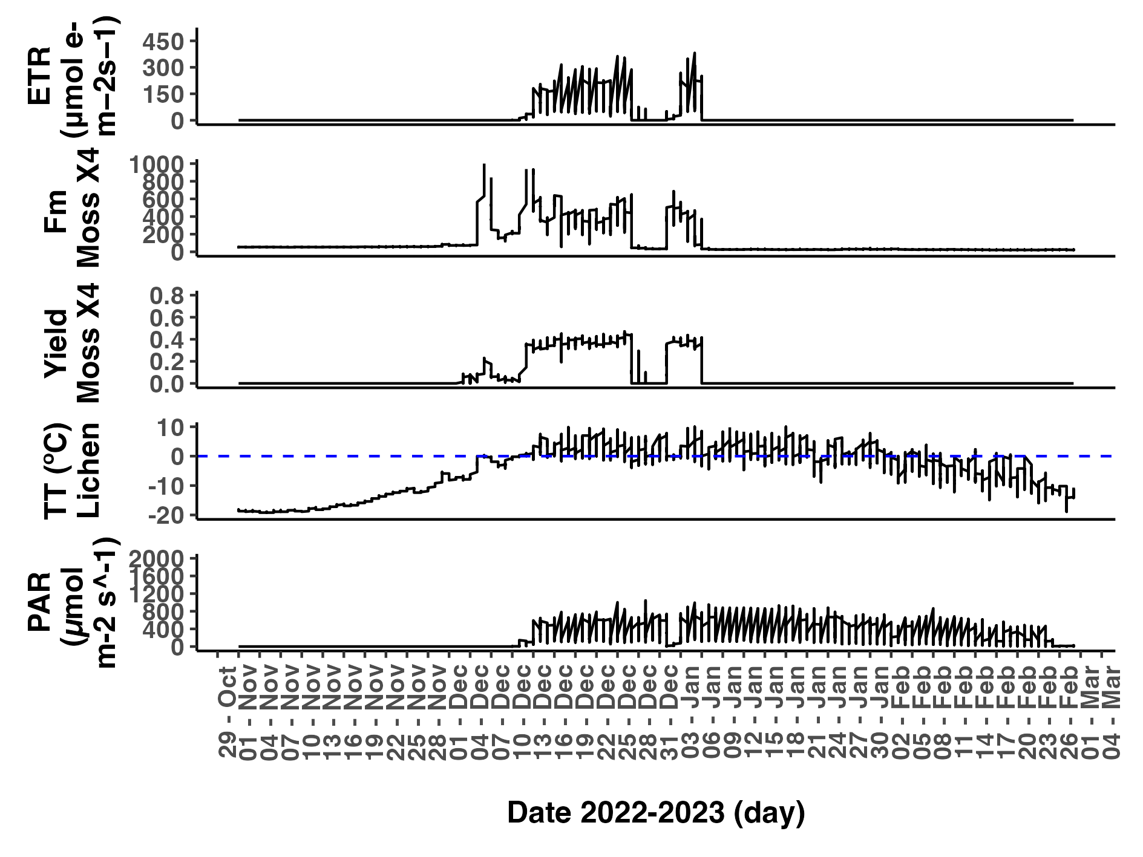

Fig.

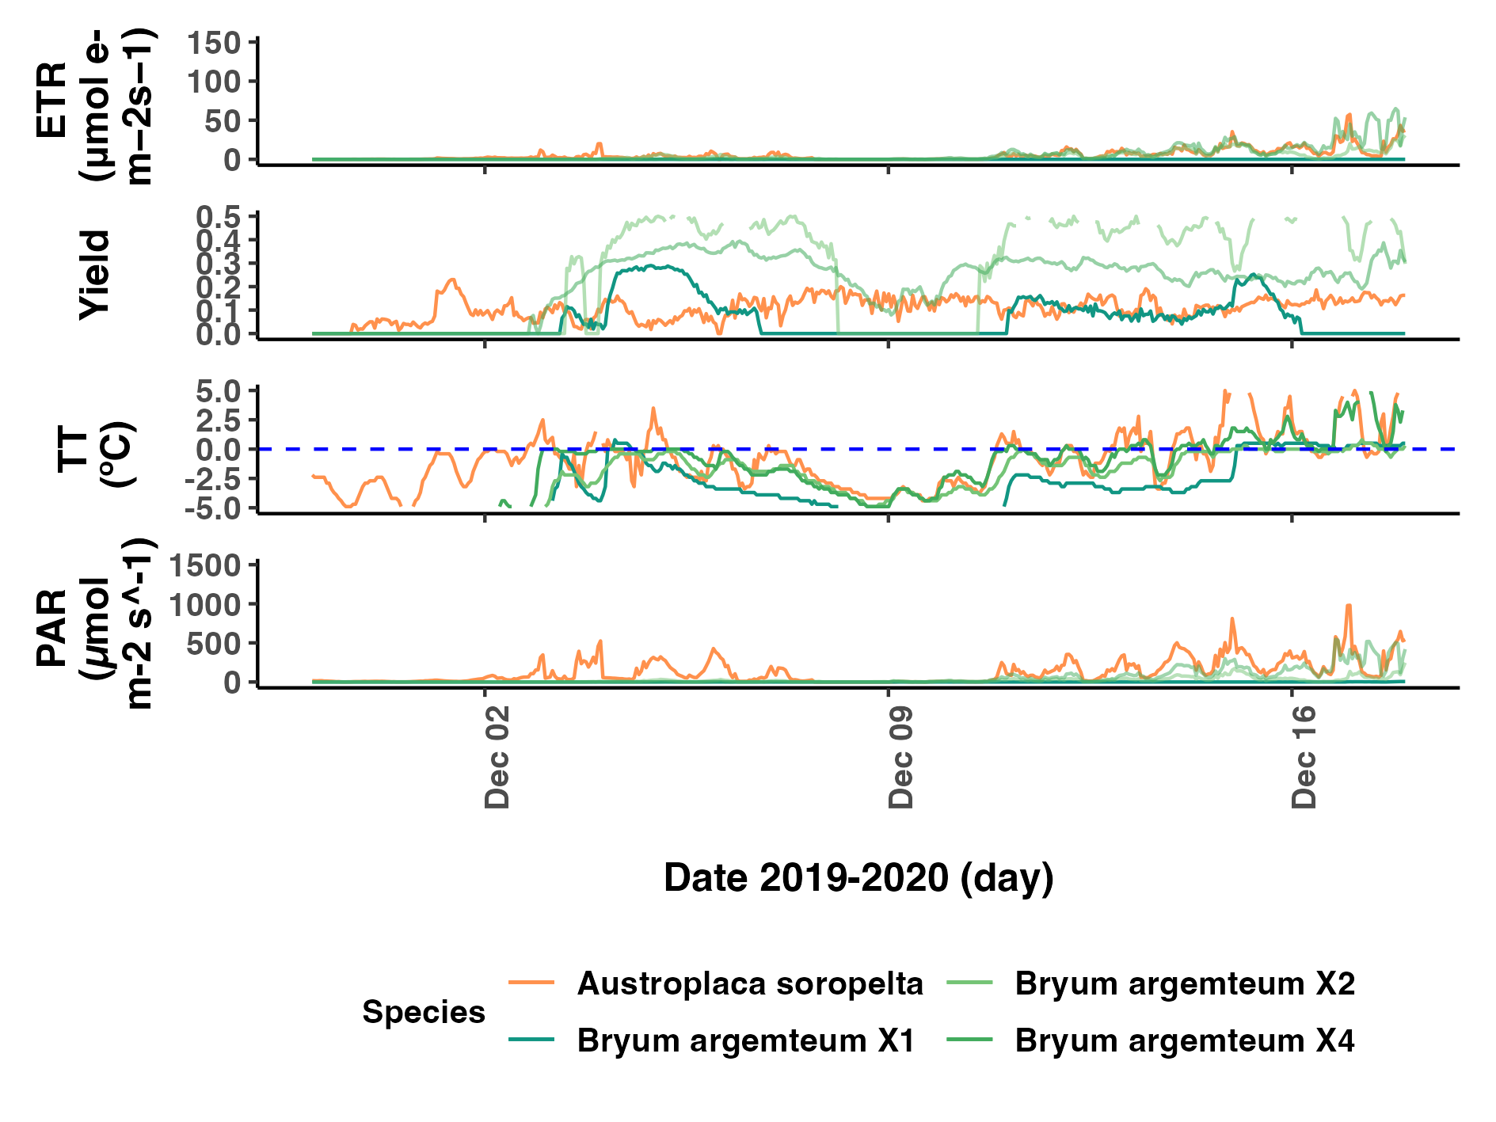

Fig.

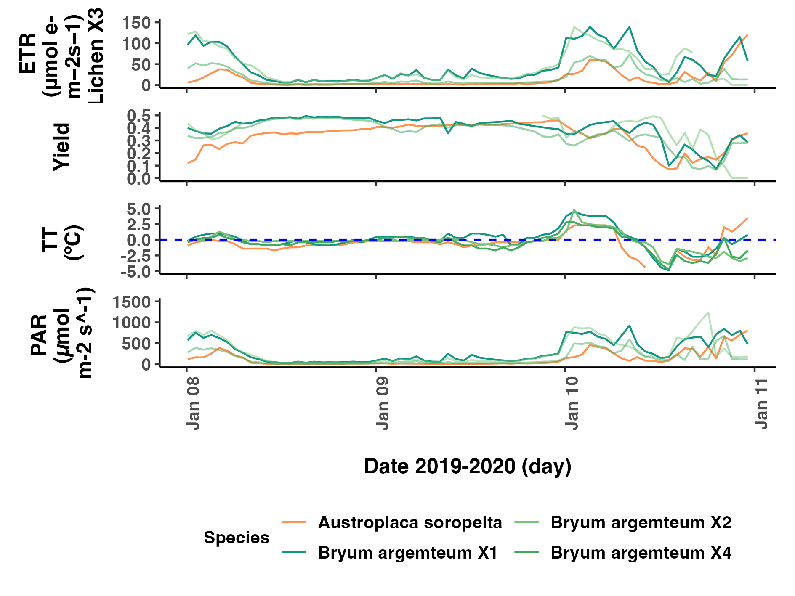

Fig.

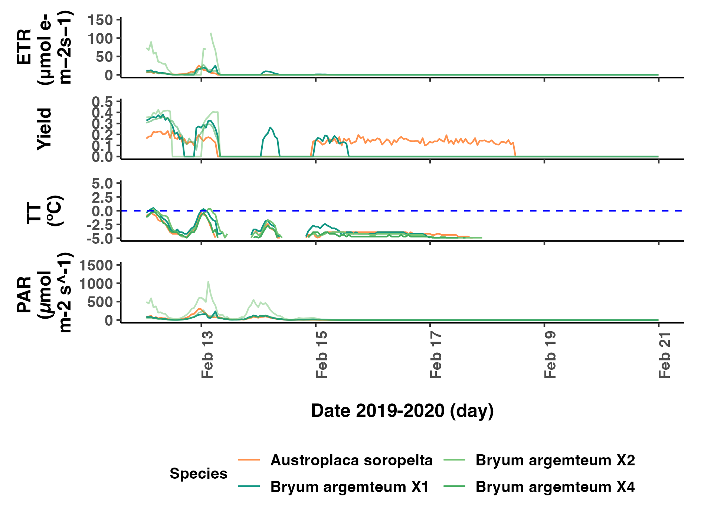

Fig.

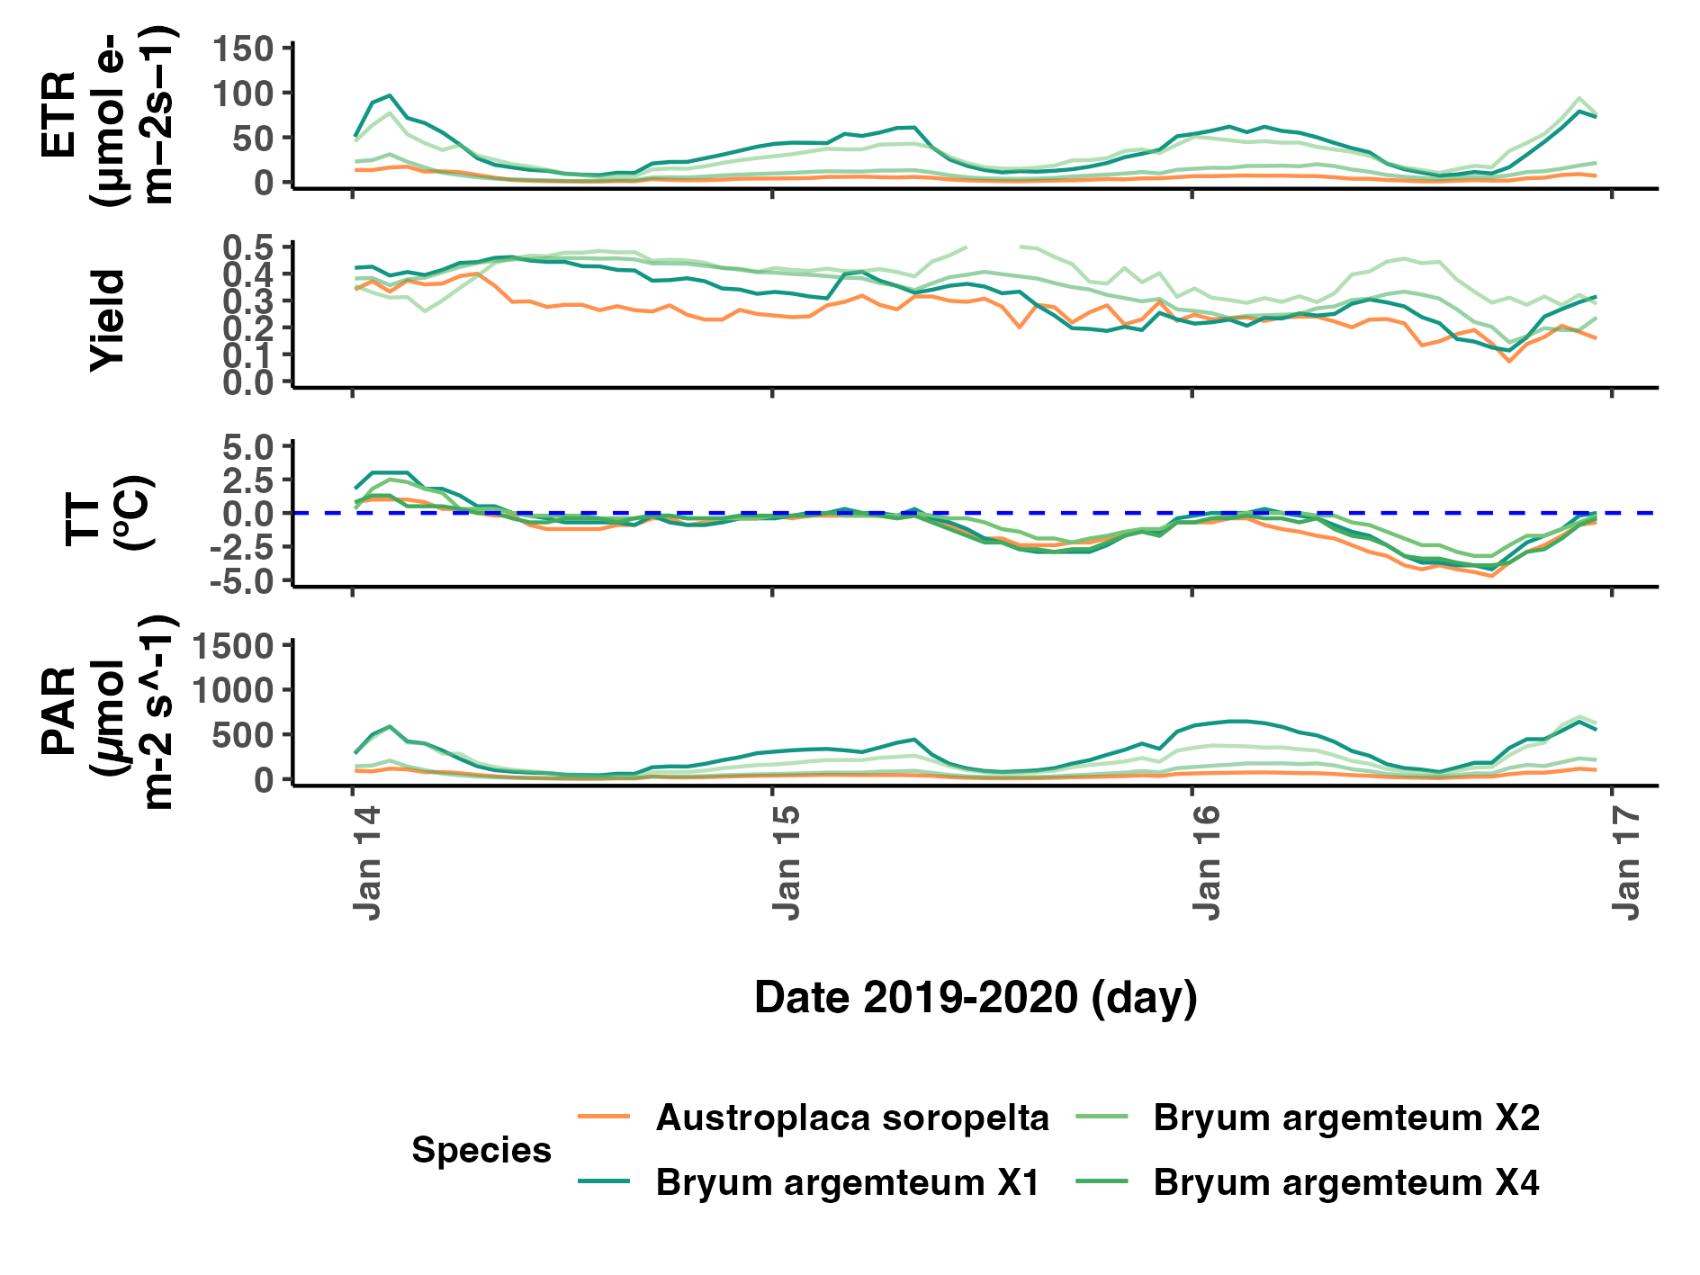

Fig.

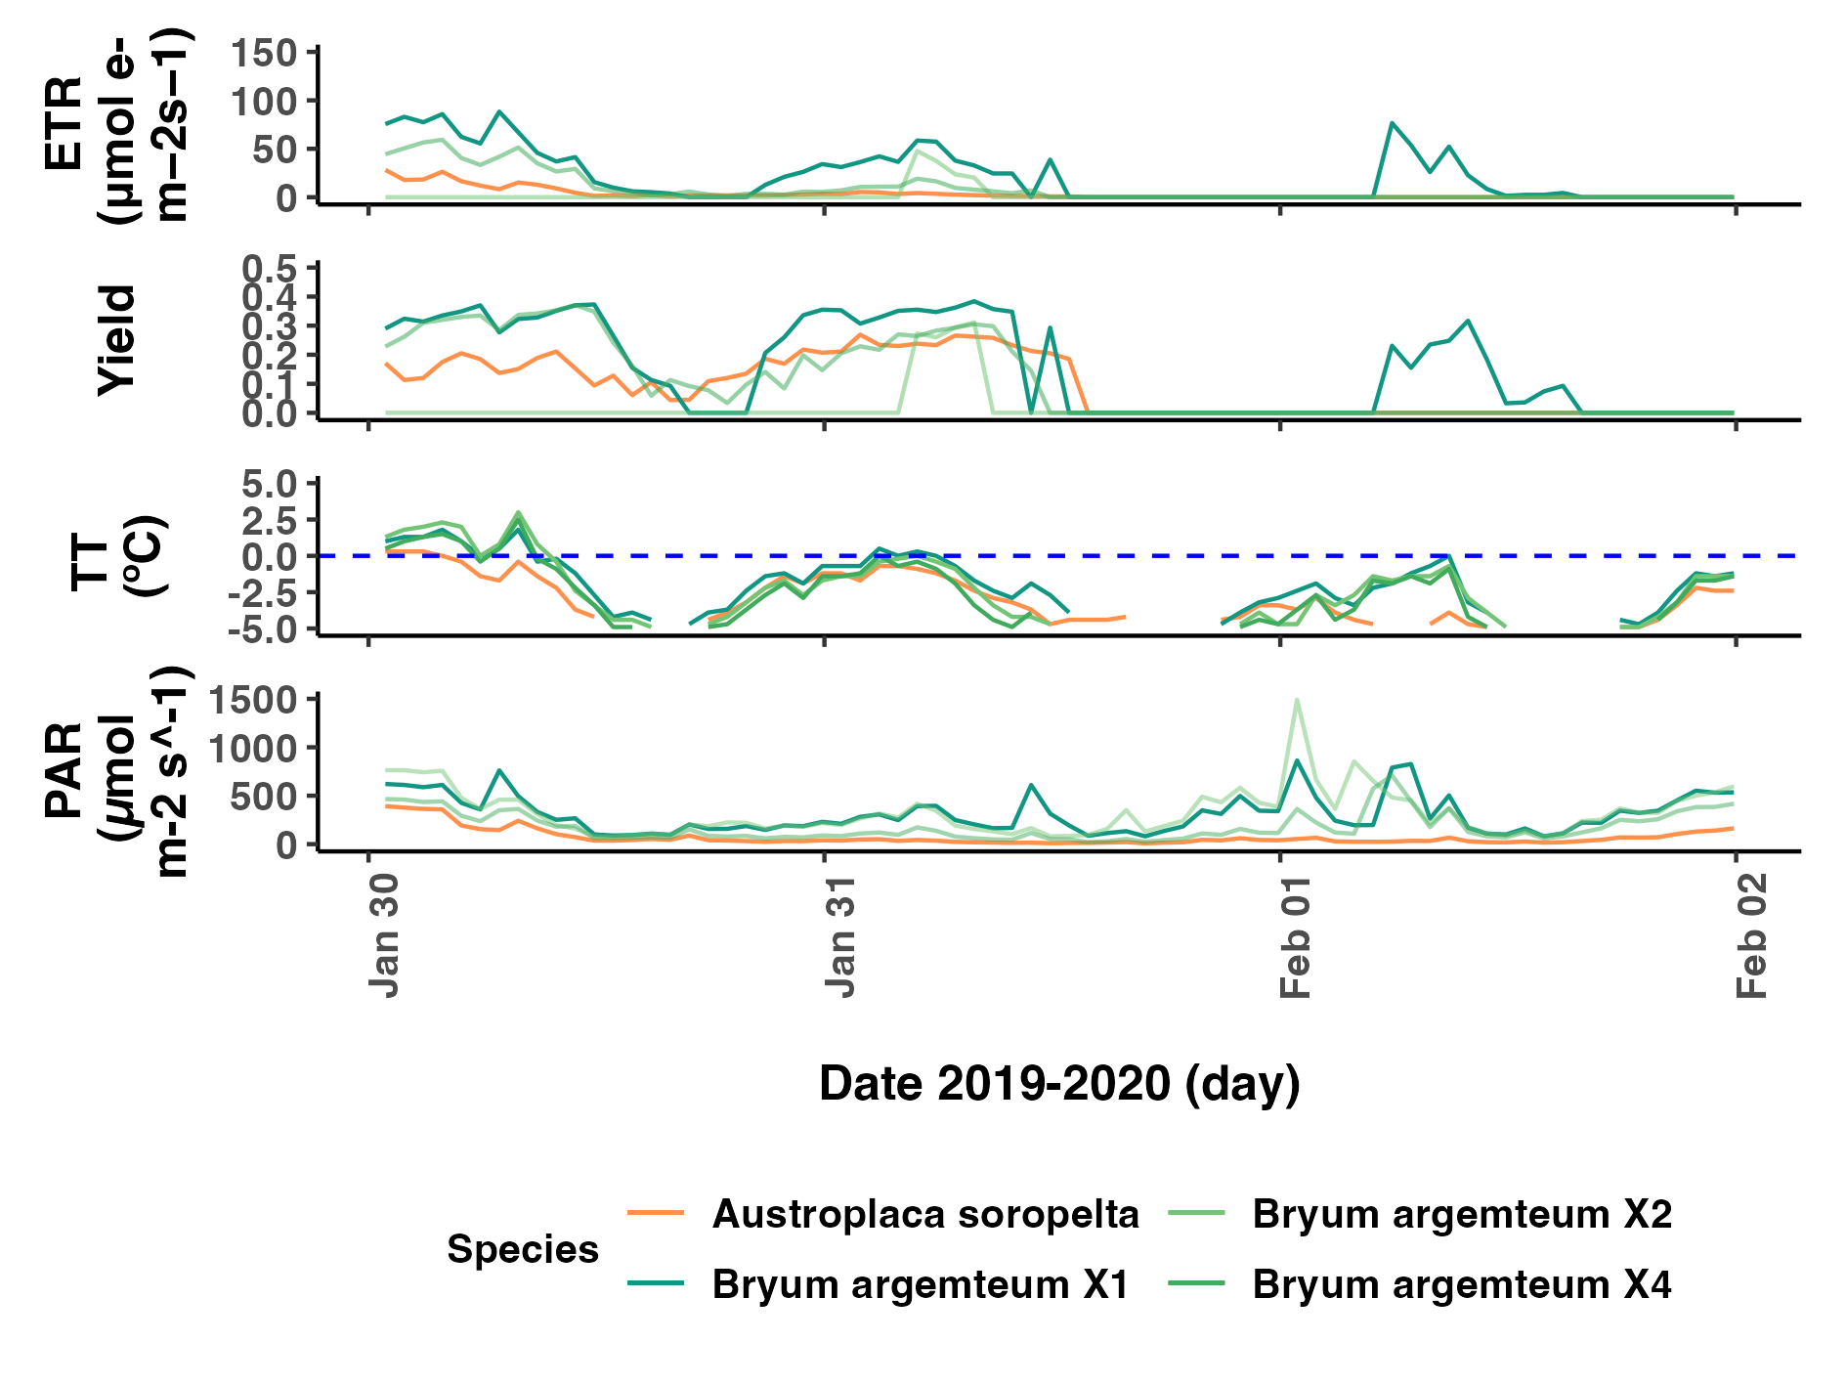

Fig.

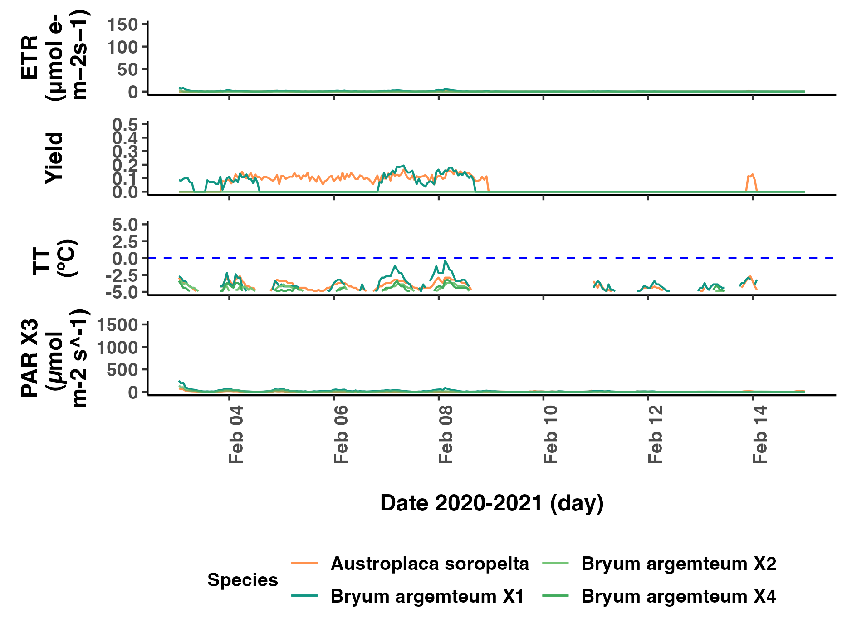

Fig.

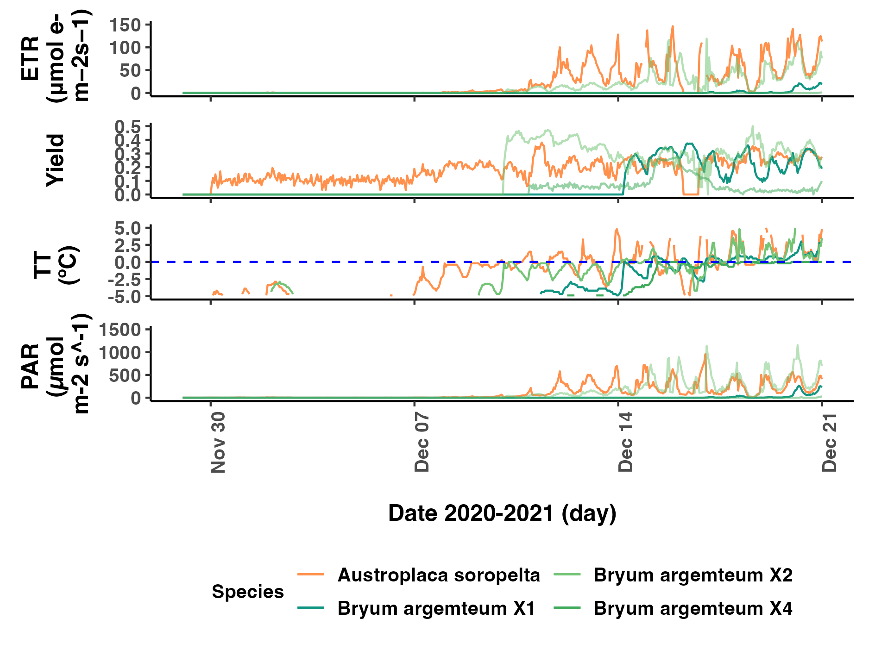

Fig.

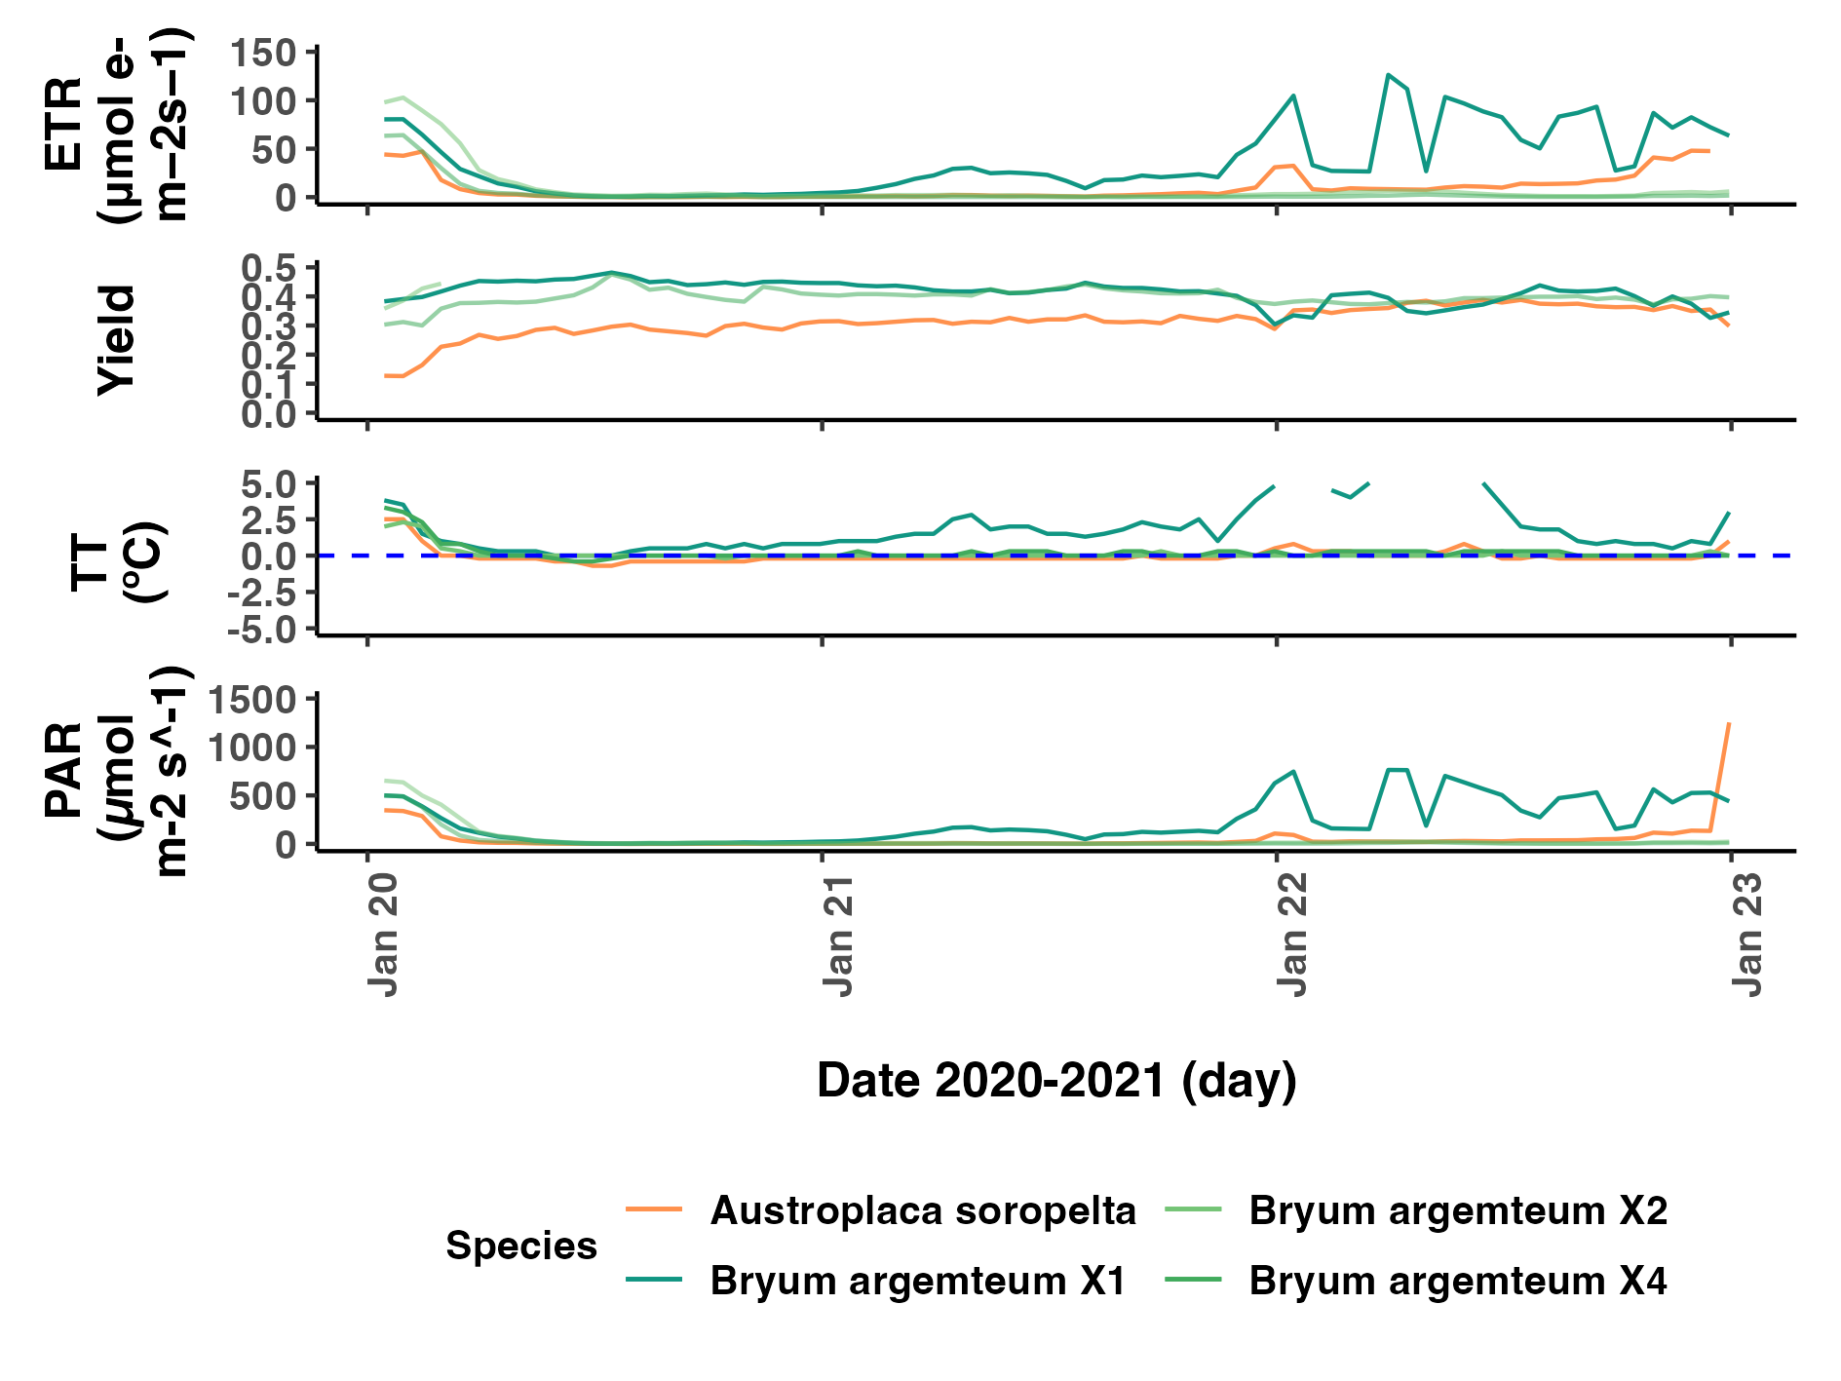

Fig.

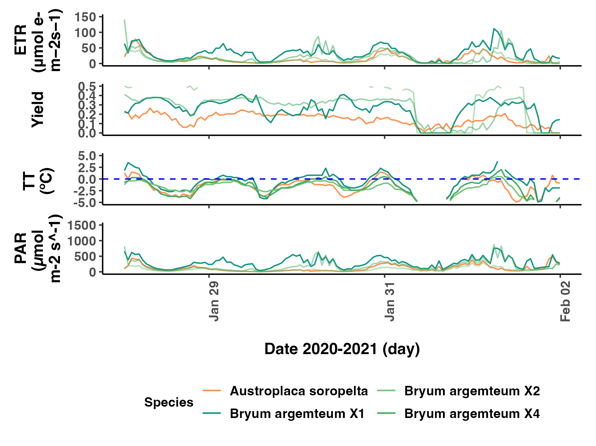

Fig.

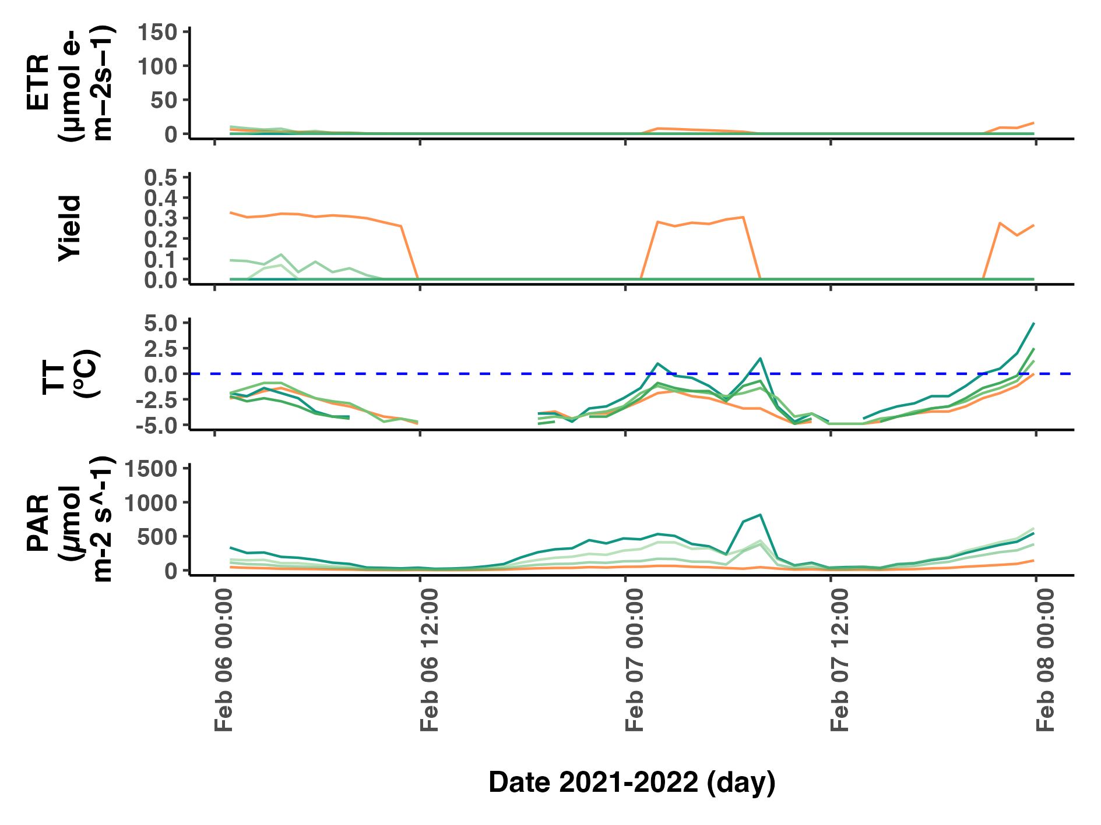

Fig.

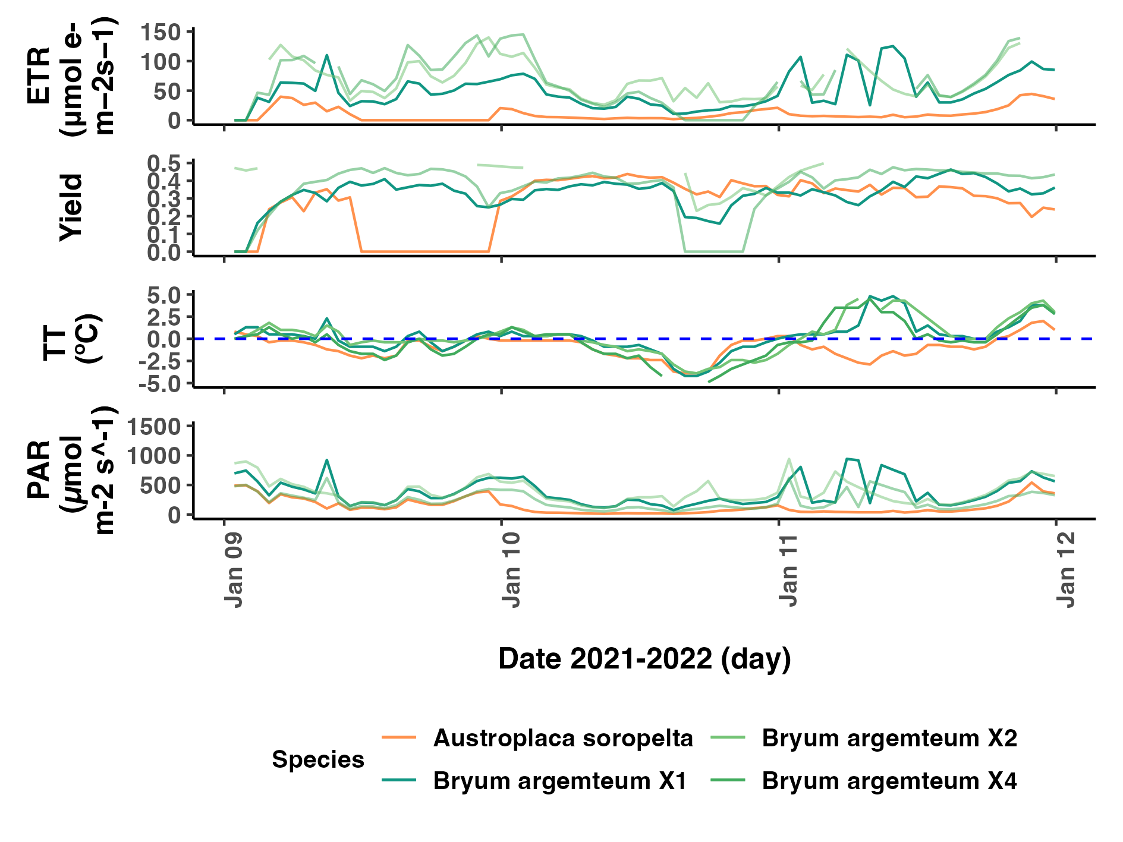

Fig.

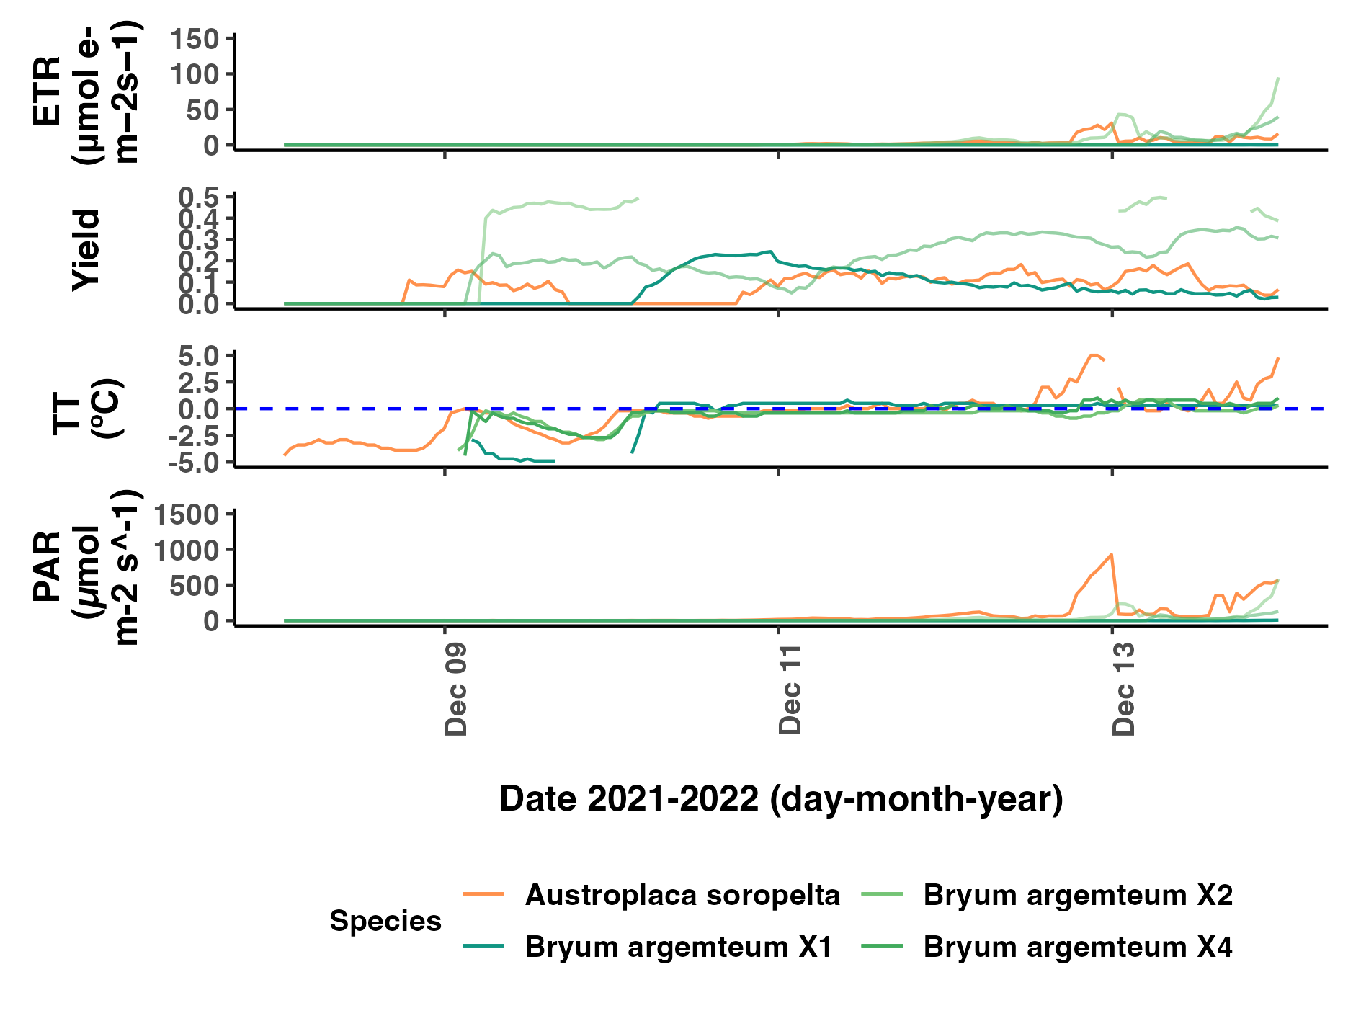

Fig.

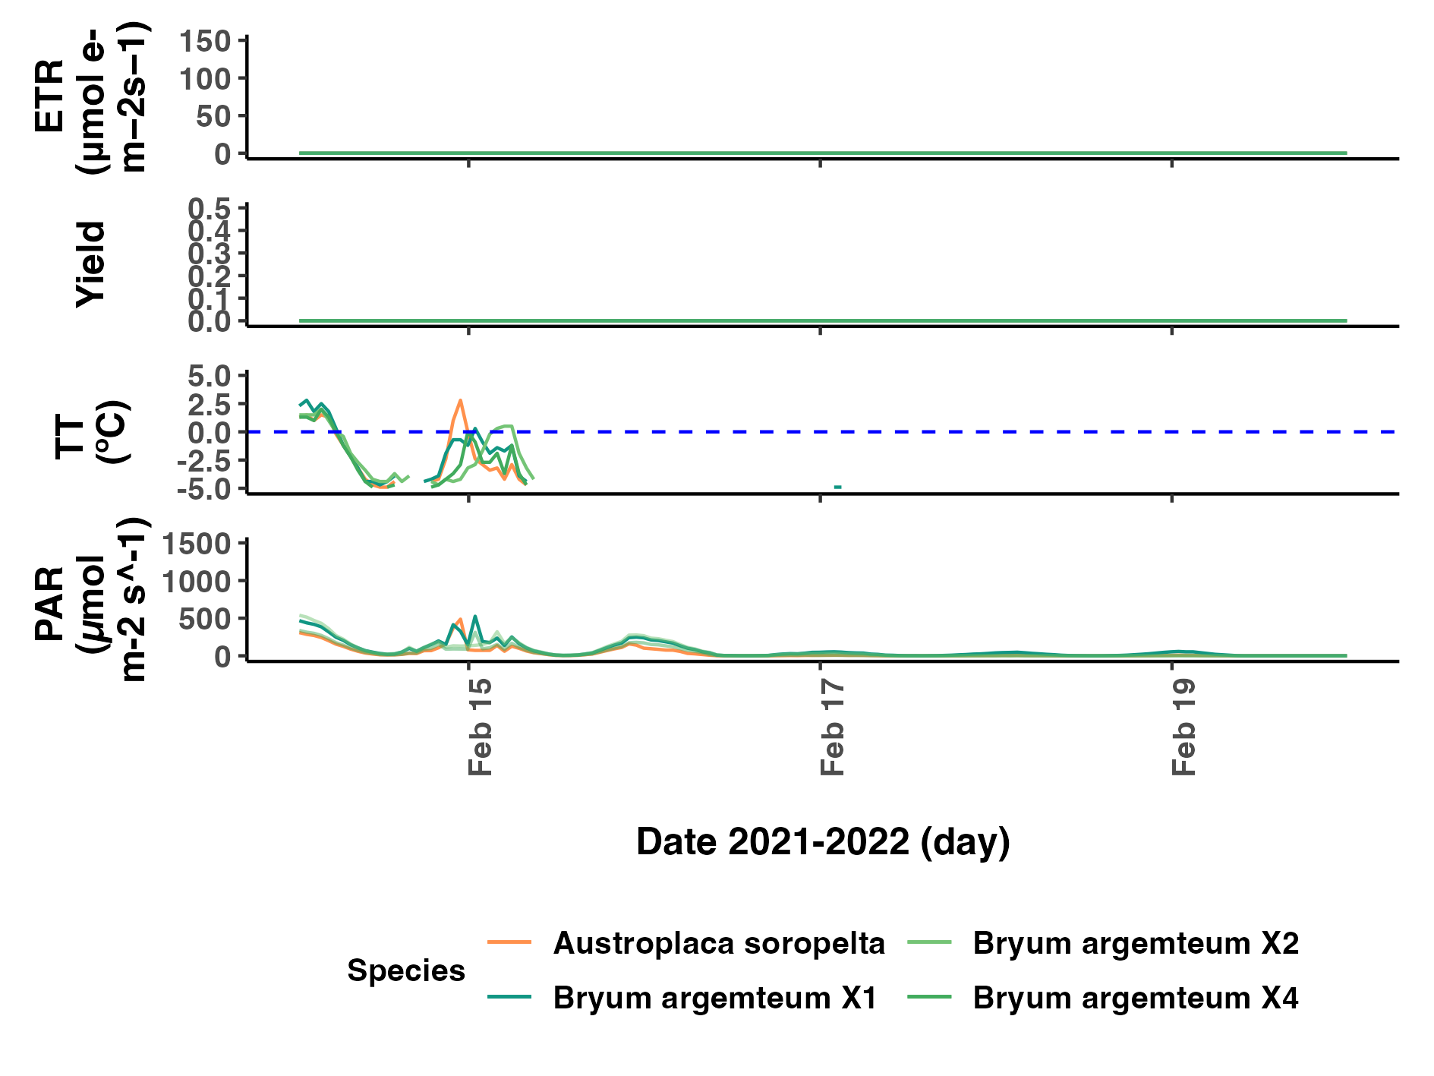

Fig.

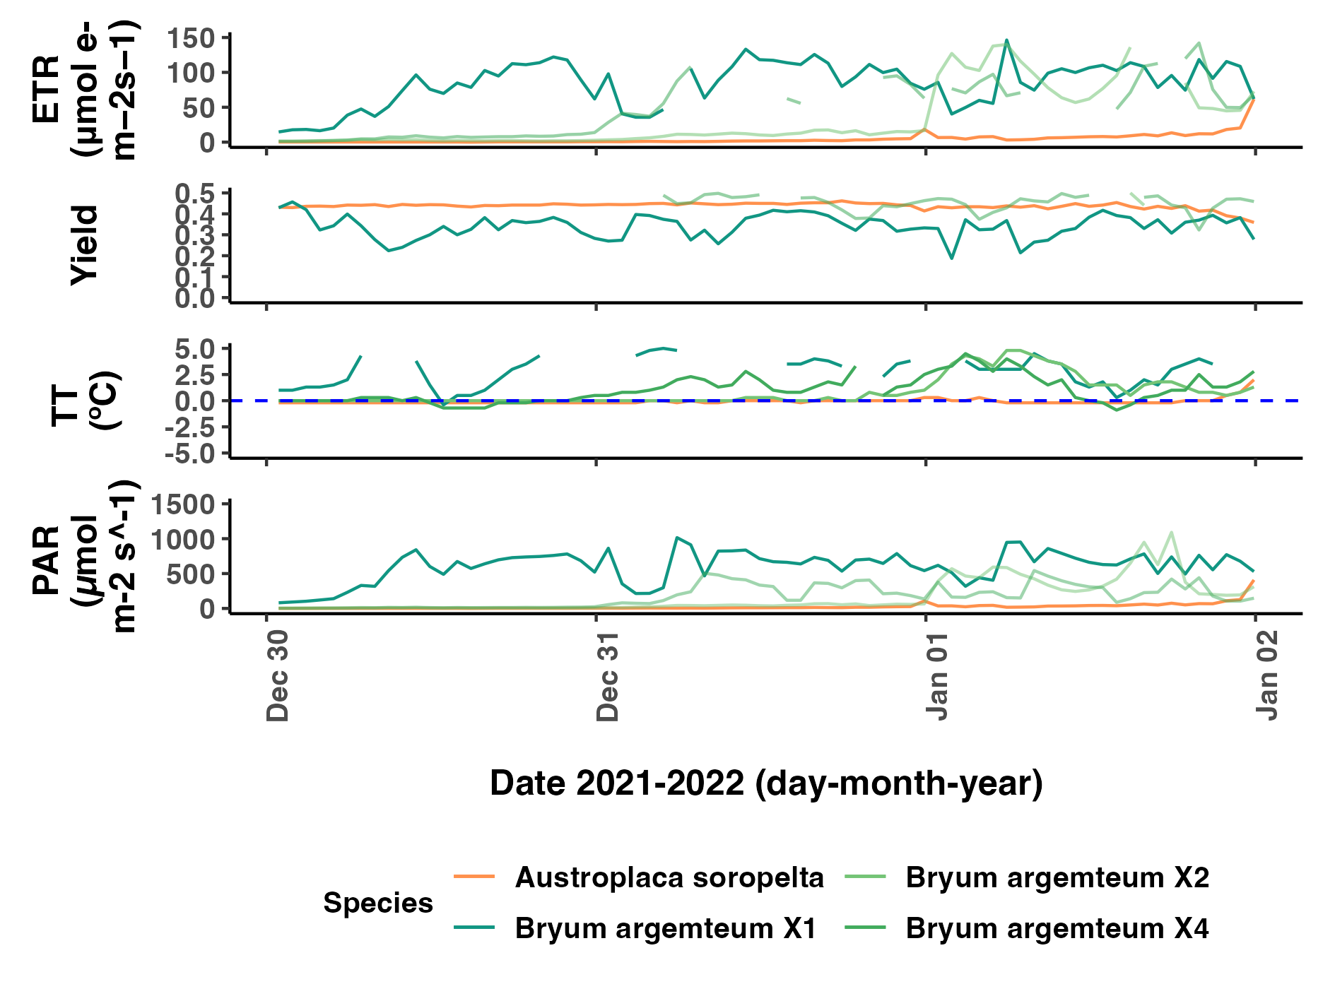

Fug.

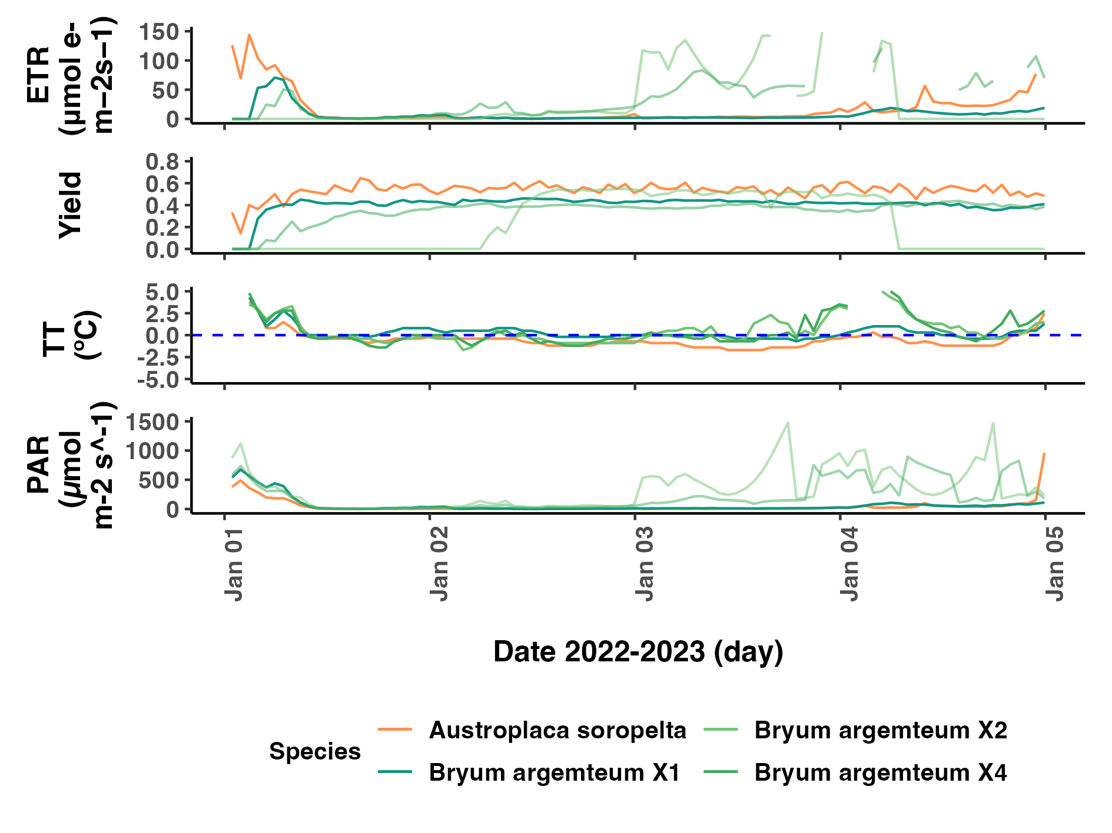

Fig.

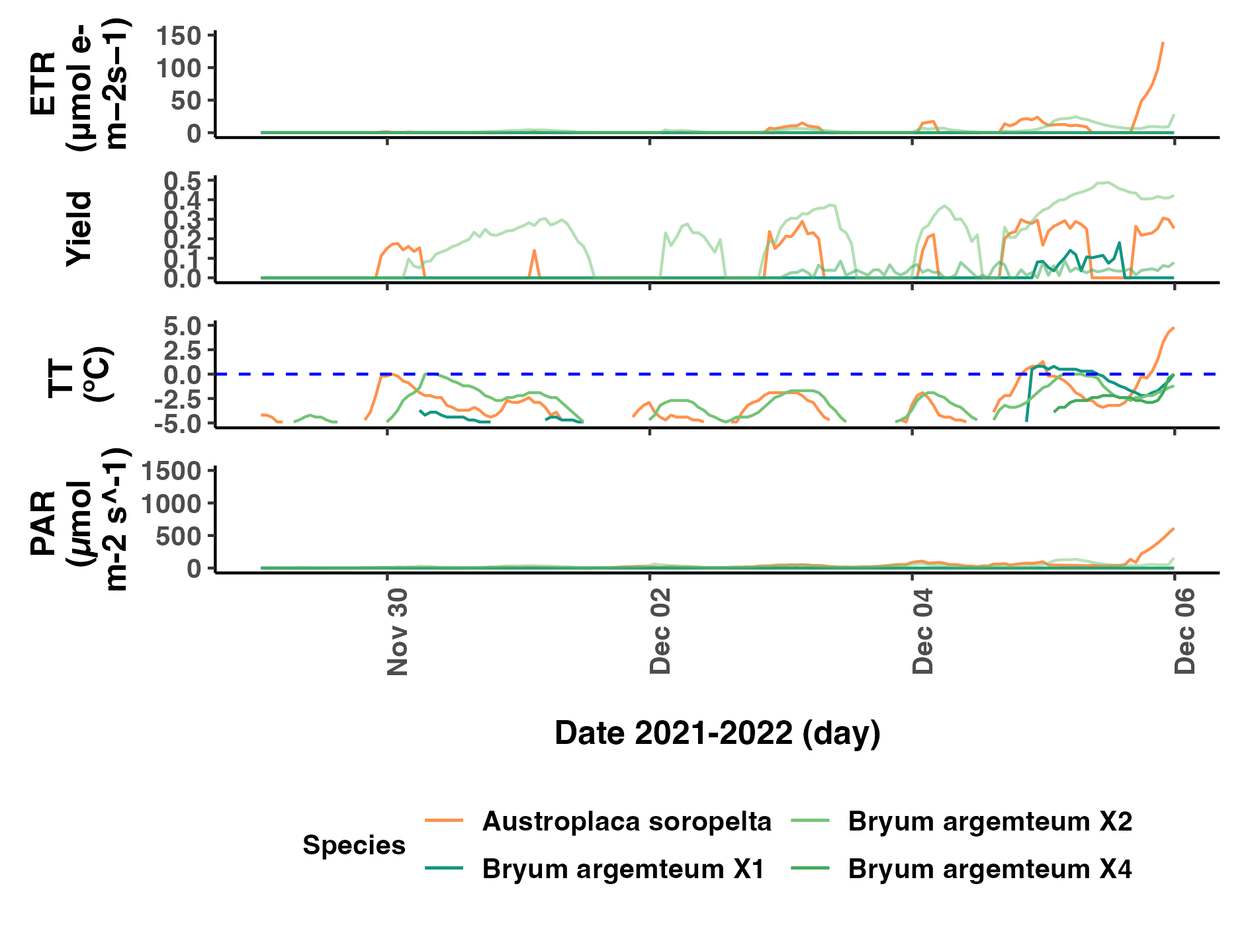

Fig.

APPENDIX 4

